iPERL NFC
Android Mobile Application Commands

Revision History
Rev | Date | State | Author | Remarks
0.1 | 03.09.2021 | Draft | Venkat | Initial version

Reference Documents / Source Codes / Mobile Application
NFC GUI – v1.5 – https://slm.sms-esaap.com/iPERL/nfcs5
NFC DLL – v1.3 – https://slm.sms-esaap.com/iPERL/nfcs5
iPERL v4.5 Metrology Firmware – https://slm.sms-esaap.com/iPERL_Firmware/iperl_s45_metro/-/tree/mode_switching
iPERL v4.5 Radio Firmware – https://slm.sms-esaap.com/iPERL_Firmware/iperl_s45_sensusrf/-/tree/feature_branch_iperls45
Android Mobile Application – ‘ST25 NFC Tap’ from ST Microelectronics

Contents
iPERL NFC Android Mobile Application Commands 1
Contents 2
1 Search for NFC application in Android mobile’s Google play store 3
2 Installing ‘ST25 NFC Tap‘ application 4
3 Application Icon 5
4 Check for NFC support in mobile (If existing) 6
5 Check for NFC support in mobile (If NOT existing) 7
6 Detect and connect with iPERL device 8
7 Go to Memory menu 9
8 Modifying Testmode config or VRTM config 10
9 Entering Test Mode 11
10 Entering VRTM mode 12
11 Entering Active Mode 13

Search for NFC application in Android mobile’s Google play store

In Android Google play store, search for ‘st25 nfc tap’, you will find the application with title “ST25 NFC Tap”

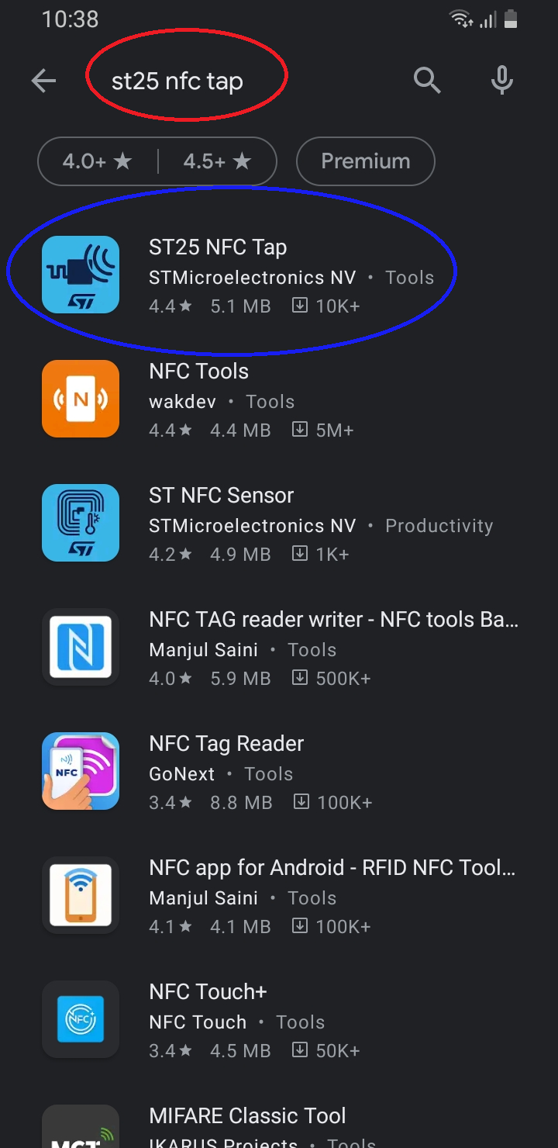

Installing ‘ST25 NFC Tap‘ application

Select the app “ST25 NFC Tap” and click on Install.

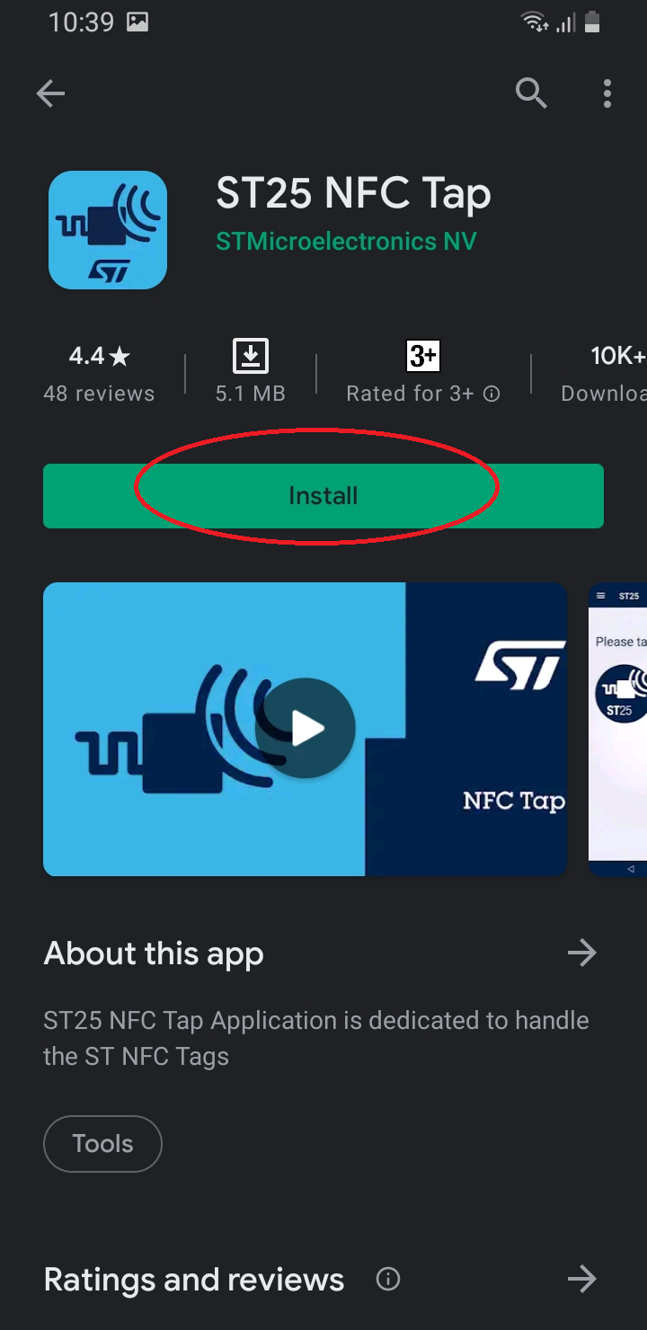

Application Icon

After successful installation, we will see the application with the below Icon

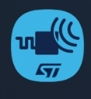

Check for NFC support in mobile (If existing)
Once we open the application, we should see the below screen. If the screen is like this, then proceed with step-6 because this mobile supports NFC.

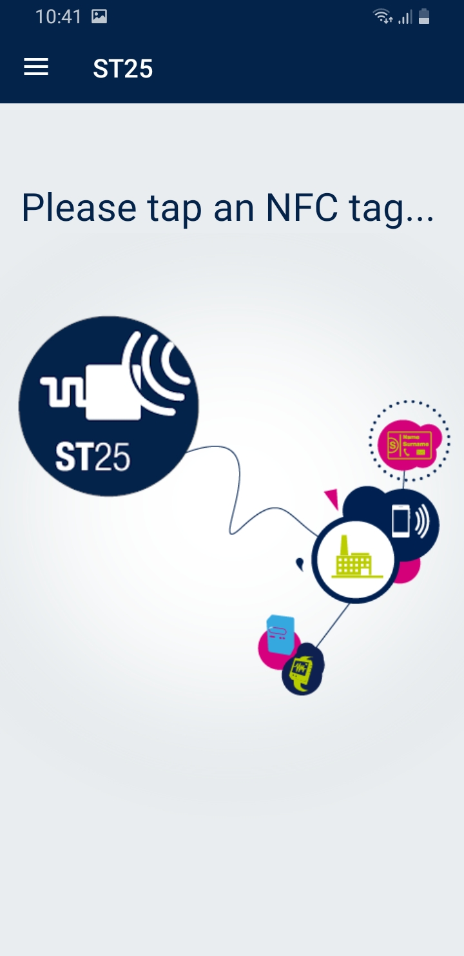

Check for NFC support in mobile (If NOT existing)

Once we open the application, if we see the below, then we have to change the mobile because this mobile doesn’t have NFC support.

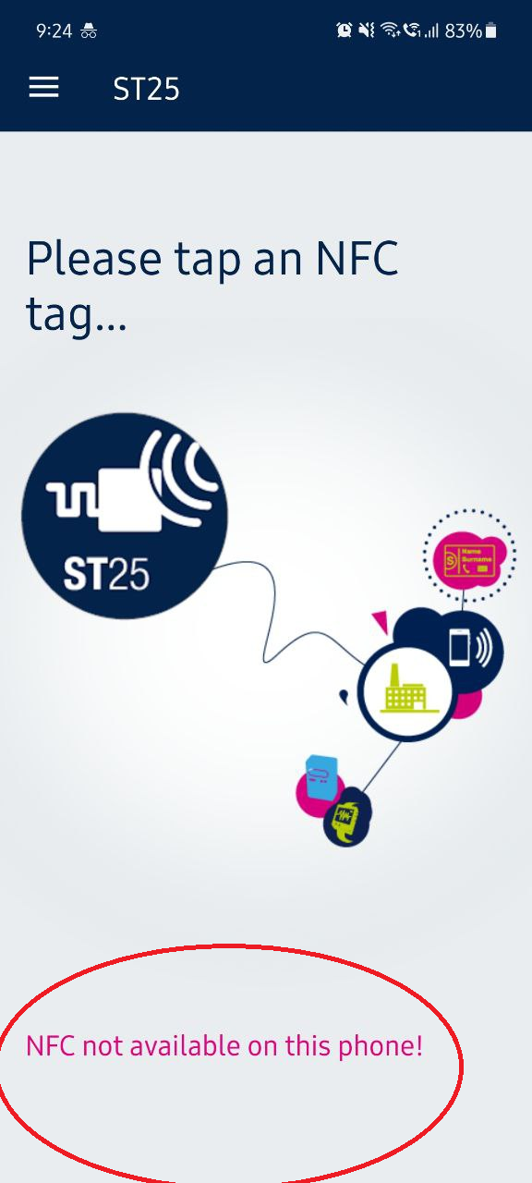

Detect and connect with iPERL device

Place mobile near iPERL and we should see the below screen if both become pair and if successful
connection is established for further communication between mobile application and iPERL.

If this screen is not seen, then try to place mobile and iPERL together until this screen is seen.

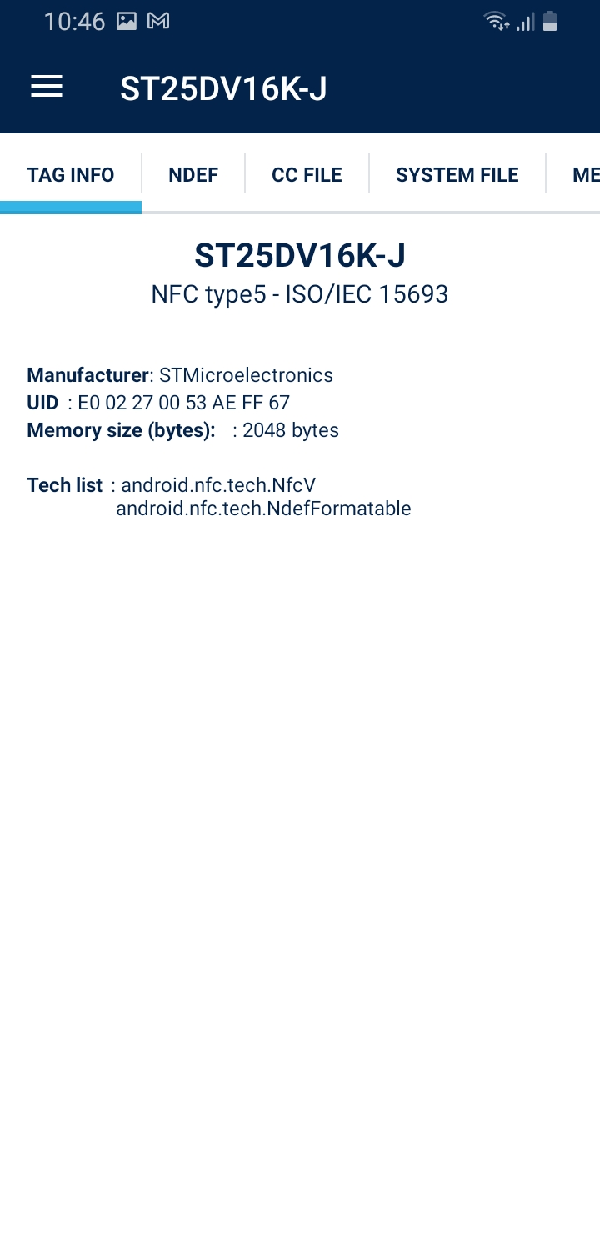

Go to Memory menu

From this “MEMORY” menu, we can write or read EEPROM (read/write memory in NFC chip, which is in iPERL)

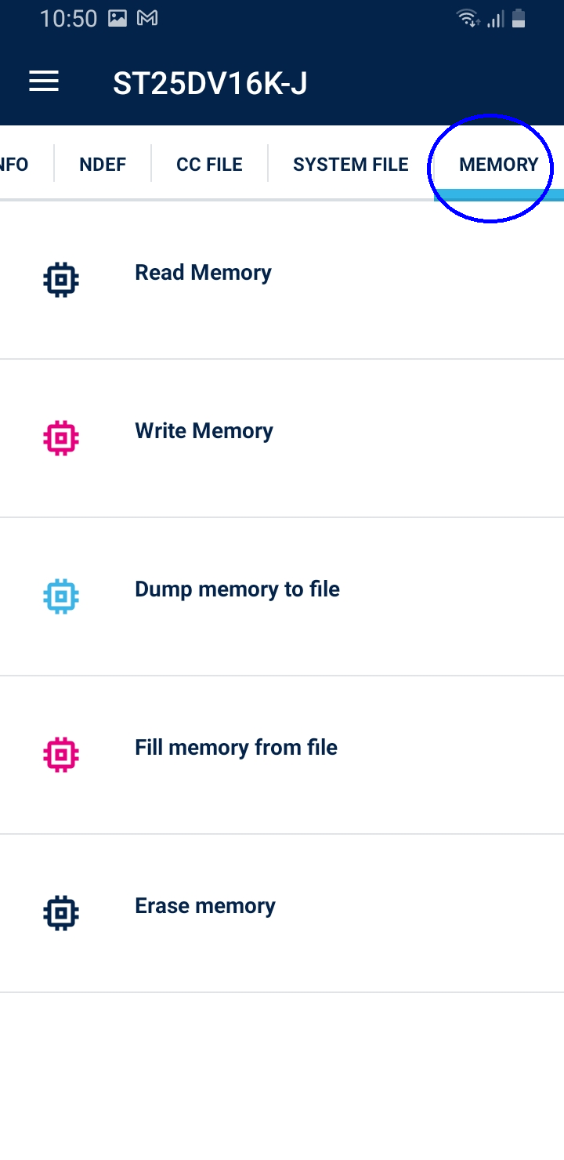

Modifying Testmode config or VRTM config

In “MEMORY” menu, select “Write Memory”, enter the below (as required) and select OK. In the below example, writing test mode or VRTM configuration of 160 (0xA0) at the memory location 261 (0x105). We can write any required configuration.

This location (261) holds Test mode or VRTM configuration. When user tries to change following iPERL mode transiitons with mobile app commands then only this configuration is used.
Active Mode Test Mode
Actgive Mode VRTM Mode

Please note, this location always retains previously written value as latest.

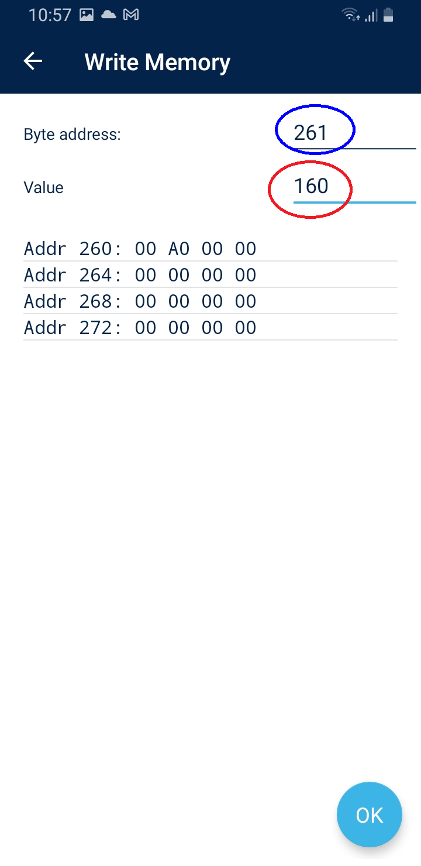

Entering Test Mode

In “MEMORY” menu, select “Write Memory”, enter the below and select OK.
This will change the iPERL state to Test mode (This command is only allowed if the iPERL is in Active mode, otherwise this command is ignored)

For switching to Test mode (ofcourse only when iPERL is in Active Mode), write 90 (0x5A) at the memory location 260 (0x104).

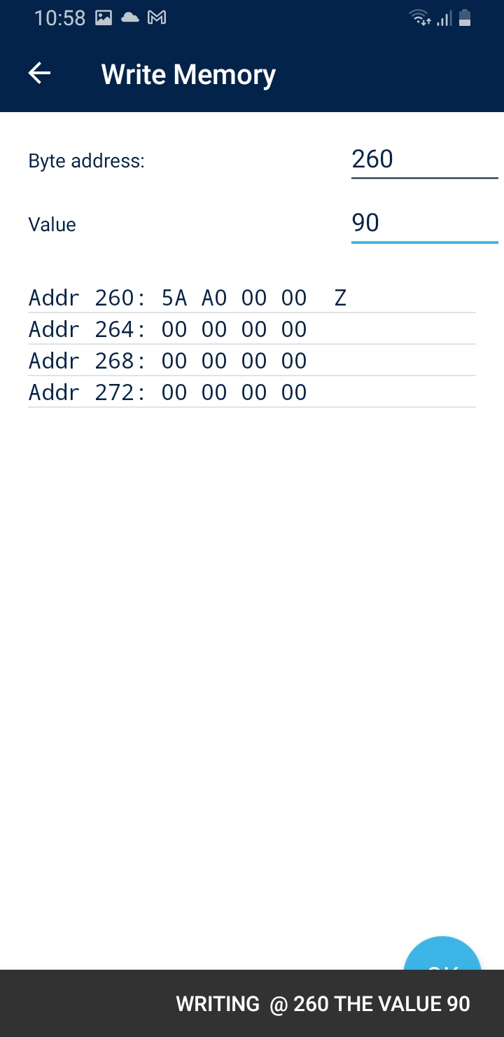

Entering VRTM mode

In “MEMORY” menu, select “Write Memory”, enter the below and select OK.
This will change the iPERL state to VRTM mode (This command is only allowed if the iPERL is in Active mode, otherwise this command is ignored)

For switching to VRTM mode (ofcourse only when iPERL is in Active Mode), write 165 (0xA5) at the memory location 260 (0x104).

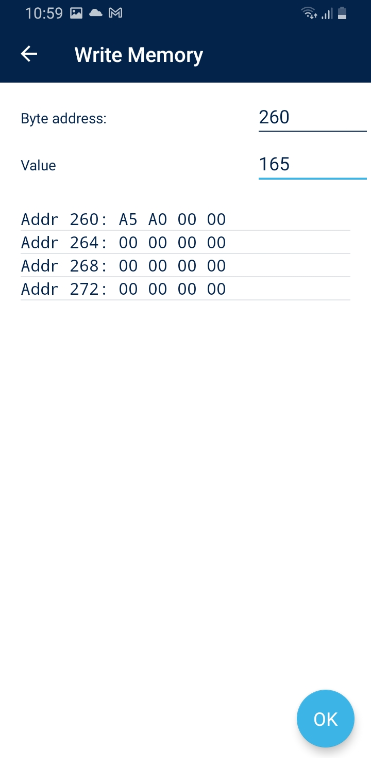

Entering Active Mode

In “MEMORY” menu, select “Write Memory”, enter the below and select OK.
This will change the iPERL state to Active mode (This command is only allowed if the iPERL is in Tset mode or VRTM mode, otherwise this command is ignored)

For switching to Active mode (ofcourse only when iPERL is in Test mode or VRTM), write 18 (0x12) at the memory location 260 (0x104).

