Project Number:  14011 | Document Type:  Quick Reference |  |  | 
Date:  07-Jun-2023 | Product Name:  Cordonel™ FW-Update |  |  | Revision:  F
History:
Rev | Date | Comment | Author
A | 14-Oct-2019 | Initial with name TBF_FW_UPDATE | Thomas Wiedebusch
B | 16-Dec-2019 | Partial write enabled | Thomas Wiedebusch
C | 16-Dec-2019 | Corrections according to review from A.Frost | Thomas Wiedebusch
D | 22-Jan-2020 | Timings, Retries changed | Thomas Wiedebusch
E | 14-Apr-2023 | Derived from TBF_FW_UPDATE  Manual update description | Thomas Wiedebusch
F | 07-Jun-2023 | Display IdLE 9999 – Switching back to normal operation, CRC Error status | Thomas Wiedebusch

Copyright © 2019-2023 by
SENSUS GmbH
CONFIDENTIAL
File: Quick Reference GenesisToolBox FW-Update.docx

Reviews
Rev | Date | Reviewer | Department

List of Contents
1 General Part 7
1.1 Introduction 7
1.2 Document Content 7
1.3 System Overview 7
2 Firmware 7
2.1 FW Release Path 7
3 Genesis Tool Box Launcher 9
4 FW Update 10
4.1 Start 10
4.2 Connect 12
4.3 Loading ABC 14
4.4 Loading ADF 15
4.5 FW Update 16
5 Manual Update Control 20
5.1 Essential Rules 20
5.2 Operating Instructions 21
5.2.1 Preparation 21
5.2.2 Incomplete Update 22
5.2.3 Incomplete Update Finalization 23
5.2.4 First Manual Run 24
5.2.5 Second and Recurrent Manual Runs 27
5.2.6 Finalization 28
5.3 Erasing Applications 29
5.3.1 Erase Sequence 29
6 FW Update Internals 30
6.1 Hidden FW Update Operations 30
6.2 Interface 30
6.3 Partial write 30
6.4 File Write Retries 30
6.5 Record Timings/Retries 30
6.6 FW-Update Retries 31
6.7 Application Download State Reminder 31
6.8 Trigger Upgrade 31
6.9 Update Time 31
7 Logging 32
8 Troubleshooting 33
8.1 Licence Expired 33
8.2 Connection Problems 33
8.3 Display Remains in “IdLE 9999” 33
8.4 Purple Lines with Status Message CRC Error 34
8.5 Invalid Slot Selection 34
8.6 Large Files 34
8.7 Password Access 34
8.8 FW-Update Failed 35
8.9 Light Sensistivity 35
8.10 Additional Tools 35
9 Outlook 36
9.1 DB Content 36
10 Contacts 36
11 References 36

List of Tables
Table 1.1 Abbreviations 6
Table 10.1 Contact 36
List of Figures
Figure 2.1 Example ABC 8
Figure 3.1 GTB Start Window 9
Figure 4.1 FW-Update – Start Window 10
Figure 4.2 FW-Update – Connect 12
Figure 4.3 FW-Update – Installed Applications 13
Figure 4.4 FW-Update – Update Required, FW-Update DISABLED 14
Figure 4.5 FW-Update – Update Required, FW-Update ENABLED 15
Figure 4.6 FW-Update – FW-Update Ongoing 16
Figure 4.7 FW-Update – FW-Update Ongoing with ERRORS 17
Figure 4.8 FW-Update – Upgrade Control File Write 18
Figure 4.9 FW-Update – Update Successful 19
Figure 5.1 Manual FW-Update – Initial Screen 21
Figure 5.2 Manual FW-Update – Incomplete Update 22
Figure 5.3 Manual FW-Update – Incomplete Update Finalization 23
Figure 5.4 Manual FW-Update – First Run Execution 24
Figure 5.5 Manual FW-Update – Download Success Message 25
Figure 5.6 Manual FW-Update – SYSTEM, CONFIGEXCHANGE and IRDA Update Preparation 25
Figure 5.7 Manual FW-Update – After First Run 26
Figure 5.8 Manual FW-Update – Second Run Execution 27
Figure 5.9 Manual FW-Update – Successfully Finished 28
Figure 5.10 Manual FW-Update – Erase Applications 29
Figure 8.1 Licence Expired Message 33
Figure 8.2 Invalid Slot Selection Window 34
Figure 8.3 FW-Update Failed Message 35

Abbreviations
ABC | Application Binary Container, this is the application code
ADF | Applications Description File, test file listing a package of binaries for a valid combination of applications including versions and CRCs
Common | Implementation of commonly used functions
Cordonel™ | Water meter with ultra-sonic measurement, initial name GENESIS
CRC | Cyclic Redundancy Check, used as checksum used to validate a binary file
DB | Data Base
FW | Firmware, this is a combination of several applications combined to an ABC.
GENESIS | Legacy name for the Cordonel™
GTB | GENESIS Toolbox, selection of Tools to access to the Cordonel™ internals
HW | Hardware
ID | Identification number
IrDA | Infrared Data Association, used as serial communication interface
LED | Light Emitting Diode, used as serial communication interface
PCB | Printed Circuit Board, the Cordonel™ electronics
SW | Software
tbd | to be defined
TBF | Test Bench Framework, the entire SW for the test benches and meters
UM | User Manual
VPN | Virtual Private Network
Table 1.1 Abbreviations

General Part

Introduction
For Cordonel™-Water-Meter a FW-Update shall be achievable. Therefore a software (SW) has been designed as part of the Test-Bench-Framework (TBF) which is included in the GENESIS Toolbox (GTB).

Document Content
This document covers the FW-Update process. Additional a deeper look to the internals will be imagined, a troubleshooting guide is going to complete the user knowledge.

System Overview
For the system overview and setup of the GTB and the Cordonel™ interfaces refer to the documentation [GTB].

Firmware
The firmware (FW) is the collection of applications being installed to the Cordonel. The underlaying operation system is Breeze™. The version of the operating system can be observed after establisched connection to the Cordonel behind the “System Core Revision” field.

FW Release Path
In advance to a FW-Update the “Application Binary Container “ (ABC) and the “Application Description File” (ADF) have to be collected. The Share-Point folder contains a hughe number of releases, which are often pre-releases for test purposes only! Be aware to use exclusively validated, qualified and relesed ABCs. R&D Product Support can help with this issue.
NOTE:
Installing an unqualified ABC may cause unpredictable operation of the device. Even worse, the communication line could be blocked, in this case further FW-Update cannot be executed to correct this issue and the Cordonel™ will become an expensive piece of waste.
The latest FW can be found on the Share-Point:
http://project.emea.sensus.net/PWA/EMEAAP_Genesis/Project Documents/300_R+D/340_Software+Firmware/342_Software_and_Firmware/ReleasedFirmware/Automated_Builds
Branch to the required version-folder which can be identified by the name, date and version e.g. Cordonel_20190820_R101A.
There are two sorts of ADFs in the main folder of the release and one common interface description file:
North American (NA): naproduct.txt,European, Middle East, Africa (EMEA) or Rest Of World (ROW): rowproduct_433.txt/rowproduct_868.txt (where the _433 or _868 is the radio frequency) and the commmon configuration.json.
The validated versions are combined to a FW package containing the ABCs. The ADF is a text file specifying these binaries with there CRCs and version information.
The ABC is stored below the version-folder /binaries/rowproduct_433, /binaries/rowproduct_868 or /binaries/naproduct and contains the applications e.g.:
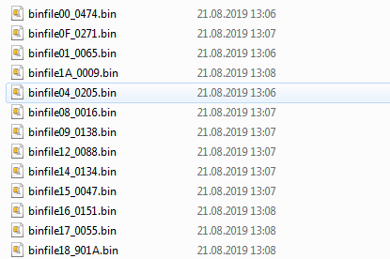
Figure 2.1 Example ABC
Download the ADC and the ADF to a local memory space or, on direct network access, map the network drive which is the preferred way to access the FW.
NOTE:
Be aware NOT to change the ADF and ABC content, because this may result in malfunctions of the entire Cordonel™ eventually causing an irreversible lock of the entire device!

Genesis Tool Box Launcher
The [Firmware Update] starts the “FW Update” program of the GTB.
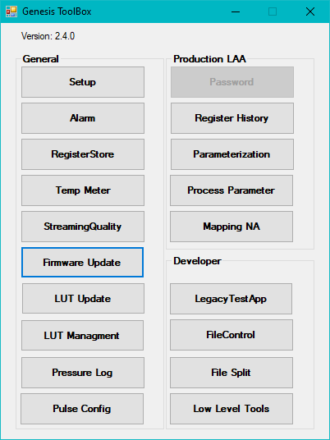
Figure 3.1 GTB Start Window

FW Update
The FW update is a program, which connects to the Cordonel, reads out the current installed versions of all applications, compares these with the required new update package and performs the update.

Start
CAUTION:
A FW update which includes a new GENESISFLOW version requires an entirely re-processing of all production steps to calibrate and verify the proper operation of the Cordonel™. For production this update shall be done at the assembly line before any other processes will be initiated.
Selection of [Firmware Update] tool at the GTB start window will result in this display:
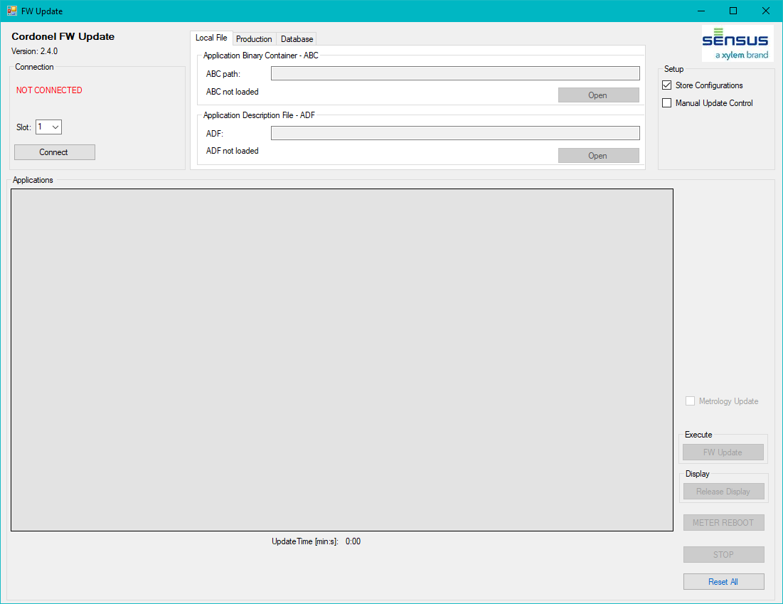
Figure 4.1 FW-Update – Start Window
Explaining the screen:
- Cordonel FW Update version, important for all support issues,
- NOT CONNECTED, communication to Cordonel™ is not established.
Those steps have to be executed to prepare the FW-Update:
- Select a valid Slot,
- Connect the Cordonel™,
- Open the “Application Binary Container – ABC” by selection of the “ABC path”,
- Open the “Application Description File – ADF”,
- Send [FW Update] command.
Setup:
- Store Configuration, if selected, will store all configurations from RAM to FLASH memory of the Cordonel before the FW-Update process downloads the first data. This will be executed as soon as the [FW Update] button will be pressed. The “Store Configuration” option makes only sense, if any setup has been changed and needed to be static after the update. On initial updates, without prior changing of any Cordonel register setting, it can be deselected.
- Manual Update Control, this option enables a manual selection of the applications to erase or to install. This option has to be used carefully and is intended to be used only for development purposes, as the user needs exactly to know, what she is doing. The “Manual Update” will be explained later in this document.

Connect
The [Connect] starts the detection and login process to the Cordonel.:
- Reading the PcbId from Cordonel,
- Connecting to DB and aquireing the password, alternatively on missing DB connection take the password from the OfflineFile.json,
- Reading all installed applications with version information and CRC from Cordonel,
- Reading LUT, Region, Radioand Meter Size information from Cordonel,
- Reading the “System Core Revision” from Cordonel.
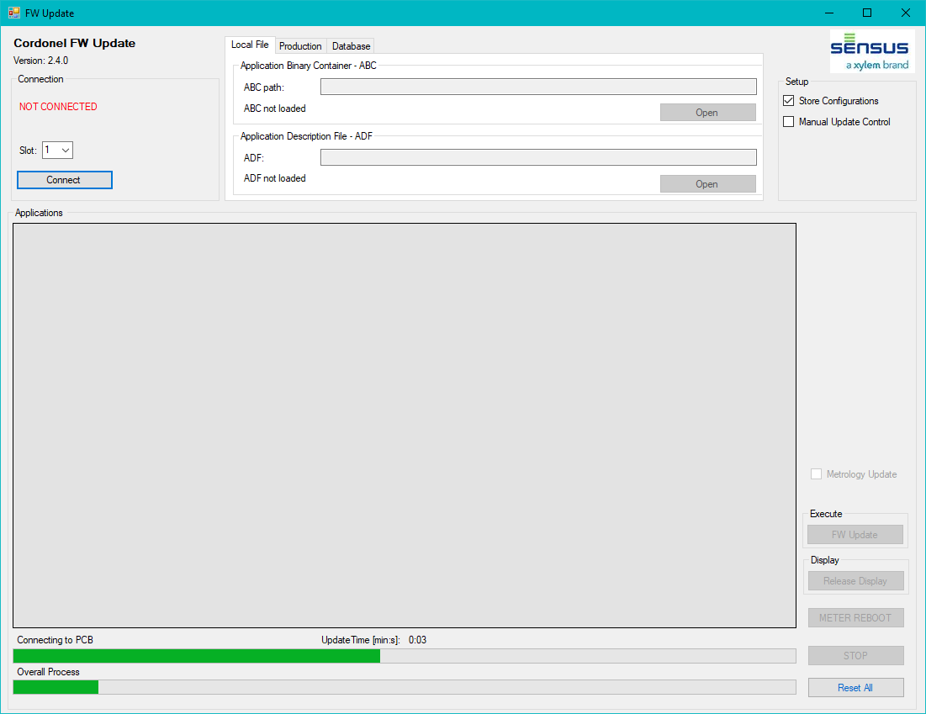
Figure 4.2 FW-Update – Connect
Explaining the screen:
- Connection in progress indicated by the two green bars at the bottom,
- A timer shows the elapsed time.
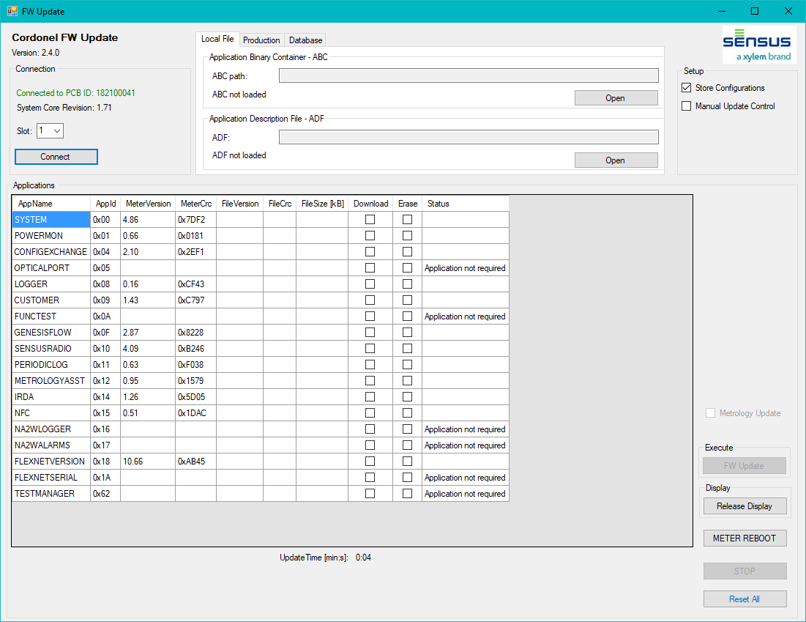
Figure 4.3 FW-Update – Installed Applications
Explaining the screen:
- Connection to PCBID: xxxxxx, communication established, log-in succeeded,
- System Core Revision: xx.yy,
- Black table entries, installed application name and ID, MeterVersion and MeterCRC.

Loading ABC
First the ABC has to be loaded. This has to contain all applications which are bundeled as valid release, even if it is already installed with the identical version. This is important for the crosscheck with the ADF, which specifies the package. If the ADF is not loaded or the ADF does not specify the identical version and number of applications stored in the ABC, the [FW Update] button will be locked and the “ADF to ABC mismatch” message will be displayed.
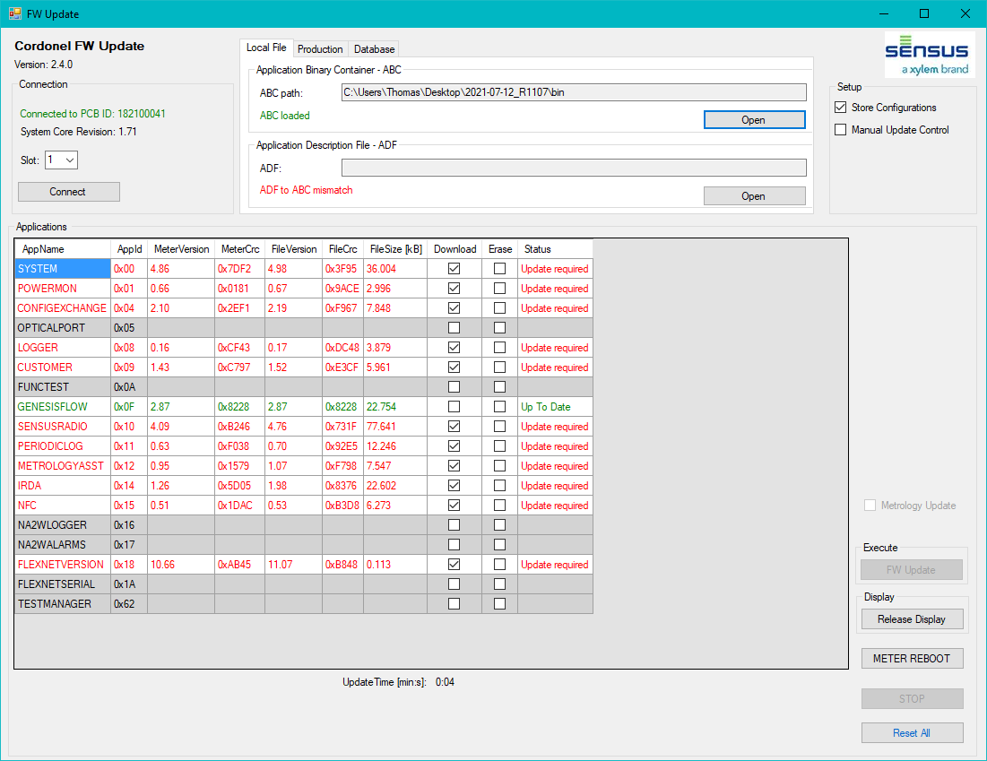
Figure 4.4 FW-Update – Update Required, FW-Update DISABLED
Explaining the screen:
- Green table entries are up to date,
- Red table entries needed to be processed, either being updated or installed,
- Black entries with gray background, not installed or erasure is required,
- Package file to update file mismatch, the ABC and the ADF are not connected to each other,
- The “FW-Update” button is locked to avoid an unsupported ABC update.

Loading ADF
The ADF will finally specify the correctness of the ABC. Finally it specifies and compares the correct “System Core Revision” as an incompatible Breeze™ may not be able to handle those applications. An incompatible “System Core Revision” will lock the [FW Update].
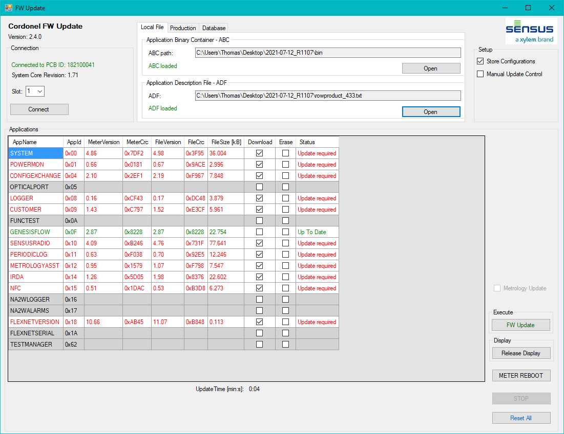
Figure 4.5 FW-Update – Update Required, FW-Update ENABLED
Explaining the screen:
- “Store Configuration” will take all previously settings and save it to non-volatile memory, if this is not required, it can be deselected to speed up the FW update process.
- Green table entries are up to date,
- Red table entries needed to be processed, either being updated or installed,
- Black entries with grey background, not installed or erasure is required,
- ABC and ADF are matching to each other,
- The [FW Update] button is enabled.

FW Update
After sucessfully laoding of all information needed to perform the update, press [FW Update]. On old releases or on unchanged register values, the “Store Configuration” shall be deselected.
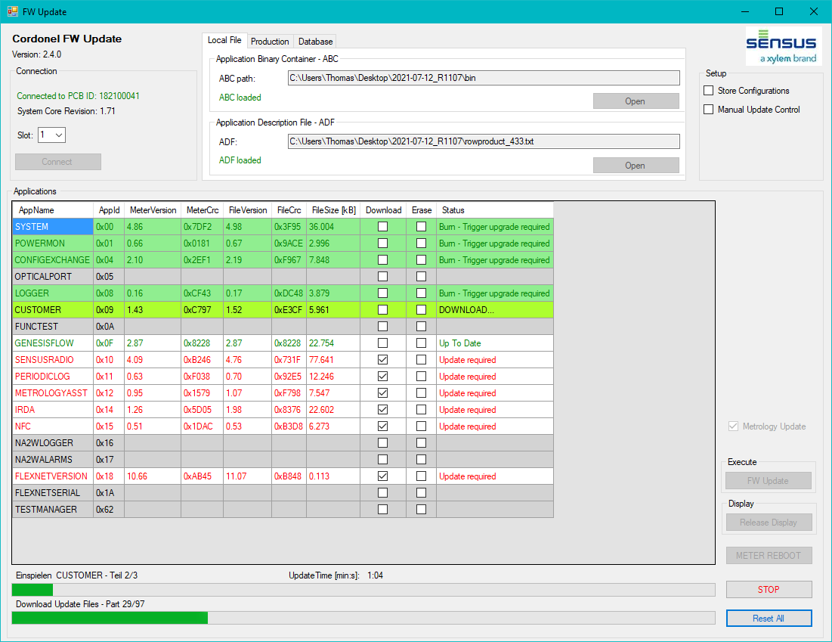
Figure 4.6 FW-Update – FW-Update Ongoing
Explaining the screen:
- Entries with green background are successfully downloaded,
- Light green background is the actual ongoing download,
- Process bars naming the actual ongoing download and the file part of parts,
- Red entries are not processed so far,
- The [STOP] button is enabled to interrupt the update process,
- The [Reset All] button is enabled to clear all information stored in the software reminder of the successfully downloaded applications to give it a fresh start.
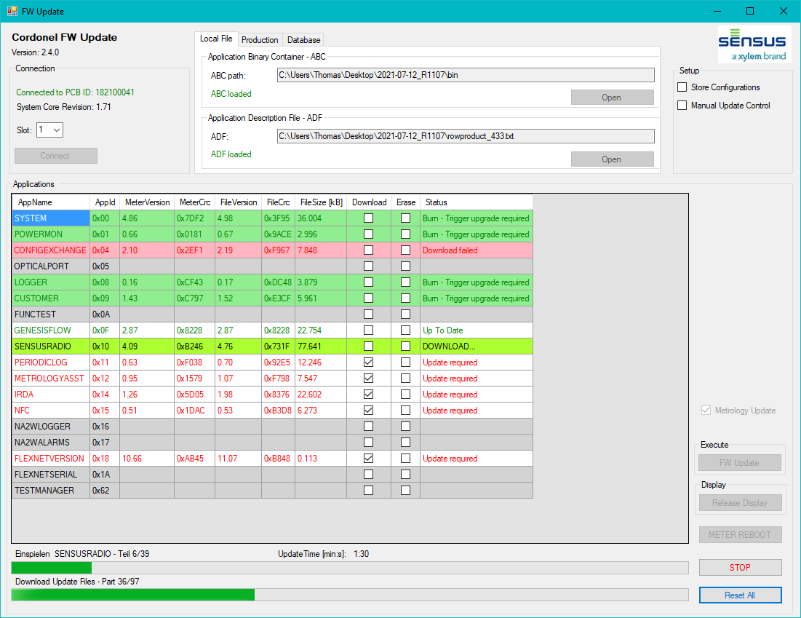
Figure 4.7 FW-Update – FW-Update Ongoing with ERRORS
Explaining the screen:
- Light green background is the actual active download,
- Process bars naming the actual ongoing download and the file part of parts,
- Entries with red background failed to download, failed parts will be retried after download of the other applications.
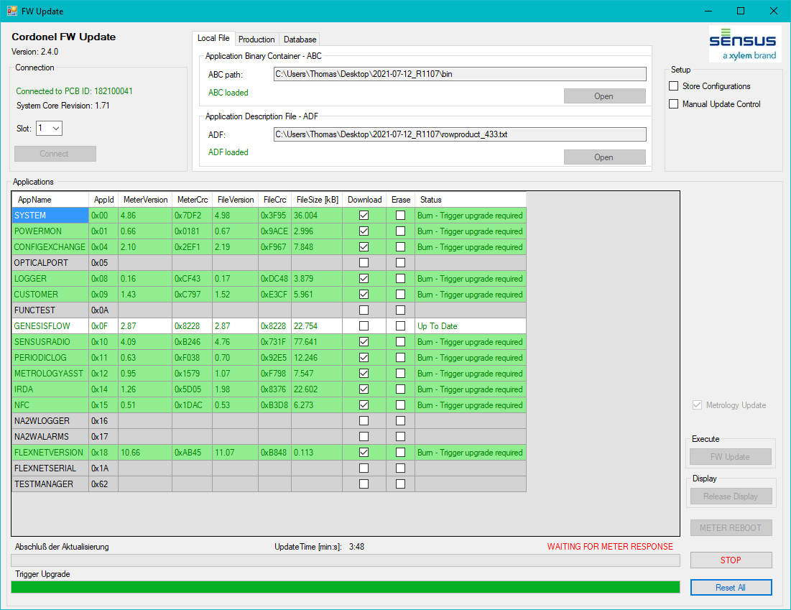
Figure 4.8 FW-Update – Upgrade Control File Write
Explaining the screen:
- All applications are successfully downloaded.

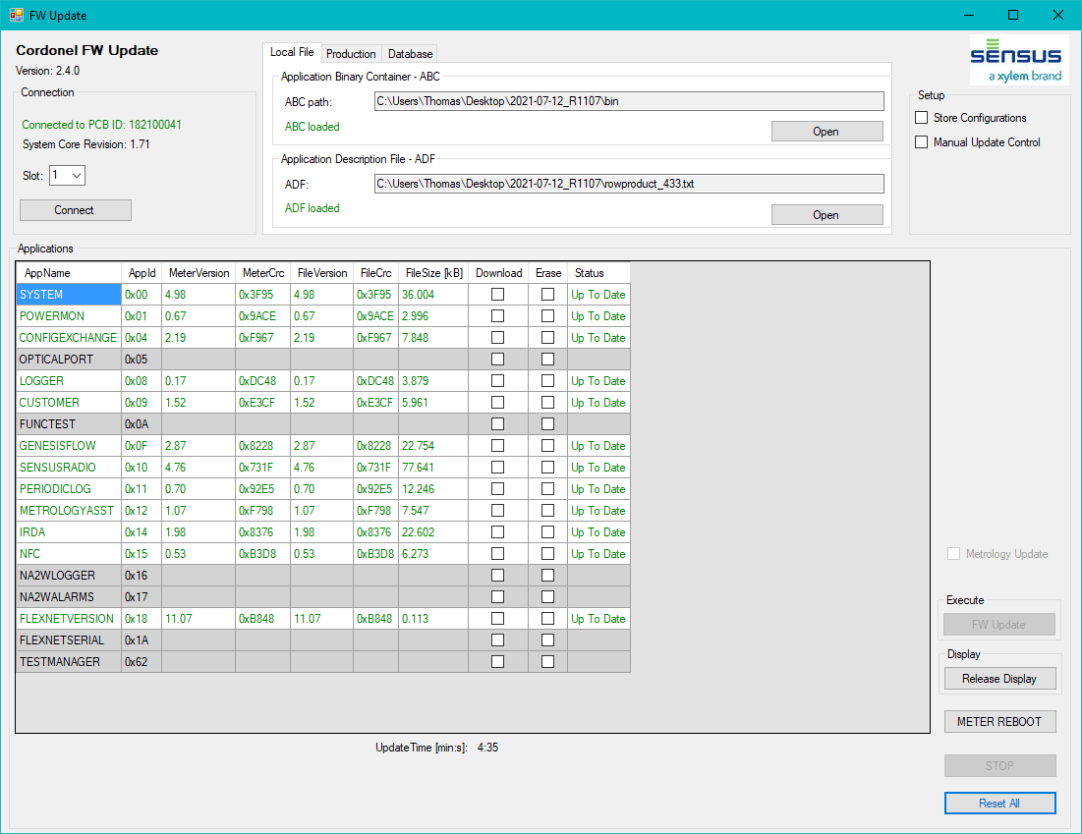
Figure 4.9 FW-Update – Update Successful
Explaining the screen:
- The Cordonel™ is up to date compared with the required ABC.

Manual Update Control
Sometimes the memory of the Cordonel seems to be fragmented or too small to accept an entire update of all applications in one run. This can be identified, if the FW update process fails even after an entire retry. Often the larger applications like the SENSUSRADIO will fail. Therefore a trick can be used to run a partial upgrade of a single or a series of applications.
CAUTION:
This “Manual Update Control” is under full responsibility of the update operator. It should only be used for debug and tests and should not be used for commercial Cordonels. The update operator has to guarantee the installation of all applications contained in the ABC and ADF after finalization. This can easily be observed if every line is displayed in green after a final [Connect]. Do not forget to document the proper installetion after the last step!

Essential Rules
These rules are very important and have to be read carefully!
To keep the functionallity of the Cordonel, some rules have to be taken into account:
- Only packages or applications shall be installed in one run, which are able to work together! These can be easily identified, as they are part of the identical ABC and ADF. Installing only a few applications makes it essential to erase all others, which should NOT be installed in the same run and marked as different (in red and with the status “Update required”). If they are flagged being compatible (in green and status “Up To Date”) they need not to be erased or updated and can remain in the Cordonel during the partial update sequence.
- SYSTEM, CONFIGEXCHANGE and IRDA cannot be erased (locked by the FW-Update SW), but they have to be installed in the very first run together (except one of it is marked in green). Otherwise the Cordonel may be unable to communicate anymore and is lost for further operations.

Operating Instructions

Preparation
- [Connect] the Cordonel,
- Load the required ABC and ADF,
- Select “Manual Update Control” checkbox.
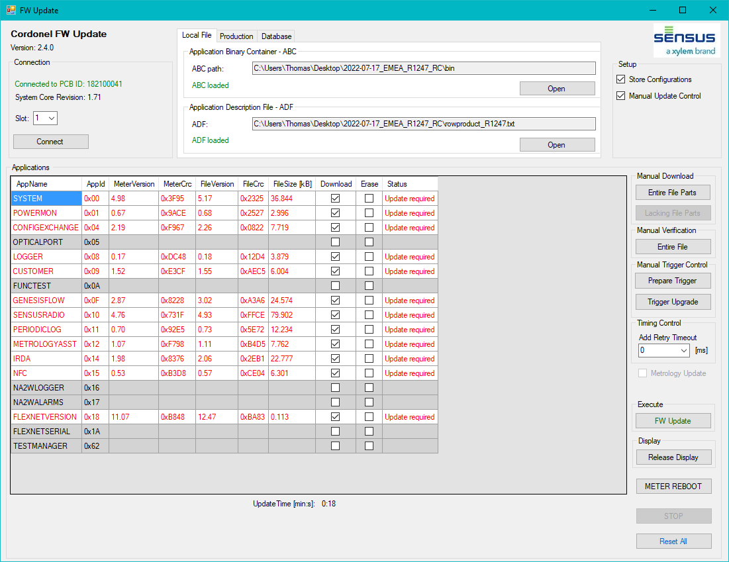
Figure 5.1 Manual FW-Update – Initial Screen
Explaining the screen:
- The Cordonel™ is prepared for the update, the [FW Update] button is enabled and can be tried,

Incomplete Update
If the update cannot be completed, but lots of applications are already successfully downloaded, the problemetic applications can be selected for “Erase” and a manual update can be performed with the actual downloaded applications.
CAUTION:
Verify that SYSTEM, CONFIGEXCHANGE and IRDA are green labeled with status “Up To Date” or “Burn – Trigger upgrade required”! If NOT, press [Reset All] to start with a fresh download!
SKIPPING THIS CHECK AND THE ERASURE OF THE OLD INCOMPATIBLE APPLICATIONS IS ABSOLUTELY DANGEROUS AS THE CORDONEL MAY BE UNABLE TO COMMUNICATE AFTERWARDS.
On any doubts it is better to skip this step with [Reset All]!
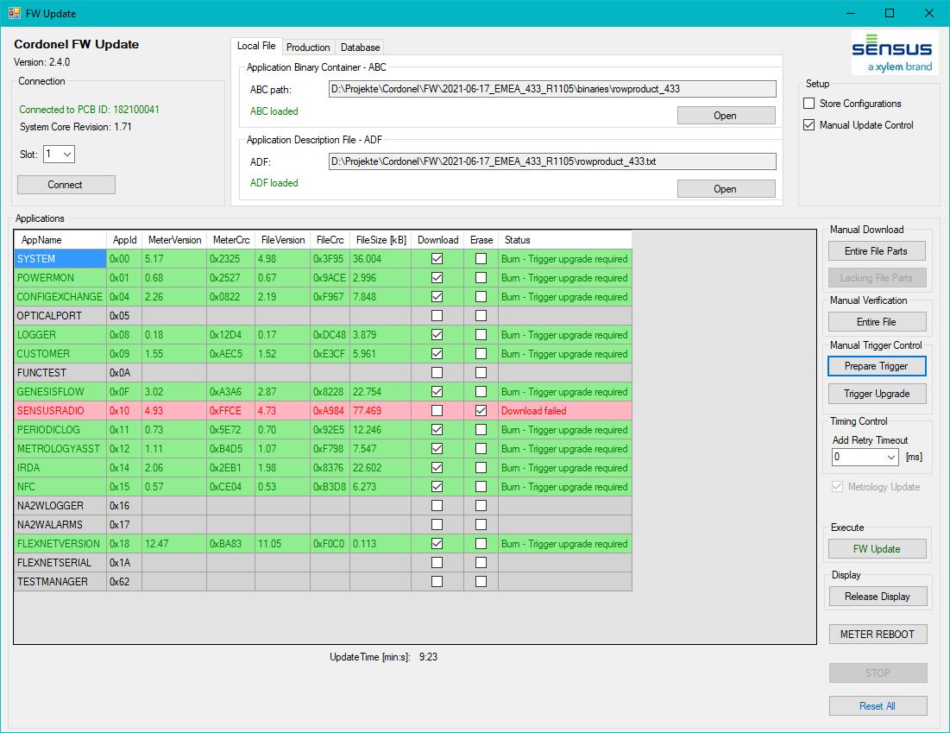
Figure 5.2 Manual FW-Update – Incomplete Update
- IMPORTANT: Select “Erase” for the “unable to install” applications marked in red. These may not work together with others from this package and lock the device even for communication,
- Press [Prepare Trigger] as this will generate the upgrade control file with the command paramaters to upgrade all green labeled applications and erase the red ones, it will copy the successfully downloaded apps to the application memory and restart the device with these,
- Press [Trigger Upgrade] to force the update,
- Press [Connect] to finalize the first run.

Incomplete Update Finalization
After this incomplete update the process can be completed just pressing the [FW Update].
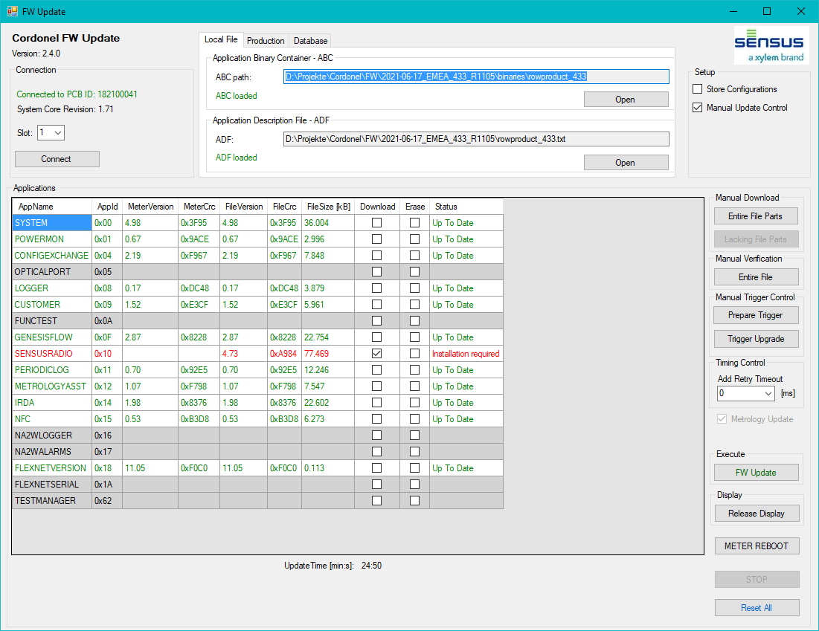
Figure 5.3 Manual FW-Update – Incomplete Update Finalization
Explaining the screen:
- The Cordonel™ is incompletely updated as the SENSUSRADIO is not installed. This will be done with the next procedure on pressing [FW Update].

First Manual Run
If the operator will perform the manual update from the scratch, this is the first step needed to be executed.
- Deselect “Store Configuration”, settings will not be saved,
- Select SYSTEM, CONFIGEXCHANGE and IRDA in “Download” row,
- Unselect all other apps in “Download” row,
- Press [Entire File Parts] to download only the selected of the “Download” row.
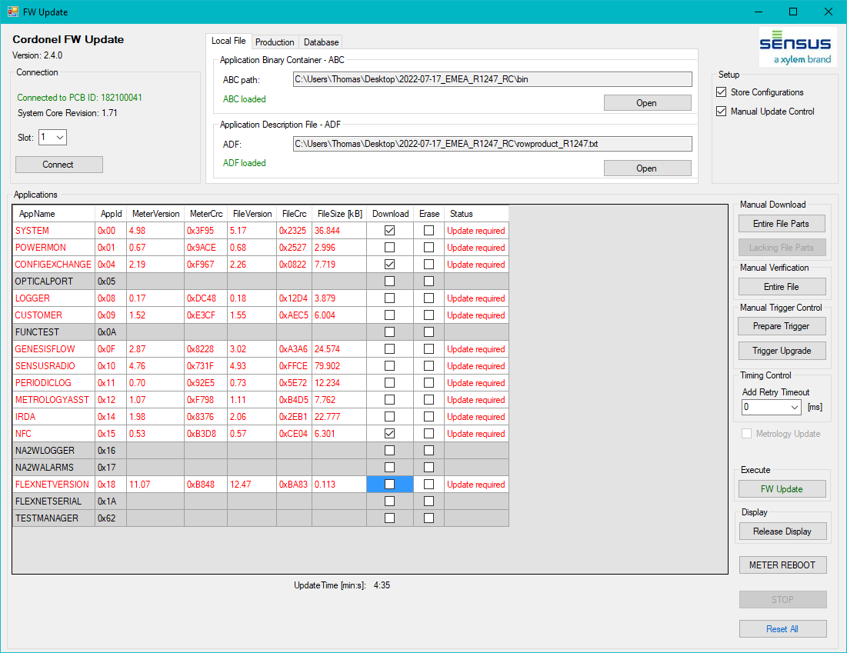
Figure 5.4 Manual FW-Update – First Run Execution
Explaining the screen:
- The Cordonel™ will download just the selected applications.

After the update the following message box will pop up:
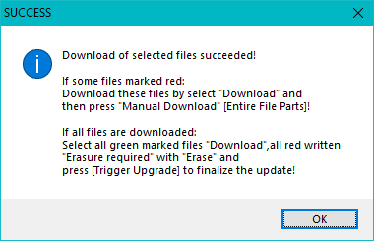
Figure 5.5 Manual FW-Update – Download Success Message
Now the SYSTEM, CONFIGEXCHANGE and IRDA are downloaded. To activate these (copy it from temporary memory to the application memory):
- Select SYSTEM, CONFIGEXCHANGE and IRDA in the “Download” row,
- Select all others in the “Erase” row to avoid unpredictable operation of incompatible applications!
- Press [Prepare Trigger],
- Press [Trigger Upgrade].
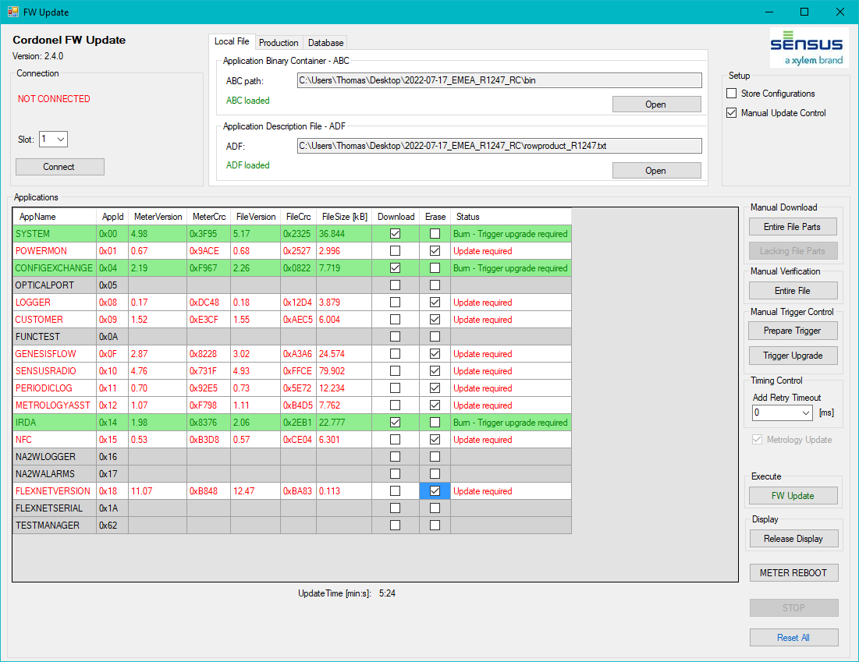
Figure 5.6 Manual FW-Update – SYSTEM, CONFIGEXCHANGE and IRDA Update Preparation

Press [Connect] again to specify all installed applications.
After the first run the essential applications SYSTEM, CONFIGEXCHANGE and IRDA are installed:
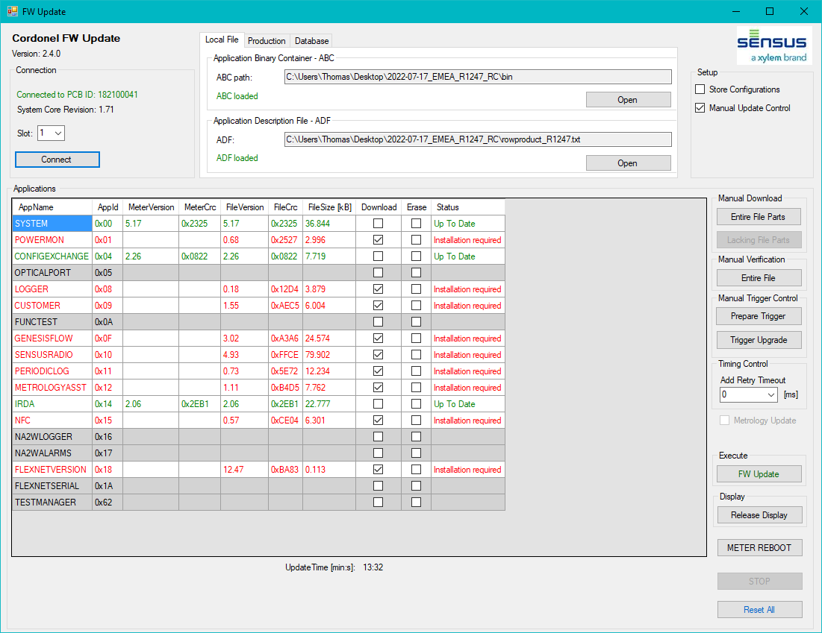
Figure 5.7 Manual FW-Update – After First Run

Second and Recurrent Manual Runs
- Select a few applications for installation,
- Deselect oll others dispayed in red,
- Press [FW Update].
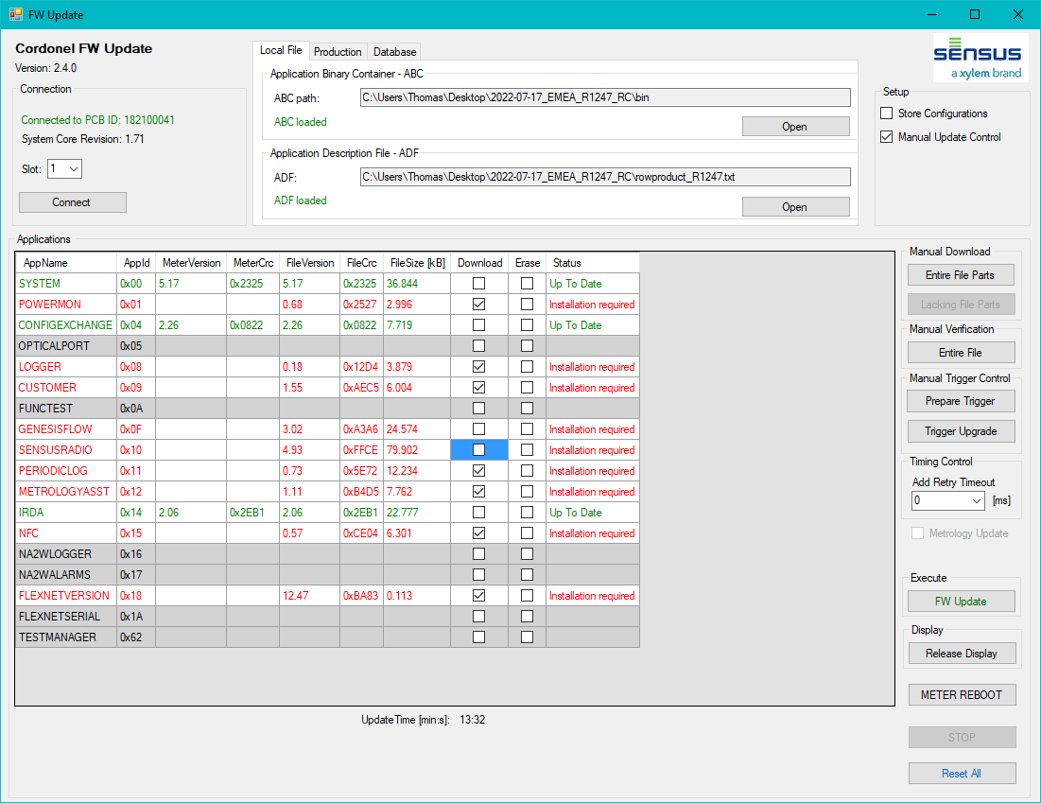
Figure 5.8 Manual FW-Update – Second Run Execution
Repeat this step until all applications are updated.

Finalization
If all applications are marked in green and status “Up To Date”, the manual update has been successfully performed:

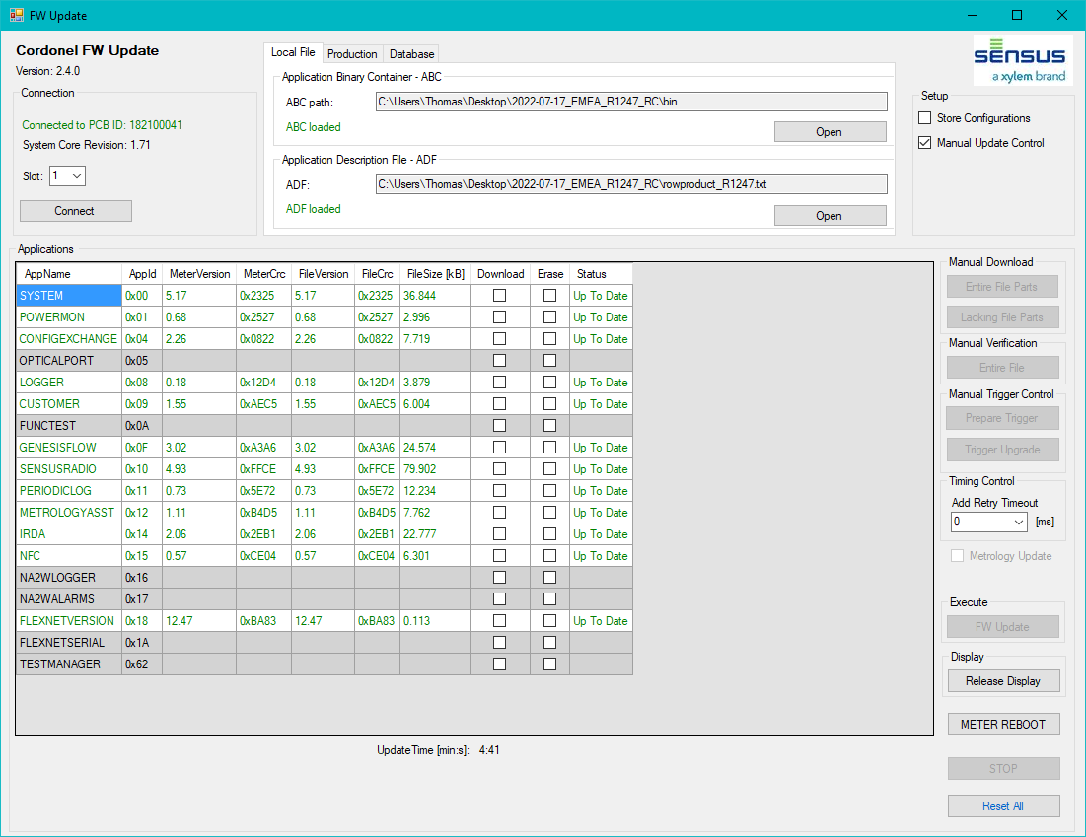
Figure 5.9 Manual FW-Update – Successfully Finished

Erasing Applications
For test purposes it may be required to erase some of the applications. This is useful if a small update shall be tested. As all applications are valid, the [FW Update] butten is locked.

CAUTION:
Never release any Cordonel with incompletely installed ABC! All applications have to be installed for the required Water-Meter function! Release the device only if all lines are green and the status shows “Up To Date”. Do not forget to document this step for your own sake!

Erase Sequence
- Select “Manual Update Control”,
- Select the “Erase” row for those applications needed to be erased,
- Press [Prepare Trigger], this will generate the required upgrade control file out of the user forced selection,
- Press [Trigger Upgrade] this will send the upgrade control file to the Cordonel and force a “Trigger Upgrade” command.
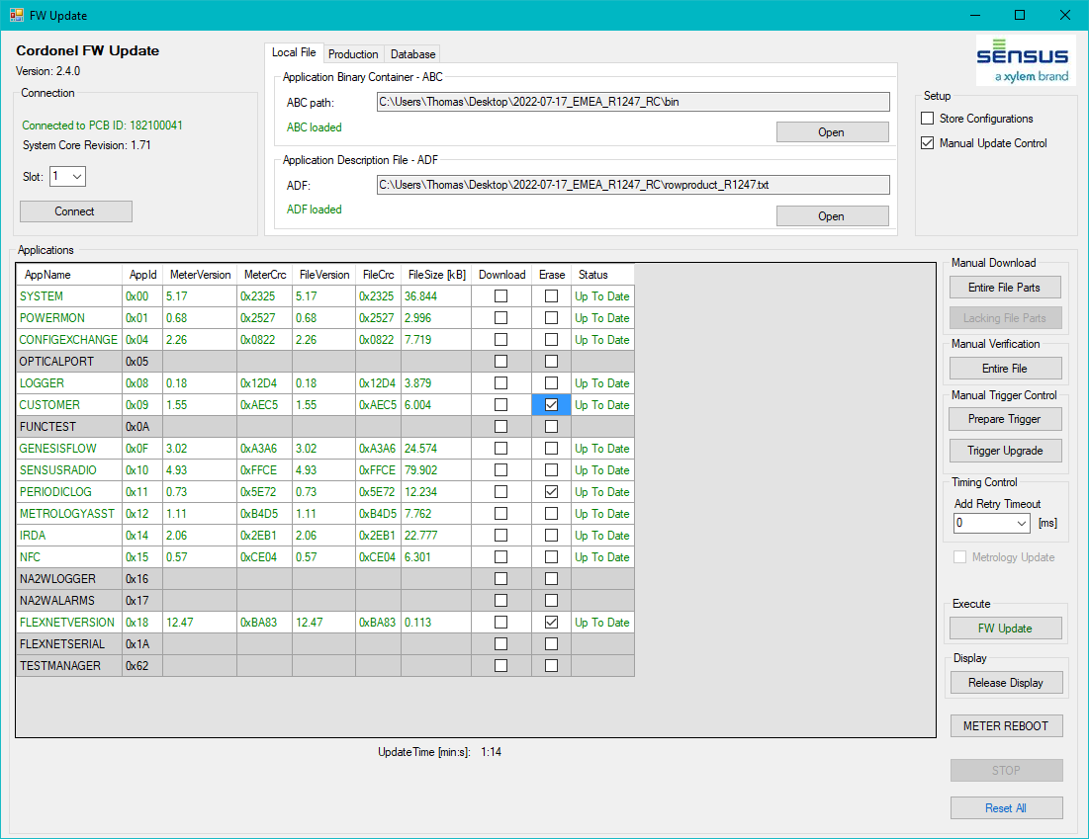
Figure 5.10 Manual FW-Update – Erase Applications

FW Update Internals

Hidden FW Update Operations
Some functions will be executed behind the scene as soon as the [FW Update] button will be pressed:
- Erase the very large memory file “1\tstfile”, this will free the reserved space of the SENSUSRADIO app for the download of the applications. With the next reboot, the SENSUSRADIO will restore this file.
- Enable update of GENESISFLOW by setting SYSTEM_UpgradePermission to 0xFF, as this FW update procedure has to be done before the flow-tests or will be used for development.
- Lock the display with the message “IdLE 8888” meaning “FW Update” is ongoing.

Interface
The configuration.json file, included in the GTB installation folder, is the interface description between the TBF and the Cordonel™. This will be updated automatically starting the GTB with established VPN via the DB Laatzen. Avoid editing this file; otherwise some commands to the device may fail.

Partial write
The single files (applications) are going to be split in 2kB parts. These are then written to the file system of the Cordonel™. The actual process is being displayed at the FW-Udate window in the bottom left corner, where the overall and individual information of the parts can be observed.
These 2kB file parts are split into chunks of 56B for a single record being written to the water-meter file system. This is a restriction of the Cordonel™ communication buffer.

File Write Retries
During the file write operations, the retries are denied to avoid a doubling of identical records. One exception is a retry on a received “wakeup-timeout-message” from the IrDA. Then a retry will be initiated after 1000ms. A repetition of this retry on a second “wakeup-timeout-message” will be denied, instead this part of the file is going to be skipped during this update loop and retried on the next overall update trial.

Record Timings/Retries
A communication answer will be expected after 50ms, then it will be handled as missing answer. If the answer is missed, a timeout will be held before a retry is going to be initiated. For standard register access 2 retries are allowed resulting in 3 communication trials. If all of these trials fail, the record will be dismissed and the program will continue with the next program step.
During a standard register access operation an initial timeout for the IrDA communication before retrying, on invalid or missing answer, is set to 150ms. This will be increased with every retry by another 100ms, causing the last timeout at the second retry being around 350ms before the record will be dismissed.
For file write operations this timeout will be extended to 5000ms before the missing answer will be taken into account. The recommendation for this time was 15000ms, but during extensive tests it came out, that there is absolutely no advantage to wait that long. If the device didn’t answer after at least 5000ms it will answer never, even not after 15000ms. If during the “wait-for-answer” time a “wakeup-timeout-message” is incoming, the timeout will be skipped and after 1000ms a retry of the same record will be initiated. For file access operation only one retry on the “wakeup-timeout-message” is allowed, else the retry is forbidden.

FW-Update Retries
The FW-Update is fully automated and tries to retry the entire FW-Update procedure 5 times until a message is going to pop-up informing about a failed update.
First the update procedure tries to write every part of every application. If one part fails, it leaves this part out and flags the download for this application as failed. With the next retry only the missing parts will be downloaded.
The first two retries will use the missing file parts, if this fails, the retry number 3 will try to download the entiere file (even if just one part of this file failed). This is due to the observation, that a retry at the same file position may not succeed. Retrying the entire file will assign a new physical location of the file system due to the file system fragmentation.
The last two retries will then use only the missing file parts again.

Application Download State Reminder
As long as the FW-Update is active and the [Reset All] button has not been pressed, the FW-Update SW will remind the application states. This is for manually executed retry purposes avoiding a recurrent download of successfully downloaded applications.

Trigger Upgrade
The trigger upgrade will kick-off the flashing procedure at the Cordonel™. The file download has sent the applications to a file-system, the trigger-upgrade updates the applications in the program memory called flashing.

Update Time
The update time is very depending on the quality of the serial connection, the sealing against natural and artifical light exposure and the Cordonel™ file system (may be highly fragmented) and processing time, resulting in retries and timeouts.
The time can be split into 3 processing steps:
The download time which will be approxitmately 1.5s/kB,
The “Trigger Upgrade Command” resulting in update the the Applications from the file system to the application memory (FLASHING) and execution of a re-start (RE-BOOT) of the Cordonel™, which is about 10s to 30s,
The connection time after restart, which is about 3s on a good data base conncetion and may grow to 30s, if the data base cannot be reached immediately.
The overall update time will be displayed on the FW-Update window.

Logging
All interactions between single program interfaces as well as the communciaction to the Cordonel™ are going to be logged. The default loaction for the logging files is:
C:\GenesisLog\yyyy-mm-dd\Xylem.Common.Ui.GenesisToolBox\*.log, where the yyyy-mm-dd is the year, the month and the day of logging.
The focus is set to the default.log, which contains all information of the program actions. This file can be used for troubleshooting.
The logging location can be changed in the GTB Main -> [Setup].
REMIND: It is always useful to attach this default.log if asking for support of the SW developer!

Troubleshooting

Licence Expired
The licence will be handled by a DB in Laatzen, Germany. Therefore it is essential to establish a VPN connection or be directly conncted to the SENSUS Laatzen network before EVERY new start of the GTB. Otherwise the licence cannot be obtained and the following window will pop up:
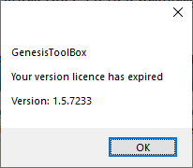
Figure 8.1 Licence Expired Message
The licence is linked to the version and has an expiration date. On new released SW this licence of an older version may be removed forcing the users to upate to the latest GTB.
Sometimes the initial start of the SW shows that window caused by a connection timeout even if this licence is valid. Therefore a second trial should be started.
On licence problems contact the SW deveopers.

Connection Problems
If the connection to the device fails, the “Setup” tool of the GTB may help to check for proper settings. The “DetectRequest” checks the assignment of the IrDA serial port including a communication check. If this succeeds, the entire path including a valid response to the Cordonel™ has been vaidated.
Causes of failed analysis:
- Wrong assignment of serial ports (ports have to be identical to [Setup],
- Wrong selection of protocol (IrdaRequest needed to be set),
- Adjustment of IrDA-Plug-In,
- Natural sun light or artifical light emmitting (cover the device very well),
- Disconnected cable,
- Disconnected power-plug of the Mini-MOXA.

Display Remains in “IdLE 9999”
After a successfully performed FW-Update the display remains in “IdLE 9999” to indicate the
success of this step. As the GTB is designed for production purposes, this is used to visualize the
production steps of an individual device. If it is stored somewhere in the factory it is not needed to
attach an IrDA and establish a communication to see the next required production process directly
in the display.

To get the display back to normal operation press the button [Release Display] which is active as
soon as the Cordonel is connected.

Purple Lines with Status Message CRC Error
The CRC Error message will be displayed if the MeterVersion and the FileVersion of the specific application is identical but the CRCs are different. This will be highlighted with are “purple” entries with the status “CRC Error” after loading the ABC and ADF and connected to the Cordonel. As this is doubtful on a official released FW, a communication problem is indicated.
Follow the instruction on chapter [8.9] Light Sensitivity.

Invalid Slot Selection
Selection of an invalid “Slot” in the FW-Update window will diplay:
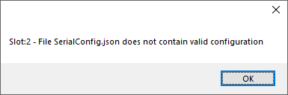
Figure 8.2 Invalid Slot Selection Window

Large Files
Large files may fail during the FW-Update process. The only way to correct for this issue is a retry or a manual controlled update. This repetition has to be initiated manually if all automated FW-Update retries are exceeded.

Password Access
If the logon to the Cordonel™ fails, the password may not be accessible or assigned. For this reason call the SW developer.

FW-Update Failed
If the FW-Update failed due to the configuration file write error or the trigger upgrade error this window will pop up:
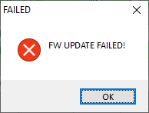
Figure 8.3 FW-Update Failed Message
SOLUTION:
- Retry manually the update procedure by pressing the “FW-Update” button, or, if this does retry again 5 times,
- Press the “Connect” button”.
From time to time the response from the Cordonel™ will be missed and cannot be reestablihed. Internally the update may have been executed as commanded. Pressing the “Connect” button will restart the communication and read out the current versions. Often this displayes an successfully updated device.

Light Sensistivity
The IrDA interface is very sensistive against sunligth and other artificial light sources. Be aware to cover the entire Cordonel™ by boxing it.
This is the most observed reason for communication and therefore update problems. An indication of communication problems are “purple” entries with the comment “CRC Error” in the overview window after loading ABC and ADF and connected to the Cordonel.

Additional Tools
The GTB has one toolset called [Low Level Tools]. This tool can be reached from the GTB main page after closing the FW update window. The low level tools can be used to analyse the Cordonel. Especially the [Tidy File System] may clean the file system removing some unused files. This may be be helpful if the Cordonel strictly denies a FW update.

Outlook
Future developments of the FW-Update will further improve the safety and performance of the update process.

DB Content
Later versions of this SW will be stronger fed by the production DB.
This DB shall cover all binary packages (ABCs) of a validated and released FW version. A package will contain all applications in a certain combination well working together.
At the time of being the packages are managed manually and can be selected by the user, which is then responsible for the installation of a tested and validated application combination.

Contacts
Name | Function | Mail
Alex Frost | FW Developer | Alex.Frost@xylem,com
Mark Clemens | FW Developer | Mark.Clemens@xylem.com
Roland Drabesch | SW Developer | Roland.Drabesch@xylem.com
Thomas Wiedebusch | SW Developer - external | thomas.wiedebusch@t-wiedebusch.de
Nikolas Orelly | IT Department | nicolas.orelly@xylem.com
Table 10.1 Contact

References
[GTB] Quick Reference GenesisToolBox Main and Setup; Published: SENSUS GmbH; Author: Thomas Wiedebusch; Edition: April 2023 - Revision A

