Project Number:  14011 | Document Type:  Quick Reference |  |  | 
Date:  02-May-2023 | Product Name:  Cordonel™ Low Level Tools |  |  | Revision:  A
History:
Rev | Date | Comment | Author
A | 02-Mai-2023 | Initial | Thomas Wiedebusch

Copyright © 2023 by
SENSUS GmbH
CONFIDENTIAL
File: Quick Reference GenesisToolBox LowLevelTools.docx

Reviews
Rev | Date | Reviewer | Department

List of Contents
1 General Part 6
1.1 Introduction 6
1.2 Document Content 6
1.3 System Overview 6
2 GenesisToolBox Launcher 6
3 Low Level Tools 7
3.1 Tools 9
3.1.1 [Release Display] 9
3.1.2 [Fix Battery] 10
3.1.3 [Store Config] 10
3.1.4 [Set Date Time] 10
3.1.5 [Tidy File System] 10
3.1.6 [Pulse Mode OFF] 10
3.1.7 [REBOOT METER] 10
3.2 Log 10
3.2.1 [Upload Config] 10
3.2.2 [Read Lof Files] 10
3.2.3 [List File Details] 10
3.3 Erase Files 10
3.3.1 [Erase File] 10
4 Contacts 10
5 References 10
List of Tables
Table 1.1 Abbreviations 5
Table 4.1 Contacts 10

List of Figures
Figure 2.1 GTB Start Window 5
Figure 3.1 Low Level Tools - After connection established 6
Figure 3.2 Process History Window – After connection established 7

Abbreviations
Common | Implementation of commonly used functions
Cordonel™ | Water meter with ultra-sonic measurement, initial name GENESIS
GENESIS | Legacy name for the Cordonel™
GTB | GENESIS Toolbox, selection of Tools to access to the Cordonel™ internals
HW | Hardware
ID | Identification number
IrDA | Infrared Data Association, used as serial communication interface
LED | Light Emitting Diode, used as serial communication interface
PCB | Printed Circuit Board, the Cordonel™ electronics
SW | Software
tbd | to be defined
TBF | Test Bench Framework, the entire SW for the test benches and meters
UM | User Manual
VPN | Virtual Private Network
Table 1.1 Abbreviations

General Part

Introduction
For the Cordonel™-Water-Meter an analyse and maintenance tool is required to check, repair or setup some of the essentials. Therefore a software (SW) has been designed as part of the Test-Bench-Framework (TBF) which is included in the GENESIS Toolbox (GTB).

Document Content
This document covers the Low-Level-Tools and describes the logic behind the processes.

System Overview
For the system overview and setup of the GTB and the Cordonel™ interfaces refer to the documentation [GTB].

Genesis Tool Box Launcher
The [Low Level Tools] starts the analyse and maintenance program of the GTB.
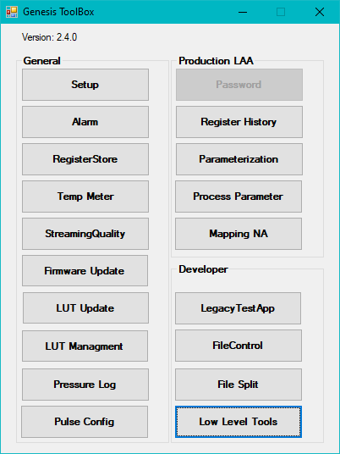
Figure 2.1 GTB Start Window

Low Level Tools
After [Connect] the main screen of the “Low Level Tools” is going to display all information collected from the Cordonel.
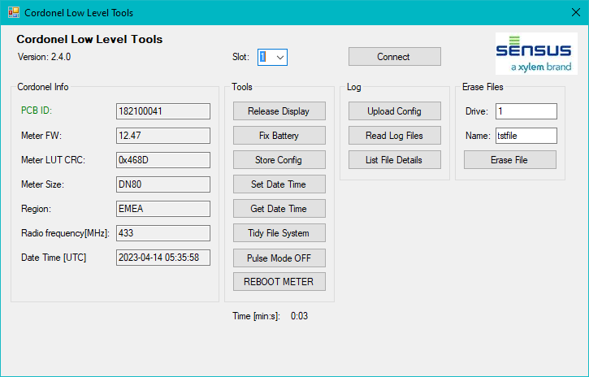
Figure 3.1 Low Level Tools - After connection established
After a successfully initiated connection process the buttons for further operations are enabled. This is due to the fact, that all those operations can only be executed after authorization with a high authorization level (7 or 8).
During all meter accesses the “default.log” will be filled with the raw communication. This is the base for inspection.

During the connection process a “Process History” window will pop up and display additional information. The content can be marked (e.g. using [Ctrl] + [A]) and copied (e.g. using [Ctrl] + [C]) and can be used for reporting of the executed processing steps and their results.
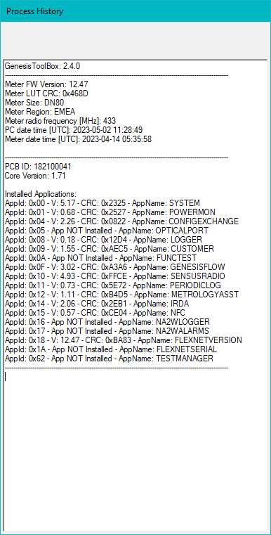
Figure 3.2 Process History Window – After connection established

Tools
The “Tools” section can be used to setup the Cordonel and try to repair the file system.

[Release Display]
The “Release Display” switches the display from any process information like “IdLE 9999” back to the normal operation showing the accumulated volume and the flow rate.
The process information will be used during production to support a direct display of the executed last process step and the result of it. This is useful for any operator to observe what to do next with the Cordonel on a direct visual inspection of the display without the need to establish a connection to the device.
If for some reason like an incomplete executed process the display remains showing the process information, this toll is useful to bring it back to the customer mode.
Internal operational sequence:
- Login to Cordonel with Level 8,
- Write GENESISFLOW_TriggerIdle 0 - this switches the display back to normal operation,
- Write GENESISFLOW_StoreConfiguration 1 - this stores the setup to keep it upon reboot,
- Logout from Cordonel.

[Fix Battery]

[Store Config]
The “Store Config” stores all configurations of each detected application. This safes the information which will persist in RAM memory and copies it to the FLASH memory. After this step the configurations will remain static in the non-volatile memory section of the Cordonel. The configurations are stored in the “0\config” file.
Internal operational sequence:
- Login to Cordonel with Level 8,
- Write XXX_StoreConfiguration 1 to each application detected during connection process,
- Read back XXX_StoreConfiguration of each application and check for 0 (success),
- Logout from Cordonel.

[Set Date Time]
The “Set Date Time” synchronizes the Cordonel with the PC in UTC.
Internal operational sequence:
- Login to Cordonel with Level 8,
- Get PC date and time in UTC with offset 01-Jan-2000,
- Write SYSTEM_CalendarSeconds UTC with offset 01-Jan-2000,
- Read back SYSTEM_CalendarSeconds and convert to UTC absolute,
- Logout from Cordonel.

[Get Date Time]
The “Get Date Time” reads the Cordonel UTC.
Internal operational sequence:
- Login to Cordonel with Level 8,
- Read back SYSTEM_CalendarSeconds and convert to UTC absolute,
- Logout from Cordonel.

[Tidy File System]

[Pulse Mode OFF]
The “Pulse Mode OFF” deactivates the pulse generation of the Cordonel.
Once a pulse module has been inserted into the IrDA slot of the Cordonel and the pulse mode has been configured to be active, this will continuously send pulses on this interface. Therefore it is not possible to establish an uninterrupted communication on the IrDA interface. To free this IrDA for the pure communication, the pulse mode needs to be switched off.
Internal operational sequence:
- Login to Cordonel with Level 8,
- Write METROLOGYASST_PulseMode 0,
- Write METROLOGYASST_StoreConfiguration 1 - this stores the setup to keep it upon reboot,
- Logout from Cordonel.

[REBOOT METER]

Log

[Upload Config]

[Read Lof Files]

[List File Details]

Erase Files

[Erase File]

Contacts
Name | Function | Mail
Alex Frost | FW Developer | Alex.Frost@xylem,com
Mark Clemens | FW Developer | Mark.Clemens@xylem.com
Roland Drabesch | SW Developer | Roland.Drabesch@xylem.com
Thomas Wiedebusch | SW Developer - external | thomas.wiedebusch@t-wiedebusch.de
Nikolas Orelly | IT Department | nicolas.orelly@xylem.com
Table 4.1 Contacts

References
[GTB] Quick Reference GenesisToolBox Main and Setup; Published: SENSUS GmbH; Author: Thomas Wiedebusch; Edition: April 2023 - Revision A

