 | Software Requirement Specification |   SENSUS GmbH
Date:  17-Jul-2018 | Test Bench Framework (TBF) | Revision: A
History:
Rev | Date | Comment | Author | Approved (Date/Signature)
A | 07-Mar-2017  17-Jul-2018 | Initial | T.Wiedebusch

Copyright © 2017..2018 by
SENSUS GmbH
File:  TBF_SRSe.docx | Copyright © 2017..2018 by  SENSUS GmbH
List of Contents
1 General Part 6
1.1 Introduction 6
1.2 Purpose 6
1.3 Content 6
1.4 System Description 6
1.5 System Overview 6
2 General Requirements 7
2.1 System Requirements 7
2.2 Development Tools 7
2.3 Coding Convention 7
2.4 Standard Naming 7
2.5 Units 7
2.6 Technical Guiding Rules 7
2.7 Documentation Language 8
2.8 Required Documents 8
3 TBF Requirements 9
3.1 Measurements 9
3.1.1 Static Start/ Stop Measurement 10
3.1.2 Flying Start/ Stop Measurement 11
3.2 Calibration Process 13
3.2.1 Preparation 13
3.2.2 Calculation of Calibration Factor 13
3.2.3 Finalization 13
3.3 Accuracy Validation Process 13
3.3.1 Preparation 13
3.3.2 Calculation of Accuracy 13
3.3.3 Finalization 14
3.4 Communication Chains 14
3.4.1 Request via IrDA 14
3.4.2 Request via RFID 14
3.4.3 Request via UART 14
3.4.4 Streaming the LED 14
3.5 Communication Protocols 14
3.5.1 Request Protocol 14
3.5.2 Streaming Protocol 15
3.5.2.1 Streaming Protocol Version ‘f’ 15
3.5.2.2 Streaming Protocol Version ‘h’ 16
3.6 Transmission Protocols 17
3.6.1 IrDA Transmit Protocol 17
3.6.2 RFID Transmit Protocol 18
3.6.3 UART Transmit Protocol 18
3.6.4 LED Transmit Protocol 18
3.7 Communication Ports 18
3.7.1.1 Serial Communication Port 18
3.7.1.2 IrDA Communication Port 18
3.7.1.3 RFID Communication Port 18
3.8 Record Types 18
3.8.1 ASCII String Record Type 18
3.8.2 Byte Record Type 19
3.9 Overflow Handling 19
3.9.1.1 Timing Overflow 19
3.9.1.2 Calibration Volume Overflow 19
3.9.1.3 Display Volume Overflow 19
4 Schedule 20
4.1 TBF Meeting Minutes 20
5 Contacts 20
6 References 21
List of Tables
Table 1.1 Abbreviations 5
Table 1.2 Addresses 5
Table 3.1 Streaming Protocol Version ‘f’ 15
Table 3.2 Streaming Protocol Version ‘h’ 17
Table 5.1 Contacts 20
List of Pictures
Picture 1.1 Block Sheet 6
Picture 3.1 Measurement Block Sheet 9
Picture 3.2 Flying Start/Stop Measurement Sequence 10
Picture 3.3 Flying Start/Stop Measurement Start-Sequence 11
Picture 3.4 Flying Start/Stop Stop-Sequence 12
Picture 3.4 Request via IrDA 14
Picture 3.4 Request via RFID 14
Picture 3.4 Request via UART 14
Picture 3.4 Streaming the LED 14
List of Equations
Equation 3.1 Average Flow Rate 12
Equation 3.2 Recalculated Test Volume 12
Equation 3.3 Calculation of Calibration Factor 13
Equation 3.4 Calculation of Accuracy 13

Abbreviations
cmd | command
DLL | Dynamic Link Library
DUT | Device under Test, the water meter being manufactured or tested
Elde | Special hardware interface for test bench control
Genesis | Water meter with ultra-sonic measurement
FM2014 | Frequency measurement system
FM85/FM85.P | Frequency measurement system, legacy
FW | Firmware
GUI | Graphical User Interface
HW | Hardware
MID | Magneto Inductive Device, reference water meter
Prüf2000.exe | Laatzen production test bench software written in VB
PTB | Physikalisch Technische Bundesanstalt, German norming authority
P20xx | Test bench identifiers
SDD | Software Design Document
SIS | Software Interface Specification
SPS | Speicherprogrammierbare Steuerung, Siemens™ device for HW-Interfaces
SRS | Software Requirement Specification
SW | Software
tbd | to be defined
TBF | Test Bench Framework, this software product controlling the test bench
VB | Visual Basic
Table 1.1 Abbreviations
Addresses
SENSUS GmbH, Meineckestr. 10, 30880 Laatzen, Germany
SENSUS GmbH, Industriestraße 16, 67063 Ludwigshafen am Rhein, Germany
SENSUS Metering Systems, Dr. Alberta Schweitzera 194, 91601 Stará Turá, Slovakia
Sentec Ltd, 5 The Westbrook Centre, Milton Road, Cambridge, CB4 1YG, UK
HSW Thomas Wiedebusch, Ostermarsch 17c, 31191 Algermissen, Germany
Table 1.2 Addresses

General Part

Introduction
This SRS document describes the TBF (V2) requirements. The initial software has been developed by Milan Hanajik to support world-wide test benches containing an Elde controller.
A special adaption is being needed to adapt this framework to the specific infrastructure of the SENSUS-Laatzen test benches, which do use a FM2014 and a SPS to control the test bench and to calibrate and test the water-meters instead of the Elde controller.
A new test bench is going to be installed for the Genesis-water-meter. This test bench initially uses the Elde controller and shall support later on the SPS + FM2014 as replacement for Elde.
New to the TBF is the module supporting the Genesis. This has to be developed by SENSUS-Laatzen. For Genesis support of the Laatzen production test benches, a plugin DLL has to be developed for the existing VB program Prüf2000.exe which does currently control these test benches.
A later development will import the entire Laatzen production test bench HW to the TBF being able to exchange the legacy Prüf2000.exe and bringing a world-wide TBF standard into the field.

Purpose
For summarization of all work needed to be done, this document is being used as common discussion base. It will avoid misunderstandings of the requirements. Cyclically it shall be reviewed by certain authorities or experts to approve the requirements.

Content

System Description

System Overview
Picture 1.1 Block Sheet

General Requirements
The basic requirements will cover all elements needed to build and run the software. It should be avoided to enforce the operation at legacy systems which are not state of the art. A common list of tools may be needed to simplify data and file exchange or rebuild the software on a different PC.

System Requirements
PC with Intel™ I5 Core or higher
Operating system MS-Windows™ 7 professional and higher
Minimum 2 GB RAM
Minimum 100 GB SDD
Display resolution 1280x1024 dots and higher

Development Tools
Development Environment: MS-VisualStudio™ 2015/2017 Professional
Compiler: MS C# 6.0
.Net Framework: 4.0 (for WinXP compatibility)
Documentation: MS Word/Excel/Visio™
Code Revision (CVS): MS-TFS™ 2012
Test-Projects .Net Framework: 4.5.2
TBF .Net Framework: 4.5.2

Coding Convention
It is required to use the English language for all source code comments. A coding standard shall be used for program internals.

Standard Naming
The DIN EN14154 Part 1 to 3 [DIN_EN14154] describes the test procedures for water-meters. This norm can be found in German und English language. This norm is the base for naming conventions regarding the the specific vocabulary used in concatenation with the water-meters, the test bench and metrology.
The menu item language (English/German) shall be selectable for the country the program is going to be used. The table [MTS_1_3] will show the translations between English and German.

Units
All units shall be based on SI-Units. A unit list for standardized SI-Units has been published by the PTB institute [SI_UNITS].

Technical Guiding Rules
Guiding rules for water-meter-test have been published by the German PTB institute and are required for all test executed in Germany [TR_W2] and [DIN_EN14154].

Documentation Language
It is required to use the English language for every documentation and the user manual.

Required Documents
Software Requirement Specification (SRS)
Software Design Document (SDD)
User Manual (UM)

TBF Requirements

Measurements
Two different types of measurements can be executed to calibrate the DUT or validate the accuracy, the “Static Start/ Stop Measurement” or the “Flying Start/ Stop Measurement”.
The measurement block sheet [Picture 3.1] will give a rough simplified overview of how a software and hardware components are connected to each other and the command flow between these modules.
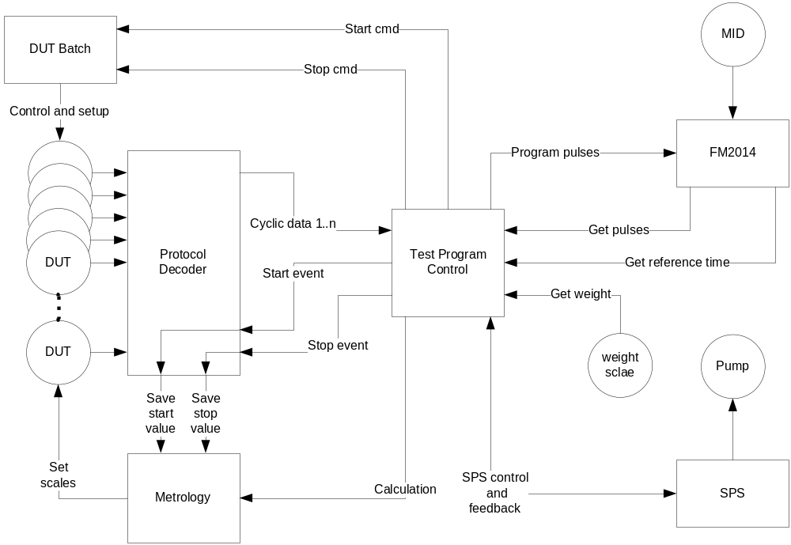
Picture 3.1 Measurement Block Sheet

Static Start/ Stop Measurement
For the “Static Start/ Stop Measurement” the reference volume and the desired deviation is being needed from the overlying test program. The reference volume will directly read from a weight scale or the MID. This procedure is independent of any measurement time. The measured volumes of the reference and the DUT will directly be used to calculate the scale, as described in [Chapter 3.2.2 Calculation of Calibration Factor], or the DUT accuracy, as described in [Chapter 3.3.2 Calculation of Accuracy].
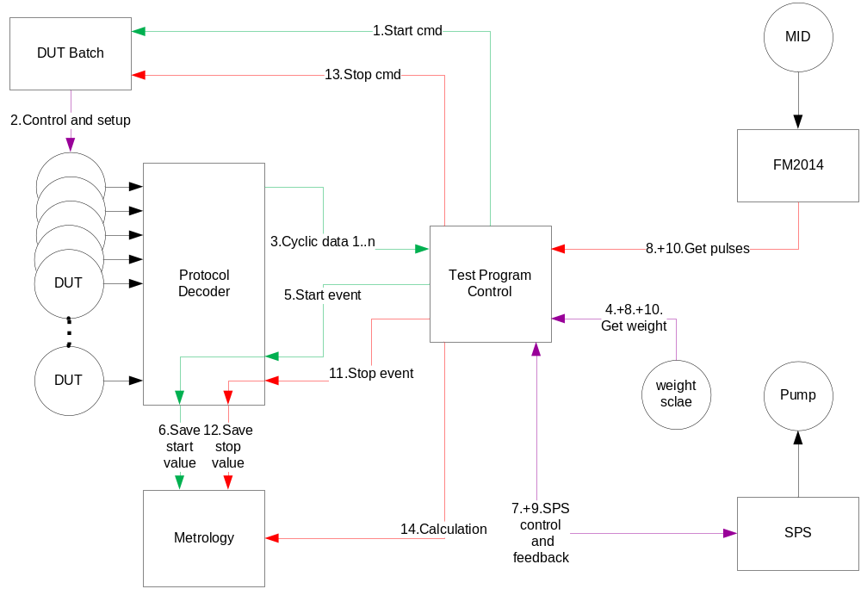
Picture 3.2 Flying Start/Stop Measurement Sequence
The measurement sequence will be:
- Send “Start cmd” to DUT batch,
- The DUT batch will prepare all connected DUTs,
- Wait for readiness of DUTs, these will send “Cyclic data” if ready,
- Read reference start volume from weight scale or assume 0 counted pulses for the MID,
- Send the “Start event” to the protocol decoding unit,
- “Save start values” of each DUT,
- Start the pump,
- “Get weight” or “Get pulses” from the FM2014 until required volume has been collected,
- Stop pump and wait a certain time for zero-flow stabilization,
- Read the “Get pulses” from the FM2014 or take the volume of the weight scale,
- Send the “Stop event” to the protocol decoding unit,
- “Save stop values” of each DUT,
- Send “Stop cmd” to DUT batch, this will prepare all DUTs,
- “Calculation” of deviation between MID and DUT.

Flying Start/ Stop Measurement
The required base of a “Flying Start/ Stop Measurement” is the constant flow rate during the entire measurement! This is essential for the enclosed procedure and the calculations of deviations and scale factors. The flow rate is going to be controlled by the SPS. Before the measurement can be started, the desired flow rate has to be reached and stabilized!
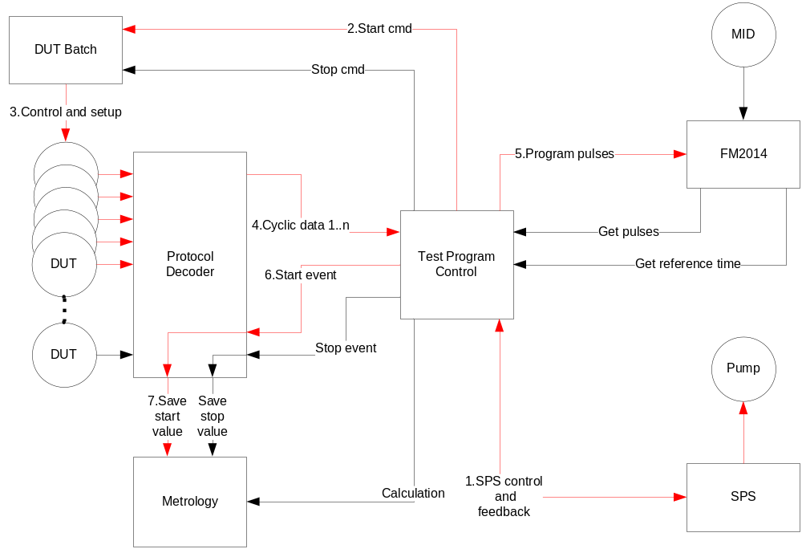
Picture 3.3 Flying Start/Stop Measurement Start-Sequence
The “Flying Start/Stop Measurement” start-sequence will be:
- Start the pump and wait for stabilization of the required flow-rate,
- Send “Start cmd” to DUT batch,
- The DUT batch will prepare all connected DUTs,
- Wait for readiness of DUTs, these will send “Cyclic data” if ready,
- Program the required pulses for the measurement volume to the FM2014 for the MID,
- Send the “Start event” to the protocol decoding unit,
- “Save start values” of each DUT.
- Measurement ongoing……

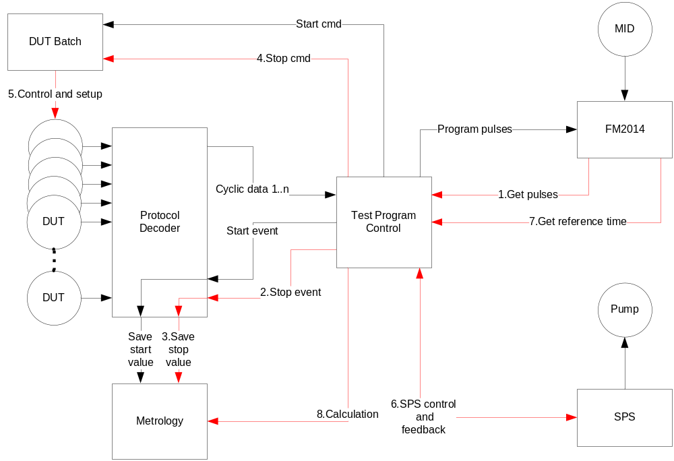
Picture 3.4 Flying Start/Stop Stop-Sequence
The “Flying Start/Stop” start-sequence will be:
- Wait until the remaining pulses from the FM2014 reached zero indicating the volume has been collected,
- Send the “Stop event” to the protocol decoding unit,
- “Save stop values” of each DUT,
- Send “Stop cmd” to DUT batch,
- The DUT batch will prepare all connected DUTs,
- Stop pump,
- Get the “reference time” for the exactly measurement duration from the FM2014,
- “Calculation” of deviation between MID and DUT.

For the “Flying Start/ Stop Measurement” the individual start- and stop-volume and the start- and stop-time is being needed from the overlying test program.
Out of the start and stop values of the DUT the flow rate will be calculated.
$$Q_{DUT}= \frac{V_{DUTstop}-V_{DUTstart}}{t_{DUTstop}-t_{DUTstart}}$$
Equation 3.1 Average Flow Rate
The reference time is being used to recalculate the volume during the test time, due to the fact that the start and stop data record may be delayed by the software program flow or the unpredictable operational system timing.
$$V_{DUT}= Q_{DUT} t_{REF}$$
Equation 3.2 Recalculated Test Volume

Calibration Process
The Genesis water meter has to be calibrated to get accurate readings. In advance the amplitude and zero-flow-offset correction has to be done.
Due to the 3 paths of the Genesis, these have to calibrated independently. Each of these paths measures the entire volume as individual circuitry. The result is the average of all three paths.

Preparation
TODO Display volume
Calibration scale (default)
Switch LED to calibration mode

Calculation of Calibration Factor
The calibration is being done using the measured volume of each individual path, the reference volume, measured by a weight scale or a MID, and for the flying start/stop measurement the timings of the individual channel and the precisely timing of the reference system.
These values will be used to calculate the new calibration factor $s_{x}$. It is based on the default scale factor ${s_def}_{x}$ multiplied by the desired deviation $k$ at this specific flow-rate. The desired deviation is needed to adjust the curve of deviations depending on different flow rates into an envelope of tolerances. Detailed information of the calibration procedure for the Genesis-water-meter can be found in [GenCal].
$$s_{x}= \frac{V_{REF}}{V_{DUTx}} {s_def}_{x} k (x=1..3; 0.95<k<1.05)$$
Equation 3.3 Calculation of Calibration Factor

Finalization
TODO check tolerance
Switch LED off

Accuracy Validation Process
To verify the function of the device for different flow rates, several validation measurements have to be executed.

Preparation
TODO Display volume
Switch LED to calibration mode

Calculation of Accuracy
The deviation $d_{Q}$ at a specific flow rate shall be calculated using the reference and the measured volume.
$$d_{Q}= \frac{V_{ref}}{V_{x}}$$
Equation 3.4 Calculation of Accuracy

Finalization
TODO check tolerance
Switch LED off

Communication Chains
The following chapter shows the different layers of the SW for the communication of different protocols and HW-interfaces.

Request via IrDA
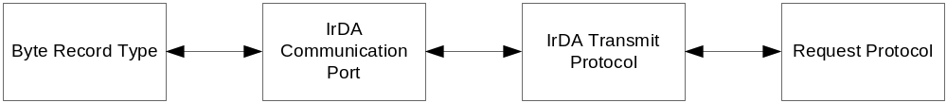
Picture 3.5 Request via IrDA

Request via RFID
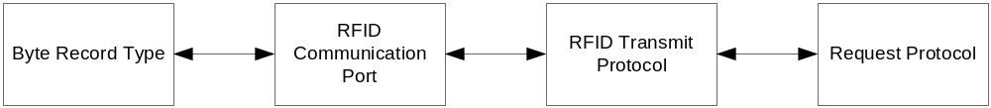
Picture 3.6 Request via RFID

Request via UART
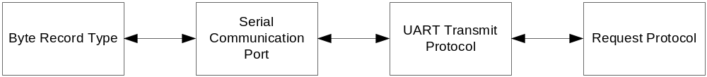
Picture 3.7 Request via UART

Streaming the LED
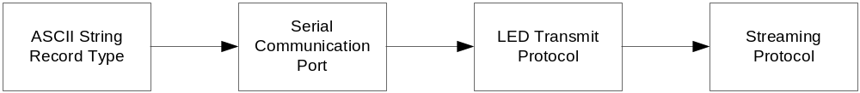
Picture 3.8 Streaming the LED

Communication Protocols
The communication protocols describe the elementary interface to the Genesis independend of the underlaying transmittion protocol or HW-Interface.

Request Protocol
The “Request Protocol” has to be used for the interactive communication to the Genesis. This protocol supports the login procedures, read out of information, change of register values for setup, test or calibration purposes. The complete descripton can be found in the “Genesis Meter Configuration.docx” [GenConf].
Example for “Read Parameter” of Genesis water meter calibration factor1:
Request
cmd | register |  | data
0x09 | 0x0D | 0x0F | 0x00 | 0x00 | 0x00 | 0x00

Answer
cmd | error code |  | data
0x0A | 0x00 | 0x00 | 0x34 | 0x12 | 0x00 | 0x00

Streaming Protocol
The “Streaming Protocol” is being used to receive data from the Genesis. These can be switched to different output versions. These output versions are described in the “Genesis Debug Serial Output.dotx” [GenDbg]. Each output version contains a set of data needed for test, debug or calibration purposes.

Streaming Protocol Version ‘f’
This protocol will be used for the “Accuracy Validation Procedure”.
Field Number | Description | Details | Unit / Scale | Resolution | Validated
1 | Display volume | The volume as displayed on the LCD. Note this will be in the units as displayed on the LCD. | depending on setup ml, gallons, m³ |  | x
2 | Time | A timestamp in seconds scaled up by 16 bits (0x10000 = 1s) | µs/digit | 15.25879 | x
3 | CRC | The CRC of all of the characters (separators included). The CRC is the 16bit CCITT with polynom 0x1021 MSB first, initialised with 0xFFFF |  | x | x
Table 3.1 Streaming Protocol Version ‘f’

Streaming Protocol Version ‘h’
This protocol will be used for the “Calibration Procedure” and raw value logging during “Accuracy Validation Procedure”.
Field Number | Description | Details | Unit / Scale | Resolution(R)  Valid range(V)  Min/Max(M)  Error(E)  Example(X) | Vali-dated
1 | Channel number | 1, 2 or 3 | x
2 | Error | An error code describing the following data  0 = No error  0x0F0B = Temperature below range  0x0F0C = Temperature above range  0x0F0D = Bad pulse width difference  0x0F0E = Amplitude out of range  0x0F0F = Time of flight out of range  0x0F10 = Delta time of flight out of range  0x0F11 = Time of flight measurement timeout  0x0F12 = Time of flight out of range
3 | Total time of flight | The average delta time of flight for the current measurement represented in internal units scaled by 38 bits (0x40 0000 0000) | ps/digit | R:3.63798
4 | Delta time of flight | The average delta time of flight for the current measurement represented in internal units scaled by 38 bits (0x40 0000 0000) | ps/digit | R: 3.63798
5 | Raw delta volume | The volume calculated in the last interval on this channel | digit
6 | Raw accumulated volume | The accumulated volume for this channel | digit
7 | Raw volume scaling | The value of raw volume that equates to 1ml | digit/ml | X:1024
8 | Sample interval | The amount of time since the last sample in seconds scaled up by 16 bits (0x10000 = 1s) | µs/digit | R:15.25879
9 | Amplitude up | The amplitude of the receive signal in mV scaled up by 22 bits  (0x40 0000 = 1mV) | pV/digit | R:238.419  V:200…650mV
10 | Amplitude down | The amplitude of the receive signal in mV scaled up by 22 bits  (0x40 0000 = 1mV) | pV/digit | 238.419  V:200…650mV
11 | Temperature | The temperature in degrees C scaled by Temperature scale below | digits/ 2^TempScale
12 | Temperature scale | Number of fractional bits in Temperature | power factor
13 | Time | A timestamp in seconds scaled up by 16 bits (0x10000 = 1s) | µs/digit | 15.25879
14 | CRC | The CRC of all of the characters (separators included). The CRC is the 16bit CCITT with polynom 0x1021 MSB first, initialised with 0xFFFF
Table 3.2 Streaming Protocol Version ‘h’

Transmission Protocols
The transmission protocols are strongly dependend of the underlaying HW-Interface. Each interface has a specific protocol at the transmission layer containing as payload the “Request Protocol” or “Streaming Protocol”.

IrDA Transmit Protocol
The detailed definition of the IrDA protocol can be found in [IrDADef].
This protocol will be used for the “Request Protocol”. It uses the “Byte Record Type” for data transmission. The “Request Protocol” can be found in the payload range of the “IrDA Transmit Protocol”.
Example for “Read Parameter” of Genesis water meter calibration factor1:
Request
IrDA header |  |  |  | IrDA payload, Request Protocol |  |  |  |  |  |  | IrDA CRC
sync | head | length | ocmd | cmd | register |  | data
0x9B | 0x20 | 0x07 | 0x02 | 0x09 | 0x0D | 0x0F | 0x00 | 0x00 | 0x00 | 0x00 | 0xXX | 0xXX

Answer
IrDA header |  |  |  | IrDA payload, Request Protocol |  |  |  |  |  |  | IrDA CRC
sync | head | length | omsg | cmd | error code |  | data
0x9B | 0x61 | 0x07 | 0x03 | 0x0A | 0x00 | 0x00 | 0x34 | 0x12 | 0x00 | 0x00 | 0xXX | 0xXX

sync: synchronization byte of IrDA, always 0x9B
head: header information of frame type, direction and listen after talk
length: length of the payload
ocmd: optical command for request, always 0x02
omsg: optical message for answer, always 0x03

RFID Transmit Protocol
This protocol is obsolete.
The “RFID Transmit Protocol” will be used for the “Request Protocol”. It uses the “Byte Record Type” for data transmission.
The CRC calculation does leave the CRC field out.

UART Transmit Protocol
This protocol is obsolete.
The “UART Transmit Protocol” will be used for the “Request Protocol”. It uses the “Byte Record Type” for data transmission.
The CRC calculation includes the CRC field itself filled with 0’s in advance.

LED Transmit Protocol
This protocol will be used for the “Streaming Protocol”. It uses the “ASCII String Record Type” for transmission of data.

Communication Ports
The Genesis water-meter uses two communication ports for test and calibaration purposes. Depending in the revision and HW these can be directly accessed, mentioned as “Serial Communication Port”, or redirected to a HW-Interface like “IrDA Communication Port”.

Serial Communication Port
This communication port is obsolete for the “Request Protocol” but will be used for the “Streaming Protocol” in concatination with the “LED Transmit Protocol”.

IrDA Communication Port
The detailed definition of the IrDA protocol can be found in [IrDADef].
An additional wake-up burst two times 0xF0 with subsequent delay time of at least 500µs before dispatching the “IrDA Transmit Protocol” record.

RFID Communication Port
This communication port is obsolete.
Record split to message chunks of 6 bytes RFID payload.

Record Types
Two different record type formats are going to be used by the Genesis water meter.

ASCII String Record Type
String transmission indicated by a line end delimiter “carriage return”. This record type will be used for the “Streaming Protocol”.

Byte Record Type
This record type will be used for the “Request Protocol”. It contains at least a synchronization byte as first byte of the record and a record length.

Overflow Handling
Due to the limited size of the values to 32Bit integer or unsigned integer values, an overflow has to be taken into account and carefully handled by the software.

Timing Overflow
The timing resolution is given by 1s / 2^16digits = 15.25879µs/digit. Due to the value format of 32Bits unsigned integer, an overflow will take palce after 65,536s or 18h:12min:16s.

Calibration Volume Overflow
The resolution for the 3 paths raw value is based on a 32Bit unsigned integer and a resolution of 1ml/1024digits. This results in an overflow volume of 4.194304m³.

Display Volume Overflow
After the display of 999.999 999m³ at a setup of 1ml resolution this value will overflow to 0.0m³ (keeping ineternally the overflow into account).

Schedule

TBF Meeting Minutes
The link to the meeting minutes will show the actual work to be done.
http://project.emea.sensus.net/PWA/EMEAAP_Genesis/Project Documents/300_R+D/380_Product_Test+Benchmarks/384_Genesis_Testbench/MeetingMinutes_GenesisTbfFreitagsRunde.xlsm

Contacts
All mail-addresses can be build using the firstName.lastName@xyleminc.com unless otherwise noted.

Name | Function | Tel / mail
Albert Morwig |  | +49 621 6904 1286  +49 171 2268 958
Thomas Helf
Thomas Quedenbaum | Leader production | +49 5102 743 175
Peter Buch |  | +49 5102 743 183
Jens Lippold |  | +49 5102 743 180
Thomas Wiedebusch | Software Developer | +49 179 146 04 93  thomas.wiedebusch@t-wiedebusch.de
Roland Drabesch | Software Developer | +49 5102 743 225
Reinhard Henning | Software Developer | +49 171 2859 742
Milan Hanajik | Primary software designer for TBF | +42 1904 195 145  milan.hanajik@hotmail.com
Nikolas Orelly | IT
Karsten Nettemann | Test bench expert/ Beta tester | +49 5102 743 150
Peter Sandvoß | Test bench expert/ Hardware specialist | +49 5102 743 118
Table 5.1 Contacts

References
[SI_UNITS] SI-Units, Published: Physikalisch Technische Bundesanstalt (PTB), 117.Edition, Booklet 2, June 2007

[TR_W2] TR W2 Technische Richtlinien für Wasserzähler, Published: Physikalisch Technische Bundesanstalt (PTB), Edition December 2012

[DIN_EN14154] DIN EN14154 Water meters test methods and equipment, Published: DIN Deutsches Institut für Normung e.V., Part 3, Edition July 2007

[MTS_1_3] Translation MTS 1_3, Published: SENSUS GmbH, Edition 16. March 2011

[GenDbg] Genesis Debug Serial Output; Published: Sentec; Author: Alex Frost
http://project.emea.sensus.net/PWA/EMEAAP_Genesis/Project%20Documents/300_R%2BD/340_Software%2BFirmware/342_Software_and_Firmware/Genesis%20Debug%20Serial%20Output.docx

[GenCal] Calibration Procedure; Published: Sentec; Authors: Alex Frost, Ben Davey, Joe Adam
http://project.emea.sensus.net/PWA/EMEAAP_Genesis/Project%20Documents/300_R+D/340_Software+Firmware/342_Software_and_Firmware/Metrology%20and%20calibration%20firmware/Calibration%20procedure.docx

[GenConf] Genesis Meter Configuration; Published: Sentec; Author: Alex Frost
http://project.emea.sensus.net/PWA/EMEAAP_Genesis/Project%20Documents/300_R%2BD/350_Electronics_Radio/356_production%20processes/Genesis%20Meter%20Configuration.docx
[IrDADef] NA2W IrDA Protocol Specification; Published: SENSUS; Author: Kevin Shay, Adam Hansen
https://intranet.sensus.net/drc/engineering/water-gas/FW/Shared Documents

