Project Number:  14011 | Document Type:  Software Requirement Specification |  | 
Date:  18-Apr-2023 | Product Name:  WorkBenchV2/Main/Common/Metrology |  | Revision:  A
History:
Rev | Date | Comment | Author | Approved (Date/Signature)
A | 07-Mar-2017  04-Mar-2019 | Initial | T.Wiedebusch

Copyright © 2017..2019 by
SENSUS GmbH
File: TBF_COM_METRO_SRSe.docx

List of Contents
1 General Part 6
1.1 Introduction 6
1.2 Purpose 6
1.3 Content 6
1.4 System Description 6
1.5 System Overview 6
2 TBF Requirements 7
2.1 Measurements 7
2.1.1 Static Start/Stop Measurement 8
2.1.2 Flying Start/Stop Measurement 9
2.2 Calculations 10
2.2.1 Calculation of DUT-Volume based on Meter Measurements 10
2.2.2 Calculation of DUT-Time based on Meter Measurements 11
2.2.3 Calculation Of DUT-Flow-Rate 11
2.2.4 Calculation Of DUT-Volume Based On Flow-Rate 11
2.2.5 Calculation Of Calibration-Factor 11
2.2.6 Calculation of Deviation 12
2.3 Error Handling 12
2.3.1 Channel Assignment 12
3 References 12
List of Tables
Table 1.1 Abbreviations 5
List of Pictures
Picture 1.1 Block Sheet 6
Picture 2.1 Measurement Block Sheet 7
Picture 2.2 Static Start/Stop Measurement Sequence 8
Picture 2.3 Flying Start/Stop Measurement Start-Sequence 9
Picture 2.4 Flying Start/Stop Stop-Sequence 10
List of Equations
Equation 2.1 DUT-Volume based on Meter Measurements 10
Equation 2.2 DUT-Time based on Meter Measurements 11
Equation 2.3 Calculation of DUT-Flow-Rate 11
Equation 2.4 Calculation of DUT-Volume based on Flow-Rate 11
Equation 2.5 Calculation of Calibration-Factor 11
Equation 2.6 Calculation of Deviation relative 12
Equation 2.7 Calculation of Deviation in Percent 12

Reviews
Rev | Date | Reviewer | Department

Abbreviations
cmd | command
DLL | Dynamic Link Library
DUT | Device under Test, the water meter being manufactured or tested
Elde | Special hardware interface for test bench control
Genesis | Water meter with ultra-sonic measurement
FM2014 | Frequency measurement system
FM85/FM85.P | Frequency measurement system, legacy
FW | Firmware
GUI | Graphical User Interface
HW | Hardware
MID | Magneto Inductive Device, reference water meter
Prüf2000.exe | Laatzen production test bench software written in VB
PTB | Physikalisch Technische Bundesanstalt, German norming authority
P20xx | Test bench identifiers
REF | Reference water meter
SDD | Software Design Document
SIS | Software Interface Specification
SPS | Speicherprogrammierbare Steuerung, Siemens™ device for HW-Interfaces
SRS | Software Requirement Specification
SW | Software
tbd | to be defined
TBF | Test Bench Framework, this software product controlling the test bench
VB | Visual Basic
Table 1.1 Abbreviations

General Part

Introduction

Purpose

Content
This document describes the “Metrology” module.

System Description

System Overview
Picture 1.1 Block Sheet

TBF Requirements

Measurements
Two different types of measurements can be executed to calibrate the DUT or validate the accuracy, the “Static Start/Stop Measurement” or the “Flying Start/Stop Measurement”.
The measurement block sheet [Picture 2.1] will give a rough simplified overview of how a software and hardware components are connected to each other and the command flow between these modules.
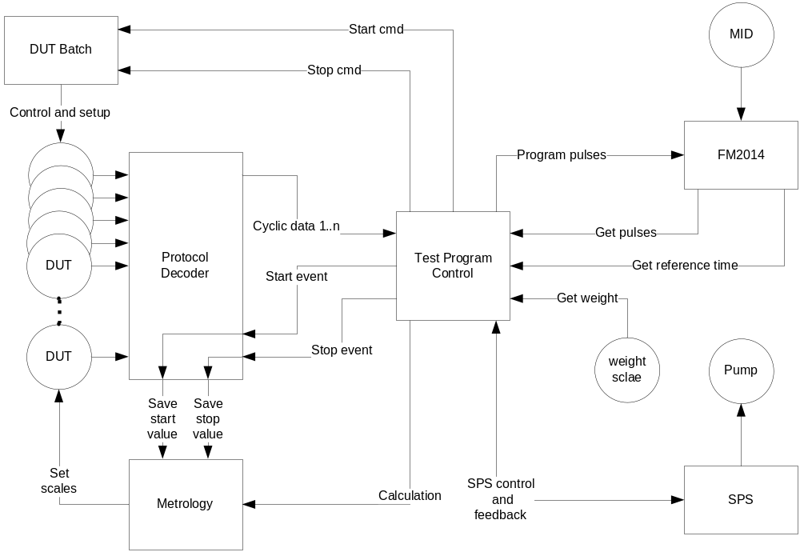
Picture 2.1 Measurement Block Sheet

Static Start/Stop Measurement
For the “Static Start/Stop Measurement” the reference volume and the desired deviation is being needed from the overlying test program. The reference volume will directly read from a weight scale or the REF. This procedure is independent of any measurement time. The measured volumes of the reference and the DUT will directly be used to calculate the scale, as described in [Chapter 2.2.5 Calculation Of Calibration-Factor], or the DUT accuracy, as described in [Chapter 2.2.6 Calculation of ].
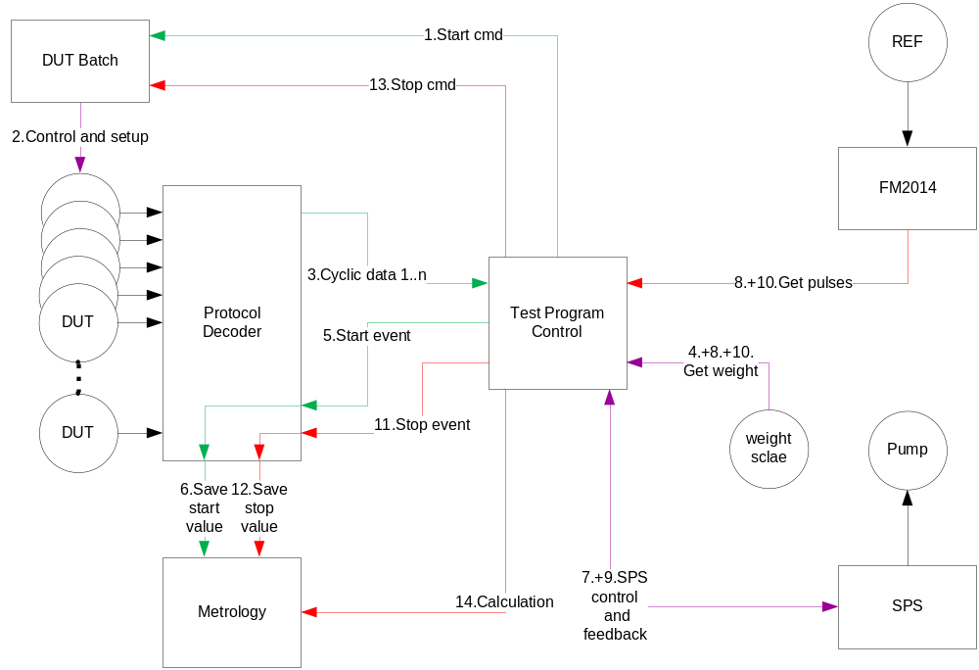
Picture 2.2 Static Start/Stop Measurement Sequence
The measurement sequence will be:
- Send “Start cmd” to DUT batch,
- The DUT batch will prepare all connected DUTs,
- Wait for readiness of DUTs, these will send “Cyclic data” if ready,
- Read reference start volume from weight scale or assume 0 counted pulses for the REF,
- Send the “Start event” to the protocol decoding unit,
- “Save start values” of each DUT,
- Start the pump,
- “Get weight” or “Get pulses” from the FM2014 until required volume has been collected,
- Stop pump and wait a certain time for zero-flow stabilization,
- Read the “Get pulses” from the FM2014 or take the volume of the weight scale,
- Send the “Stop event” to the protocol decoding unit,
- “Save stop values” of each DUT,
- Send “Stop cmd” to DUT batch, this will prepare all DUTs,
- “Calculation” of deviation between REF and DUT.

Flying Start/Stop Measurement
The required base of a “Flying Start/Stop Measurement” is the constant flow rate during the entire measurement! This is essential for the enclosed procedure and the calculations of deviations and scale factors. The flow rate is going to be controlled by the SPS. Before the measurement can be started, the desired flow rate has to be reached and stabilized!
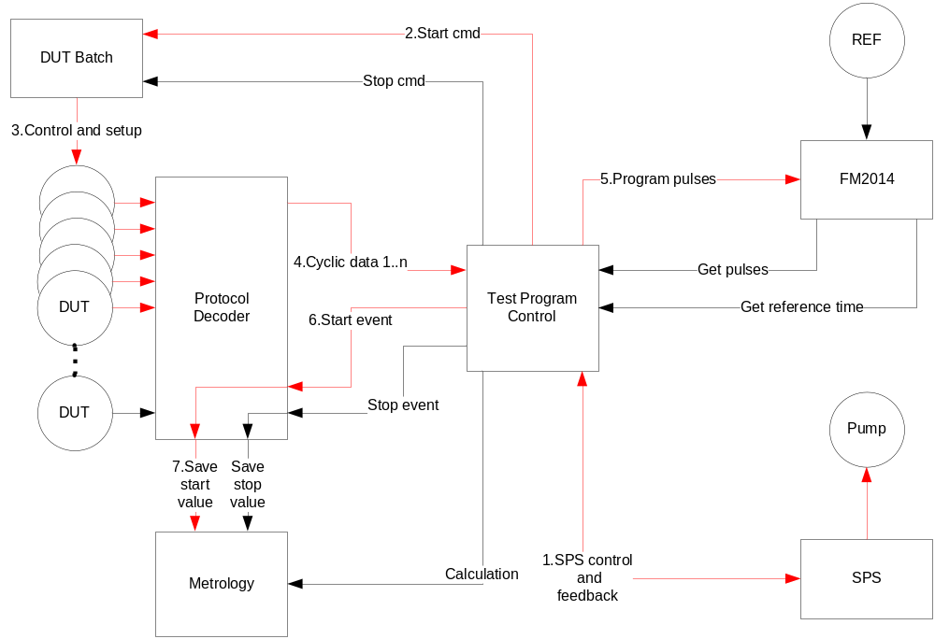
Picture 2.3 Flying Start/Stop Measurement Start-Sequence
The “Flying Start/Stop Measurement” start-sequence will be:
- Start the pump and wait for stabilization of the required flow-rate,
- Send “Start cmd” to DUT batch,
- The DUT batch will prepare all connected DUTs,
- Wait for readiness of DUTs, these will send “Cyclic data” if ready,
- Program the required pulses for the measurement volume to the FM2014 for the REF,
- Send the “Start event” to the protocol decoding unit,
- “Save start values” of each DUT.
- Measurement ongoing……

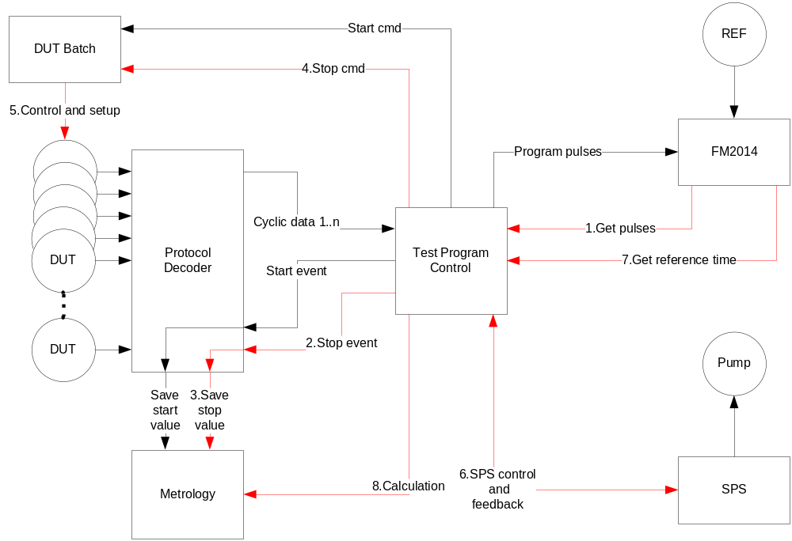
Picture 2.4 Flying Start/Stop Stop-Sequence
The “Flying Start/Stop” start-sequence will be:
- Wait until the remaining pulses from the FM2014 reached zero indicating the volume has been collected,
- Send the “Stop event” to the protocol decoding unit,
- “Save stop values” of each DUT,
- Send “Stop cmd” to DUT batch,
- The DUT batch will prepare all connected DUTs,
- Stop pump,
- Get the “reference time” for the exactly measurement duration from the FM2014,
- “Calculation” of deviation between REF and DUT.

Calculations

Calculation of DUT-Volume based on Meter Measurements
[SRS_TBF_COMMON_METRO_001]
For the “Static Start/Stop” the measurement-time is out of focus because the reference volume will be obtained from a weight-scale or a reference meter. Therefore the DUT-volume can be directly calculated using the difference between the start- and stop-volume taking an overflow into account:
$$V_{DUT}\left[m^{3}\right]= {(V}_{DUTstop}\left[m^{3}\right]+V_{DUT overflow}[m^{3}])-V_{DUTstart}[m^{3}]$$
Equation 2.1 DUT-Volume based on Meter Measurements
Error handling:
A status shall be set, if the volume of the DUT is zero.

Calculation of DUT-Time based on Meter Measurements
[SRS_TBF_COMMON_METRO _002]
For the DUT-time can be directly calculated using the difference between the start- and stop-time given by the meter:
$$t_{DUT}\left[s\right]= {(t}_{DUTstop}\left[s\right]+ t_{DUToverflow}[s])-t_{DUTstart}[s]$$
Equation 2.2 DUT-Time based on Meter Measurements
Error handling:
A status for timings below and equal to zero shall be set.

Calculation Of DUT-Flow-Rate
[SRS_TBF_COMMON_METRO _003]
For the flow-rate calculation the individual DUT-volume and the DUT-time is being needed:
$$Q_{DUT}\left[\frac{m³}{h}\right]= \frac{V_{DUT}[m^{3}]}{t_{DUT}[s]}∙\frac{3600s}{h}$$
Equation 2.3 Calculation of DUT-Flow-Rate

Calculation Of DUT-Volume Based On Flow-Rate
[SRS_TBF_COMMON_METRO _004]
For the “Flying Start/ Stop Measurement” the reference time is being used to recalculate the volume during the test time, due to the fact that the start and stop data record may be delayed by the software program flow or the unpredictable operational system timing:
$$V_{DUT}[m^{3}]= Q_{DUT}\left[\frac{m^{3}}{h}\right] ∙ t_{REF}\left[s\right]∙\frac{h}{3600s}$$
Equation 2.4 Calculation of DUT-Volume based on Flow-Rate

Calculation Of Calibration-Factor
[SRS_TBF_COMMON_METRO _005]
The calibration is being done using the measured volume of each individual path, the reference volume, measured by a weight scale or a REF, and for the flying start/stop measurement the timings of the individual channel and the precisely timing of the reference system.
These values will be used to calculate the new calibration factor $s_{x}$. It is based on the default scale factor $s_{defx}$ multiplied by the desired deviation $k$ at this specific flow-rate. The desired deviation is needed to adjust the curve of deviations depending on different flow rates into an envelope of tolerances. Detailed information of the calibration procedure for the Genesis-water-meter can be found in [GenCal]. The scale-factor shall be based on absolute values to be independent of the direction of the flow:
$$s_{x}\left[ \right]= \frac{{|V}_{REF}|}{\left|V_{DUTx}\right|} ∙ s_{defx}\left[ \right]∙ k \left[ \right] \left(x=1..3; 0.95<k<1.05\right)$$
Equation 2.5 Calculation of Calibration-Factor
Error handling:
A scale factor of zero shall be avoided with the status of REF-volume equals to 0.0!

Calculation of Deviation
[SRS_TBF_COMMON_METRO _006]
The deviation $d_{Q}$ at a specific flow rate $Q$ shall be calculated using the reference and the measured volume. The deviation calculation shall be based on absolute values to be independent of the direction of the flow rate:
$$d_{Qrel}[ ]= \frac{{{|V}_{DUT}|-|V}_{REF}|}{{|V}_{REF}|}$$
Equation 2.6 Calculation of Deviation relative
$$d_{Q}\left[\%\right]= d_{Qrel}\left[ \right]∙100\%$$
Equation 2.7 Calculation of Deviation in Percent

Error Handling
Some errors may avoid the ability to calculate the metrology values.

Channel Assignment
[SRS_TBF_COMMON_METRO _007]
It shall be checked if the required and the start- and end-record-channels are identical to avoid comparison of unequally channels.

References
[SI_UNITS] SI-Units, Published: Physikalisch Technische Bundesanstalt (PTB), 117.Edition, Booklet 2, June 2007

[TR_W2] TR W2 Technische Richtlinien für Wasserzähler, Published: Physikalisch Technische Bundesanstalt (PTB), Edition December 2012

[DIN_EN14154] DIN EN14154 Water meters test methods and equipment, Published: DIN Deutsches Institut für Normung e.V., Part 3, Edition July 2007

[MTS_1_3] Translation MTS 1_3, Published: SENSUS GmbH, Edition 16. March 2011

[GenDbg] Genesis Debug Serial Output; Published: Sentec; Author: Alex Frost
http://project.emea.sensus.net/PWA/EMEAAP_Genesis/Project%20Documents/300_R%2BD/340_Software%2BFirmware/342_Software_and_Firmware/Genesis%20Debug%20Serial%20Output.docx

[GenCal] Calibration Procedure; Published: Sentec; Authors: Alex Frost, Ben Davey, Joe Adam
http://project.emea.sensus.net/PWA/EMEAAP_Genesis/Project%20Documents/300_R+D/340_Software+Firmware/342_Software_and_Firmware/Metrology%20and%20calibration%20firmware/Calibration%20procedure.docx

[GenConf] Genesis Meter Configuration; Published: Sentec; Author: Alex Frost
http://project.emea.sensus.net/PWA/EMEAAP_Genesis/Project%20Documents/300_R%2BD/350_Electronics_Radio/356_production%20processes/Genesis%20Meter%20Configuration.docx
[IrDADef] NA2W IrDA Protocol Specification; Published: SENSUS; Author: Kevin Shay, Adam Hansen
https://intranet.sensus.net/drc/engineering/water-gas/FW/Shared Documents

