Project Number:  14011 | Document Type:  Software Requirement Specification |  |  | 
Date:  18-Apr-2023 | Product Name:  Template |  |  | Revision:  A
History
Rev | Date | Comment | Author
A | 18-Apr-2023 | Initial | Thomas Wiedebusch

Copyright © 2021..2023 by
SENSUS GmbH
CONFIDENTIAL
File: Template SRS .docx

Reviews
Rev | Date | Reviewer | Department

List Of Contents
1. Introduction 6
1.1 Content 6
1.2 System Overview 6
1.3 FW-Update Software Functions 7
2. Prerequisites 8
2.1 Hardware Requirements 8
2.2 Software Requirements 8
3. Installation 8
3.1 FW-Update Software Installation 8
3.2 Driver Installation and Setup 8
4. Requirements 9
4.1 Calculations 9
4.1.1 Calculation of DUT-Volume based on Meter Measurements 9
4.1.2 Calculation of DUT-Time based on Meter Measurements 9
4.1.3 Calculation Of DUT-Flow-Rate 9
4.1.4 Calculation Of DUT-Volume Based On Flow-Rate 10
4.1.5 Calculation Of Calibration-Factor 10
4.1.6 Calculation of Deviation 10
4.2 Error Handling 11
4.2.1 Channel Assignment 11
5. Trouble Shooting 12
6. Contacts 12
7. References 12
List Of Tables
Table 1.1 Abbreviations 5
Table 9.1 Contacts 12
List Of Figures
Figure 1.1 FW-Update with USB-IrDA – Offline Operation 6
List of Equations
Equation 2.1 DUT-Volume based on Meter Measurements 9
Equation 2.2 DUT-Time based on Meter Measurements 9
Equation 2.3 Calculation of DUT-Flow-Rate 9
Equation 2.4 Calculation of DUT-Volume based on Flow-Rate 10
Equation 2.5 Calculation of Calibration-Factor 10
Equation 2.6 Calculation of Deviation relative 10
Equation 2.7 Calculation of Deviation in Percent 10

Abbreviations
Builder Operator | Operator of the “FW-Update Builder“ assembling the “FW-Update Safe”
DLL | Dynamic Link Library
FW | Firmware, hardware depending software
FW-Update | Firmware update
FW-Update Builder | Builder of the “FW-Update Safe”, tool to select all needed components and to encrypt the “FW-Update Safe”
FW-Update Loader | Software for decryption of the “FW-Update Safe” and host for the “FW-Update Software”
FW-Update Process | The process of installing the firmware
FW-Update Safe | Encrypted container of all components needed for the “FW-Update Process” during offline operation
FW-Update SW | Software executing the “FW-Update Process”
Genesis | Legacy Name of Cordonel
HW | Hardware
Offline Operation | Without connection to the Xylem-Network
Online Operation | Directly or via VPN connected to the Xylem-Network
PCB ID | Printed Circuit Bord Identifier, unique identification number of the Cordonel HW
SRS | Software Requirement Specification
SW | Software
Update Opertor | Operator executing the “FW-Update Process“
VPN | Virtual Private Network
Table 1.1 Abbreviations

Introduction
This document is a template for the “Software Requirement Specification”.

Content
The document covers the requirements for the XXX-product.

System Overview
Two hardware systems can be used for the firmware update:
- USB-IrDA: The IrDA Plug-In adaptor is directly connected via USB to the PC. No driver installation is required.
- Micro-MOXA: The IrDA Plug-In adaptor is connected via a box containing an interface with a high noise immunity for harsh environments. A driver needs to be installed to support the RS485-4W interface.

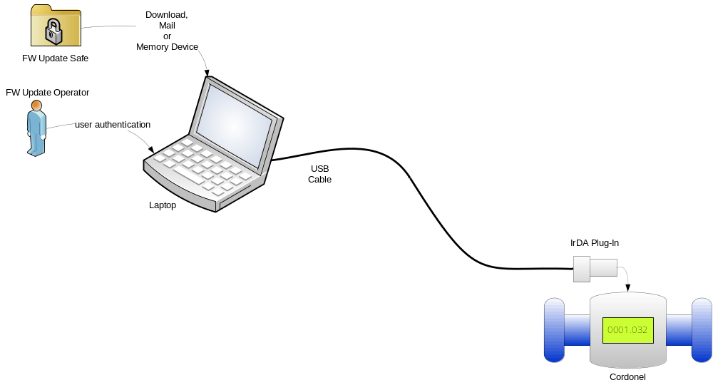
Figure 1.1 FW-Update with USB-IrDA – Offline Operation

FW-Update Software Functions
The “FW-Update SW” is the worker who updates the Cordonel, logs all processing steps, being able to analyse those on later inspection, and restores some important settings. Due to the strong update capability check, it avoids an installation of incompatible firmware.
The “FW-Update SW” base functions:
- Auto-detection of communication port and connected Cordonel,
- Generating a “FW-Update Report” file with all executed processing steps,
- Switching OFF the pulse output on IrDA to free the IrDA for standard communication and reminding the original settings of the pulse output to a file,
- Authentication with the password level 8 or, on missing or destroyed password file, with the skeleton key,
- Activate the radio using the customer encryption key,
- Store all previously adjusted settings,
- Reading out the installed firmware of the Cordonel before the update,
- Carrying out an update-capability-check for “Core Revision”, “Metrology Version”, “Region”, “Radio Frequency” and “Meter Size”,
- Lock update on failed update-capability-check,
- Reading out all configurations before the update,
- Listing all installed files on the Cordonel before the update,
- Free memory space for the update procedure by erasing unnecessary files from the Cordonel file system,
- Carrying out the FW-Update procedure,
- Reading out all configurations after the update,
- Listing all files after the update,
- Restoring necessary files for operational need which previously may have been erased,
- Restoring the password file,
- Validate password file by login with password level 8,
- Release display to normal operation for accumulated volume and flow rate,
- Restoring the pulse output to original settings.

Prerequisites

Hardware Requirements
- PC with MS-Windows™ 10 Operating system.
- USB-IrDA or Micro-MOXA with IrDA head.

Software Requirements
Microsoft™ .NET framework 4.7.2 has to be installed in advance.

Installation

FW-Update Software Installation
.

Driver Installation and Setup

Requirements
This chapter specifies the requirements of the product.

Calculations

Calculation of DUT-Volume based on Meter Measurements
[SRS_TBF_COMMON_METRO_001]
For the “Static Start/Stop” the measurement-time is out of focus because the reference volume will be obtained from a weight-scale or a reference meter. Therefore the DUT-volume can be directly calculated using the difference between the start- and stop-volume taking an overflow into account:
$$V_{DUT}\left[m^{3}\right]= {(V}_{DUTstop}\left[m^{3}\right]+V_{DUT overflow}[m^{3}])-V_{DUTstart}[m^{3}]$$
Equation 4.1 DUT-Volume based on Meter Measurements
Error handling:
A status shall be set, if the volume of the DUT is zero.

Calculation of DUT-Time based on Meter Measurements
[SRS_TBF_COMMON_METRO _002]
For the DUT-time can be directly calculated using the difference between the start- and stop-time given by the meter:
$$t_{DUT}\left[s\right]= {(t}_{DUTstop}\left[s\right]+ t_{DUToverflow}[s])-t_{DUTstart}[s]$$
Equation 4.2 DUT-Time based on Meter Measurements
Error handling:
A status for timings below and equal to zero shall be set.

Calculation Of DUT-Flow-Rate
[SRS_TBF_COMMON_METRO _003]
For the flow-rate calculation the individual DUT-volume and the DUT-time is being needed:
$$Q_{DUT}\left[\frac{m³}{h}\right]= \frac{V_{DUT}[m^{3}]}{t_{DUT}[s]}∙\frac{3600s}{h}$$
Equation 4.3 Calculation of DUT-Flow-Rate

Calculation Of DUT-Volume Based On Flow-Rate
[SRS_TBF_COMMON_METRO _004]
For the “Flying Start/ Stop Measurement” the reference time is being used to recalculate the volume during the test time, due to the fact that the start and stop data record may be delayed by the software program flow or the unpredictable operational system timing:
$$V_{DUT}[m^{3}]= Q_{DUT}\left[\frac{m^{3}}{h}\right] ∙ t_{REF}\left[s\right]∙\frac{h}{3600s}$$
Equation 4.4 Calculation of DUT-Volume based on Flow-Rate

Calculation Of Calibration-Factor
[SRS_TBF_COMMON_METRO _005]
The calibration is being done using the measured volume of each individual path, the reference volume, measured by a weight scale or a REF, and for the flying start/stop measurement the timings of the individual channel and the precisely timing of the reference system.
These values will be used to calculate the new calibration factor $s_{x}$. It is based on the default scale factor $s_{defx}$ multiplied by the desired deviation $k$ at this specific flow-rate. The desired deviation is needed to adjust the curve of deviations depending on different flow rates into an envelope of tolerances. Detailed information of the calibration procedure for the Genesis-water-meter can be found in [Fehler! Verweisquelle konnte nicht gefunden werden.]. The scale-factor shall be based on absolute values to be independent of the direction of the flow:
$$s_{x}\left[ \right]= \frac{{|V}_{REF}|}{\left|V_{DUTx}\right|} ∙ s_{defx}\left[ \right]∙ k \left[ \right] \left(x=1..3; 0.95<k<1.05\right)$$
Equation 4.5 Calculation of Calibration-Factor
Error handling:
A scale factor of zero shall be avoided with the status of REF-volume equals to 0.0!

Calculation of Deviation
[SRS_TBF_COMMON_METRO _006]
The deviation $d_{Q}$ at a specific flow rate $Q$ shall be calculated using the reference and the measured volume. The deviation calculation shall be based on absolute values to be independent of the direction of the flow rate:
$$d_{Qrel}[ ]= \frac{{{|V}_{DUT}|-|V}_{REF}|}{{|V}_{REF}|}$$
Equation 4.6 Calculation of Deviation relative
$$d_{Q}\left[\%\right]= d_{Qrel}\left[ \right]∙100\%$$
Equation 4.7 Calculation of Deviation in Percent

Error Handling
Some errors may avoid the ability to calculate the metrology values.

Channel Assignment
[SRS_TBF_COMMON_METRO _007]
It shall be checked if the required and the start- and end-record-channels are identical to avoid comparison of unequally channels.

Trouble Shooting
…

Contacts
Name | Funktion | Contact
Thomas Wiedebusch | Software development | thomas.wiedebusch@t-wiedebusch.de  +49 179 146 04 93
Jens Schulz | Productline - Manager | jens.schulz@xylem.com  +49 5102 743 195
Roland Drabesch | Lead - Software development | roland.drabesch@xylem.com  +49 5102 743 225
Table 6.1 Contacts

References
[FWU_MRD] Cordonel Service FW-Update Process MRD; Published: SENSUS GmbH; Author: Thomas Wiedebusch; Edition: September 2020 - Revision B
[FWU_BLD] Quick Reference Cordonel Service FW-Update Builder; Published: SENSUS GmbH; Author: Thomas Wiedebusch; Edition: Mar 2023 - Revision D
[FWU_LDR] Quick Reference Cordonel Service FW-Update Loader; Published: SENSUS GmbH; Author: Thomas Wiedebusch; Edition: April 2021 - Revision A
[FWU_PK] Quick Reference Cordonel Service FW-Update Packet; Published: SENSUS GmbH; Author: Thomas Wiedebusch; Edition: April 2021 - Revision A

