Specification
Sentec Ltd
5 The Westbrook Centre
Milton Road
Cambridge CB4 1YG
United Kingdom
Telephone +44 (0)1223 303800
Facsimile +44 (0)1223 303801
Web www.sentec.co.uk
Email info@sentec.co.uk

Sensus

Cordonel Firmware

Author: Alex Frost
Date: 24 November 2023

Revision: 1.36

Sentec Ltd has produced this document and the contents are confidential. All rights are reserved. No part of this publication may be reproduced, stored in a retrieval system, or transmitted in any form or by other means, electronic, mechanical, by photocopying, recording or otherwise without the prior written permission of Sentec Ltd.
© Sentec Ltd 2017

Contents
Introduction 4
Document purpose 4
Scope 4
Document structure 4
Revisions 4
Related documents 5
General Architecture 7
Overview 7
Application Lists 7
Microcontroller 7
Clocks 8
Measurement Principle 8
Configuration Management 9
Code Location 10
Zero 11
Overview 11
Drivers 11
Firmware Upgrade Permissions 11
User interface 11
Exports 12
GenesisFlow 13
Overview 13
Version 13
Technical detail 13
User interface 16
Programmer’s interface 27
Exports 30
Newer versions 32
MetrologyAssistant 35
Overview 35
Technical detail 35
User interface 35
Programmer’s interface 36
Exports 37
IrDA 39
Overview 39
Wakeup 39
Payload types 39
Uni-Directional meter read 44
Adapter presence 44
ConfigExchange access 44
User interface 46
Programmer’s interface 47
Exports 47
NFC 49
Overview 49
Technical detail 49
User interface 53
Exports 53
OpticalPort 54
Overview 54
ConfigExchange 55
Overview 55
SensusRF 56
PeriodicLogging 57
PowerMon 58
Overview 58
User interface 58
Programmer’s interface 58
Exports 59
Customer 60
Overview 60
Technical detail 60
User interface 63
Exports 65
Logger 68
Overview 68
User interface 68
Exports 68
NA2WLogger 69
Overview 69
Technical detail 69
User interface 71
Programmer’s interface 72
Exports 74
NA2WAlarms 76
Overview 76
Technical detail 76
User interface 78
Programmer’s interface 79
Exports 83
FlexNetVersion 85
Overview 85
User interface 85
Programmer’s interface 85
Exports 86

Introduction

Document purpose
Much of the contents of this specification is taken directly from the Breeze Specification^{[1]} document.

Scope

This specification covers all parts of the Cordonel firmware with the exception of the SensusRF radio application and PeriodicLogging application.

Document structure
The document starts with a general overview. This is followed by a chapter for each Breeze application on the Cordonel meter.

Revisions
Revision | Details
1.00 | First draft.
1.01 | Address some review comments
1.02 | Add draft of IrDA and NFC applications and description of the ultrasonic measurement principle
1.03 | Add some more LCD details
1.04 | Various small additions and clarifications including Idle mode on the LCD
1.05 | Test mode and seal display additions to GenesisFlow
1.06 | GenesisFlow configuration list updated
1.07 | Update scaling of GenesisFlow calibration factors
1.08 | Added NFC application details
1.09 | Major updates to GenesisFlow, MetrologyAssistant, IrDA, Customer. A few other small additions.
1.10 | Add SensusRF document reference. Display precision details added to MetrologyAssistant
1.11 | Corrections to Customer register descriptions and defaults.
1.12 | Add NA2WLogger, NA2WAlarms and FlexNetVersion sections. Update supported UI-1236 details. Update IrDA register defaults.
1.13 | Update UI-1236 details. Update registers in IrDA, MetrologyAssistant. Update product NDEF in NFC
1.14 | Minor review tweaks to IrDA section
1.15 | Updates to NFC and GenesisFlow sections, name changed to Cordonel.
1.16 | NA2W Alarms and NA2W Logger major updates. Alarm/Datalog UI-1236 updated
1.17 | NA2W Alarms review corrections
1.18 | GenesisFlow updates
1.19 | NA2W Alarms supported user defined alarm types updated
1.20 | Update test mode trigger in NFC
1.21 | IrDA: Maximum pulse weight set via UI-1236 updated.  GenesisFlow: Scale of unscaled registers updated
1.22 | IrDA: Remove unsupported UI-1236, indicate Flexnet Serial support, remove serial number writes restriction. Add new AMR digits display option. Add manufacture date.  GenesisFlow: Add new chapter with details of changes after version 287  MetrologyAsst: Add new pulse options and unit conversion exported functions  Customer: Add backup calendar time, installation time and serial string details  Zero: List drivers included in Genesis. Add enhancements not in document ^{[1]}  PowerMon, Logger: Add enhancements not in document ^{[1]}  Rename all ‘Genesis’ to ‘Cordonel’ (except GenesisFlow application which hasn’t changed its name)
1.23 | Customer: Add details for each territory
1.24 | GenesisFlow: Add change to temperature display in new versions
1.25 | NFC: Some empty params now filled in in RMA  IrDA: Two new parameters used by NFC RMA
1.26 | GenesisFlow: Fix a typo in error handling
1.27 | Customer: Add Australian Locales
1.28 | Customer: Add details to broken pipe and suspect leak alarms
1.29 | GenesisFlow: Add new LCD glass and add how pressure in ‘bar’ is displayed on original LCD
1.30 | GenesisFlow: Update to match version 302 for new MID approval – tables from files details  NFC & Customer: Minor updates to interfaces
1.31 | IrDA: Update UI-1236 Set Rate Units command and add Set/View Pressure Offset Correction
1.32 | GenesisFlow: Add 32 bit CRC display
1.33 | IrDA: Add new UI-1236 commands Set Display Mode and View Display Mode Status
1.34 | NFC: NDEF Product ID version updated
1.35 | IrDA: Add new UI-1236 commands Set/View Extended Resolution Setting  Customer: Condition Started event added  GenesisFlow: Add installation detection and correction for large meters; add option for bars above fractional digits; hide AMR display in test mode
1.36 | NA2WAlarms: updated predefined alarms details

Related documents
Reference  Number | Document | Version | Link
[1] | 12748DOC11 Breeze Core and Applications Functional Specification | 3.03 | Genesis SharePoint
[2] | 10129RPT10 Breeze Programmer’s Guide | 1.51 | Genesis SharePoint
[3] | NA2W IrDA Protocol Specification | 0.06 | Water & Gas SharePoint
[4] | NA2W IrDA Optical Payload Specification | 0.03 | Water & Gas SharePoint
[5] | FlexNet Communications Protocol | 5.36 | NA SVN
[6] | Optical Adapter Pulse Output solution specification | 0.03 | Water & Gas SharePoint
[7] | UI-1236 proposal for R08 | B1.23 | Water & Gas SharePoint
[8] | NA2W NDEF Message Specification | 1.03 | Water & Gas SharePoint
[9] | Omni Electronic Register Plus Firmware Feature Description | 1.04+ | Water & Gas SharePoint
[10] | GenesisDisplayTool | 2.0+ | Genesis SharePoint
[11] | Genesis Radio Functions Description | 0.14 | Genesis SharePoint
[12] | ally Software Functional Specification | 2018-06-19 | Water & Gas SharePoint
[13] | Omni E Register Plus Feature Description | 1.02 | Water & Gas SharePoint
[14] | UI-1203 proposal for R21 | 2015-09-16 | Water & Gas SharePoint
[15] | UI-1223 proposal for R04 | 2017-04-27 | Water & Gas SharePoint
[16] | ESAAP Genesis Firmware Upgrade Design | 0.2 | Genesis SharePoint

General Architecture

Overview
Cordonel is an ultrasonic water meter designed for commercial and industrial applications. It uses the Breeze operating system. Details on Breeze can be found in the Programmer’s Guide^{[2]}.
As well as measuring water flow Cordonel will provide measurements of temperature and pressure.
Cordonel has several interfaces: an LCD; SensusRF radio; NFC; IrDA; and LED. A 2 channel pulse output is available over the IrDA interface.
Cordonel is targeted at two markets with different requirements; North America (NA) and EMEA.

Application Lists
Cordonel includes the following list of applications for EMEA and NA
Application | EMEA | NA
Zero
PowerMon
ConfigurationExchange
Logger
GenesisFlow
Customer
MetrologyAssistant
IrDA
NFC
PeriodicLogging
SensusRF
FlexnetSerial
NA2WLogger
NA2WAlarms
FlexNetVersion
Table 1 - List of installed applications

Microcontroller
Cordonel uses an EFM32GG880F512 microcontroller from SiLabs. This is part of the ‘Giant Gecko’ range and this version comes with 512kB onboard flash and 128kB RAM.

Clocks
Cordonel has 3 oscillators used to drive clocks. A low frequency and a high frequency RC oscillator onboard the microcontroller and a low frequency TCXO. The real time clock is driven from the TCXO. The TCXO runs at 32768Hz ±10ppm so clock drift should be below 0.864 seconds per day.

Measurement Principle
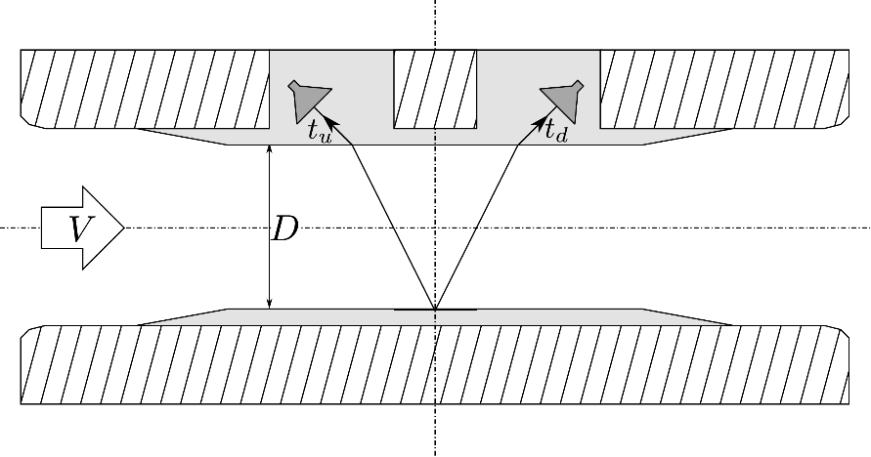
Figure 1 - Cordonel measurement section geometry
The geometry of the meter is shown schematically in Figure 1. The meter consists of a metal body with plastic inserts. Two ultrasound transducers sit in plastic inserts arranged so that an ultrasound pulse can travel from one transducer through the plastic and into the water, reflect off a metal plate on the opposite side of the meter, go back into the plastic, and arrive at the other transducer. Two such pulses are generated, one travelling downstream and one travelling upstream. The difference in travel time between the two pulses is related to the flow rate in the meter.
The timing is based on the ACAM GP30 chips. For each pulse pair this produces multiple upstream and downstream time of flights (ToFs). These time of flights are based on zero-crossing data (Figure 2). An upstream and a downstream pulse are performed one after the other. The differences (∆) in the upstream and downstream time of flight are used to calculate the flowrate.
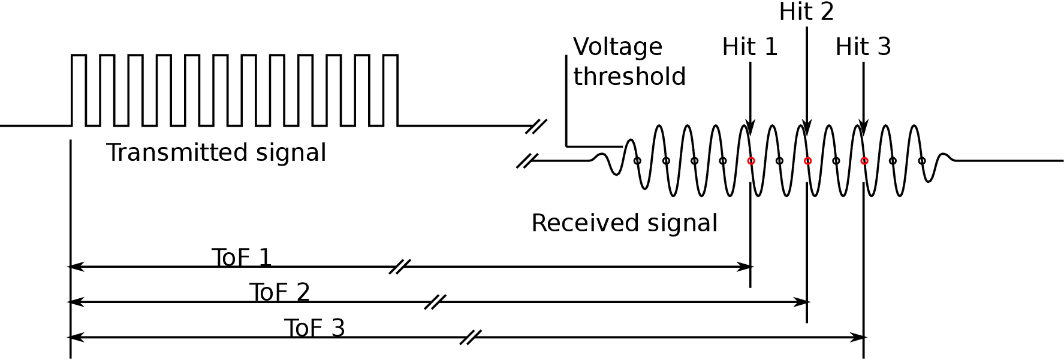
Figure 2 - GP30 timing measurement
The GP30 provides the time from the start of the transmitted pulse to zero crossings in the received pulse. The threshold at which to start counting zero crossings, which zero crossings to count and the number of zero crossings to count can all be configured.
The flow chart in Figure 3 describes how the ToFs and ∆ are used to calculate the flow rate. The interim value θ is the angle of refraction of the ultrasonic beam into the water. The flow rate is then turned into a volume by assuming constant flow rate since the last measurement and multiplying by the elapsed time.
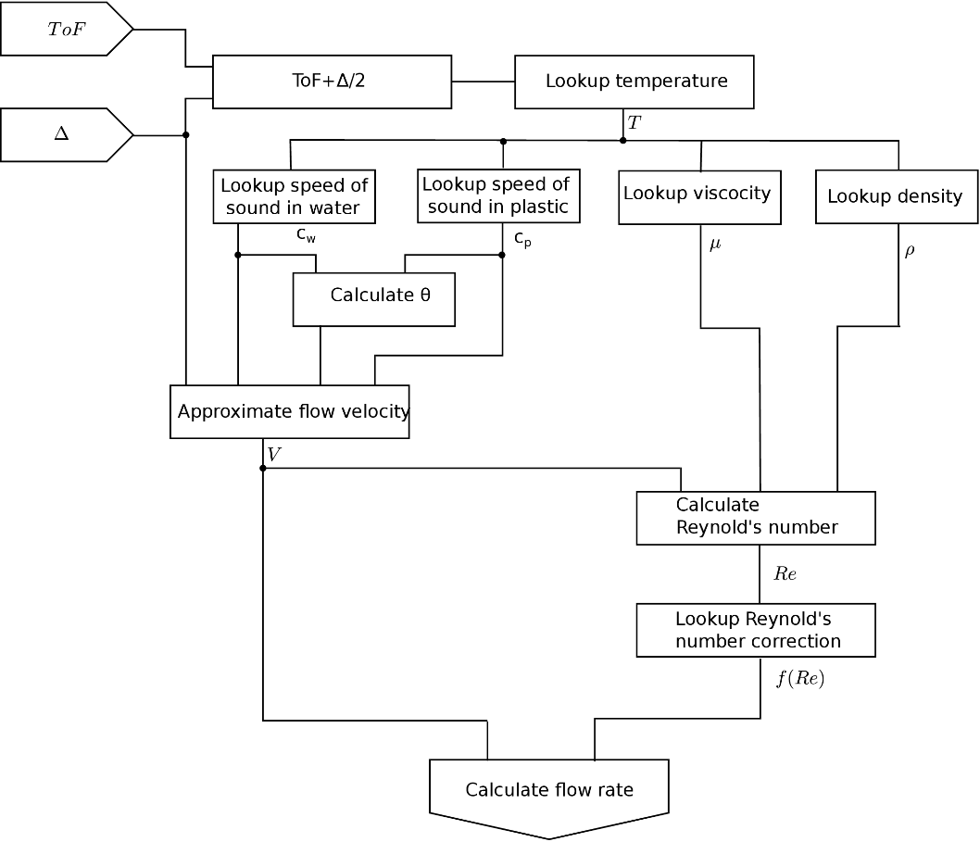
Figure 3 - Flow chart of flow rate calculation from GP30 measurements
Cordonel has 3 sets of GP30s and transducers. Each set produces a volume, these three volumes are averaged to give a volume that is used to throughout the rest of the meter. If the measurement from any of the 3 channels is deemed ‘bad’ that channel’s volume will be disregarded from the average.
As can be seen in Figure 3 one of the interim values calculated from the ToF is the temperature. The temperature calculation from each of the three channels is combined and used throughout the meter. For this reason Cordonel can measure the temperature without a dedicated temperature sensor.

Configuration Management
Each of the applications in the Breeze operating system has a list of configuration parameters. These are managed through an application called Configuration Exchange. For details on this see “Configuration Subsystem”^{[2]} and “Application ’ConfigurationExchange’”^{[1]}.
Three applications provide access through Configuration Exchange to all of the other applications’ parameters. SensusRF interprets commands over the radio as requests to set certain parameters. Optical Port has a confusing name but allows full access to all parameters using a wired UART interface. IrDA will support full access to all parameters similarly to the wired UART.

Code Location

Cordonel firmware is available under git in a collection of repositories managed by the ‘west’ tool from Zephyr. The manifest repository is at https://slm.sms-esaap.com/breeze_products/products/genesis
R
eleased builds of firmware are available at:
http://project.emea.sensus.net/PWA/EMEAAP_Genesis/Project%20Documents/300_R%2BD/340_Software%2BFirmware/342_Software_and_Firmware/ReleasedFirmware

Zero

Overview
This application provides all the device drivers used by other applications. It also provides a file system and a few system level functions.
Please see “Application ‘Zero’”^{[1]}.

Drivers
The following drivers are included in Cordonel builds
ID | Name | Details
32 | Tick | Bookable timers
36 | LCD | Segment based LCD
38 | CPU | Basic CPU control
41 | Norflash | Handling of NOR based flash
42 | Calendar | Real time clock
33 | UART | Buffered UART
54 | GP30 | Ultrasonic flow converter
49 | SI446X | Radio transceiver
50 | Pressure | Pressure sensor
46 | AES | AES encryption and decryption
53 | TCA9535 | 16 bit port extender
56 | ST25DVXXX | NFC device
55 | Commsrequest | Virtual device for sharing devices between applications

Firmware Upgrade Permissions
Breeze firmware upgrade system will check that the appropriate permissions are given for modifying applications. The permissions are managed by the UPGRADEPERMISSIONS register. The default value of 0xFF allows any application to be changed. 0xFE forbids change or removal of the ‘special’ application.
Writes to UPGRADEPERMISSIONS that restrict permission (smaller number) will result in the new permission level being written to NV memory. Writes that grant more permission will stay in RAM so that after the next reboot the permission will return to the more restricted level already in NV memory.

User interface

Configuration register list
In addition to the registers in ^{[1]} there are the following.
Number | Alias | Default | Meaning
0x0000 | Base
+14 | UPGRADEPERMISSIONS | 0xFF | Bitfield of permissions related to firmware upgrade
Table 2 – Zero additional register list

Exports

Errors
In addition to the errors in ^{[1]} there are the following.
Number | Alias | Meaning
0x0000 | Base
+54 | WONT_DELETE_SPECIAL | Returned if trying to delete the special application when not allowed
+55 | WONT_UPGRADE_SPECIAL | Returned if trying to upgrade the special application when not allowed
Table 3 – Zero additional errors

GenesisFlow

Overview
This is the metrology application for the Genesis ultrasonic water metering technology. This forms the MID legally relevant software.

Version
This version of the documentation applies to GenesisFlow version “302” with CRC “A3A6”.

Technical detail

Privileged operation
As the ‘special’ application GenesisFlow has its memory protected from modification by other applications with the built in Memory Protection Unit.

Drivers
The metrology application uses the GP30 driver provided by Application Zero to retrieve the ultrasonic time of flight measurements required for calculating water flow rate.
The metrology application must have primary control of the LCD display in meter products because the display is generally part of the certified functionality of the meter. Thus the metrology application includes display code for numeric data and meter status information as well as functions to permit other applications some access to the display. Values for flow rate, temperature and pressure display on the LCD have a particular location and can be provided by other applications.

Code priority
The metrology application is given priority above other applications to ensure that the metering function is always maintained.

Flow direction
Forward flow can be defined to be left to right or right to left. The direction is indicated on the LCD. If the direction is defined as ‘undecided’ then GenesisFlow will wait for 5m³ (configurable by setting ARROWTHRESHOLD) to flow more in one direction than the other and settle on this as the forward direction. Any accumulated volume will have its sign swapped if necessary. The default state is ‘undecided’.
Crossing the ARROWTHRESHOLD volume when in Test mode will not cause the direction to become decided.

Active, Idle and Test modes
GenesisFlow can be put into Active mode by writing ‘1’ to TRIGGERACTIVE. In this mode measurements are made at SAMPLERATE.
GenesisFlow can also be put into idle mode by writing any non-zero number to TRIGGERIDLE. In this mode no measurements are made and the value written to TRIGGERIDLE is displayed on the LCD. This is used only during manufacturing to keep track of progress and to reduce battery usage.
GenesisFlow has a Test mode that displays readings at a fixed precision on the LCD. It can be entered by writing ‘1’ to TRIGGERTEST. Test mode operates exactly as Active mode with the exception that the volume is displayed to up to three extra decimal places. The presentation on the LCD is slightly different to Active mode, this is described in further detail below. EVENT_GENESISFLOW_NEW_SCALED_VOLUME is sent out as usual in Test mode with the same scaling as in Active mode. However EVENT_GENESISFLOW_NEW_SCALED_TEST_VOLUME is also sent out with the volume scaled as on the LCD. During Test mode it is not possible to edit most parameters related to measurement and display.
When entering Test mode the test volume starts from zero. When transitioning from Test mode to Active mode the Active mode volume is reset to zero if the flow direction (see above) is set to ‘undecided’. Otherwise the volume that passed in Test mode will be included in the Active mode volume.

Temperature
An accurate temperature measurement is required for calculation of volume as can be seen in the Measurement Principal section above. The temperature is calculated every 30 time of flight measurements and the value propagated to other applications with EVENT_GENESISFLOW_NEW_TEMPERATURE.
The temperature measurement must be calibrated before use. This can be done by measuring the temperature using a reference and writing the value to TOFTEMPCALIBRATE. GenesisFlow will then perform an internal calibration on the next set of good measurements.

Lookup Tables
The calculation of volume and temperature requires a set of lookup tables and a number of constants, all of which are dependent on the meter size. In order to allow development of new meter sizes without changing the legally relevant code these tables are stored in files in the filesystem. Two identical files are named ‘1\\mettbl’ and ‘1\\mettbl_b’. The former is the main file with the latter used as a backup. If the main file is ever found to be corrupt the data from the backup will be used to recreate the main file. Each file has a header with the following structure
typedef PACKED(struct)
{
uint8_t magic[8]; ///< "Magic" string for identifying the file.
uint32_t length; ///< Length of data in the file.
uint16_t crc; ///< CCITT-CRC-16 of the file from `version` to the EOF.
uint16_t version; ///< Structure version for the file data.
} tables_file_header_t;

and a body of a list of the following structure, one for each meter size supported by the file
typedef PACKED(struct)
{
uint8_t metersize; ///< Meter size for this block.
tables_meter_const_t constants; ///< Meter size constants.
uint16_t sensitivity[TABLES_SENSITIVITY_LENGTH]; ///< Sensitivity lookup table.
uint16_t reynolds_correction[TABLES_REYNOLDS_LENGTH]; ///< Reynolds correction
uint8_t tof_temp_length; ///< ToF to temp table length.
tables_tof_temp_map_entry_t tof_temp_map[TABLES_TEMP_MAX_LENGTH]; ///< ToF to temp
} tables_file_meter_size_block_t;

which depends on the following structures.
typedef PACKED(struct)
{
uint8_t pipe_scale; ///< Scale factor based on pipe diameter.
uint16_t csa_value; ///< Cross-sectional area divided by the diameter
uint8_t csa_scale;
} tables_meter_const_t;

typedef PACKED(struct)
{
uint32_t tof; ///< Time-of-flight value (in 2^32 secs).
uint32_t tof_diff; ///< Time-of-flight difference with previous value
uint32_t temp; ///< Scaled temperature.
uint32_t temp_diff; ///< Scaled temperature difference with previous value.
} tables_tof_temp_map_entry_t;

The data for the present meter size is loaded from the file at boot, when the meter size changes and when LOOKUPFILECRC is written to.
When the tables and constants are loaded from the file, the CRC of the tables_file_meter_size_block_t that is to be loaded is checked against LOOKUPFILECRC. If they match the tables are loaded and used, if they do not match then default values for the tables and constants are used and an error is logged. During volume calculation a hard error is raised.

Errors
GenesisFlow can detect errors in the measurement process and has different ways of handling them depending on their severity:

ToF error
ToF error is triggered when the data received from the GP30 does not pass range checking. The data that caused this error is excluded from the volume calculation. If there are more than TOFERRORLIMIT consecutive errors in the data from a single GP30 then the first hit levels are reset to defaults in the expectation that this will mean good data starts to be returned again

Soft error
Soft error is triggered when the GP30 data contains indications that a minor error occurred during measurement. The data that caused this error is excluded from the volume calculation. A counter of soft errors is incremented and if it reaches 4 a log entry is filed with the Logger application. A further log entry is filed when the count reaches 8, then 16, then 32 etc up to 2²⁰ after which a new log is filed every 2²⁰ errors. These subsequent logs will contain the same data as the first one so can be used for approximating the length of time the error persisted.
The soft error count is decremented on every good measurement. There is a soft error count for each GP30.

Hard error
Hard error is triggered by failures in measurement state machines and major errors reported by the GP30. The data that caused this error is excluded from the volume calculation. A request to reset all the GP30s is set to try to bring it back to a working state. A counter of hard errors is incremented and if it reaches 1 a log entry is filed with the Logger application. A further log entry is filed when the count reaches 8, then 16, then 32 etc. These subsequent logs will contain the same data as the first one so can be used for approximating the length of time the error persisted.
If the hard error count reaches HARDERRORLIMIT the error is converted to a fatal error.
The hard error count is decremented on every good measurement. There is a hard error count for each GP30.

Fatal error
Fatal error is triggered by serious failures in the GenesisFlow processing state machine, errors in the GP30 scheduling state machine and corruption of the GP30 configuration. It can also be triggered by a series of hard errors.
Every fatal error causes a log entry to be filed with the Logger application.
Fatal errors caused by GP30 configuration corruption or lookup table CRC mismatch cause a EVENT_GENESISFLOW_PARAMETER_ERROR event to be raised. Other fatal errors cause a EVENT_GENESISFLOW_METROLOGY_ERROR.

Periodic storage
In case of serious error causing meter reset the latest volume is stored in non-volatile memory once per hour. This value is restored from non-volatile memory on boot.

User interface

LCD
The metrology application manages the LCD as it is part of the metrology function for type approval purposes.

Hardware
Cordonel supports two different LCD glasses. Both are shown below

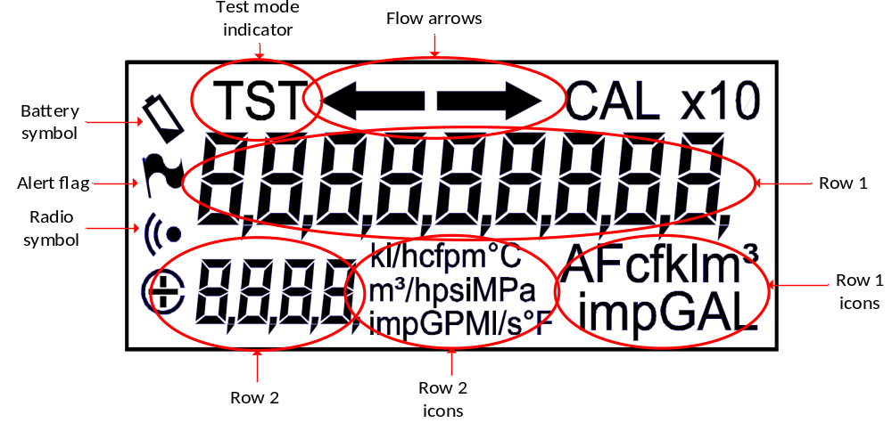Figure 4 - Cordonel ‘Original’ display layout
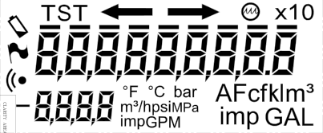
Figure 5 – Cordonel ‘New’ Display with ‘AMR bars’

The new LCD is, for the most part, the same as the original LCD however it does have the following changes:
- Bar (for pressure) icon added
- Empty pipe icon added
- AMR bar icons above each row 1 digit added
- Some unused decimal points, commas and flow rates removed

Separators
The LCD has both comma and dot separators between each digit and the ‘x10’ icon to indicate a decimal point one place to the right of the smallest row 1 LCD digit.
Whether to use a dot or a comma for decimal and whether to use a dot, comma or nothing as a thousands separator both depend on the locale configured in the meter.
The ‘New’ LCD does not support dots and commas in every position. If the settings require a dot or comma in an unsupported position then the settings will be rejected. The only exception to this is if a dot or comma is required after the furthest right digit, in this case this icon is optional and the settings will not be rejected.

Operation
GenesisFlow displays various types of information on the LCD. The following flow diagrams illustrate its behaviour during Active and Test modes. State transitions are automatic after the duration has elapsed. There is no switch or other interface to change state.

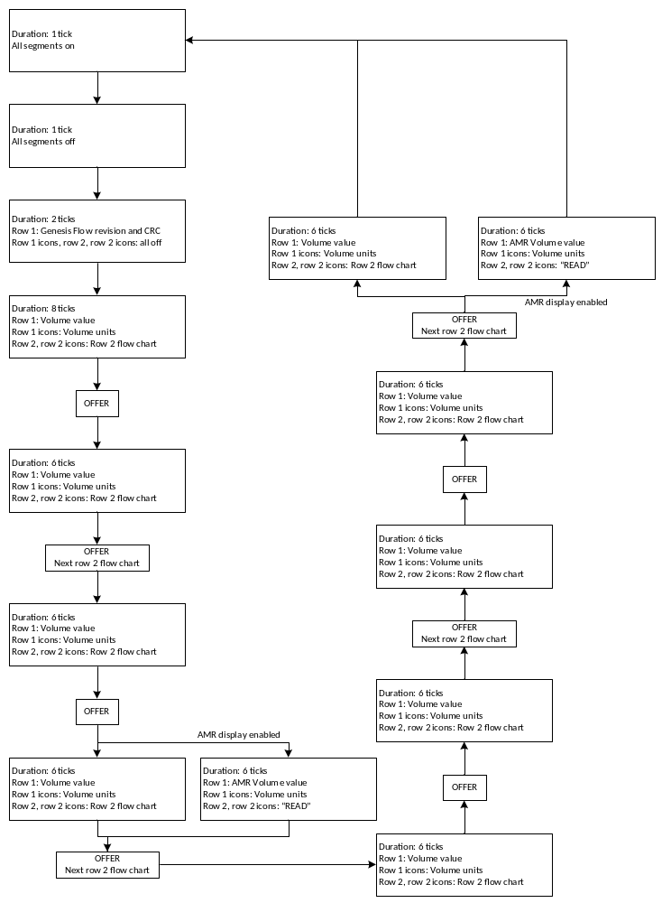
Figure 6 – State machine
Row 2 flow diagram, state transitions occur at ‘Next row 2 flow chart’ steps of the main flow diagram above.
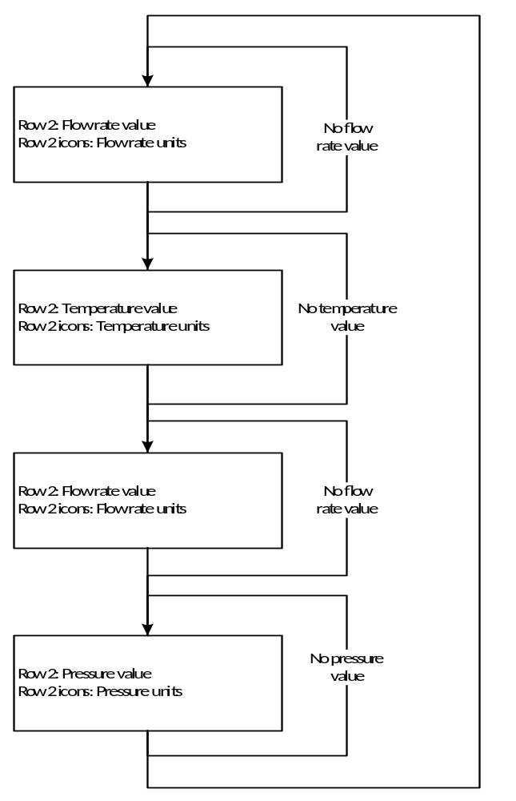
Figure 7 - Row 2 state machine

A tick is approximately 1 second.
In each ‘OFFER’ section Row 1 of the LCD is offered to another installed application for it to display short messages if required. During display of these messages row 1 icons, row 2 icons and the direction arrows will be off. Details of these messages are in the associated chapters. The applications are offered Row 1 in ascending order of application ID, each ‘OFFER’ section offering to the next in the list. For example if there are 8 applications installed each application will be offered once every 8 ‘OFFER’ sections. The maximum number of ticks any application can display messages for is 32 ticks.
GenesisFlow revision and CRC are the version number and CRC of the GenesisFlow application only. This is the legally relevant application for type approval purposes.
The ‘New’ LCD glass has an empty pipe icon which is lit when the meter is empty or filling. The ‘Original’ glass has no indication of empty pipe. Low flow cut-off is not indicated on either LCD
Negative flow rates are indicated by the ‘-‘ symbol in front of row 2. The ‘+’ symbol on the ‘Original’ LCD is not used. Only positive temperature and pressure values can be displayed.
Measurements of flow rate, pressure and temperature are supplied by other applications. The units and decimal point positions must be supplied before the readings. If readings are not supplied the display will not attempt to show this information and row 2 and row 2 icons will automatically display the next type of information. If nothing has been supplied for row 2 then a simple zero will be displayed.
When there is no valid temperature to display but the format of temperature has been set the display will now show dashes (‘----‘) rather than the last measured temperature. During empty pipe the temperature will be marked as invalid.
The flow arrows are to display the ‘forward’ direction. If forward is undefined both arrows will flash. The forward direction is automatically defined when there is net volume of ARROWTHRESHOLD in one direction. After this both arrows will stop flashing and the appropriate arrow will be solidly lit. The arrow direction can be read from and written to the FORWARDARROW register.
Display of AMR digits used in NA is handled differently on the two LCD glasses. When the ‘Original’ LCD is used a special ‘read’ screen is added to the carousel. With the ‘New’ LCD the AMR bars are indicated above the volume digits when AMR display is enabled and the non-AMR display route around the carousel is taken.
The alarm flag, radio symbol and battery symbol are not controlled by the GenesisFlow application. These are available for others to use.
During Idle mode the LCD displays ‘IdLE’ and the current value of TRIGGERIDLE in hexadecimal representation.
During Test mode the LCD states are the same as Active mode but the volume is displayed slightly differently. An example is given below.

Examples
The following table has examples of the Cordonel LCD in each state as above. Segments coloured grey indicate that another application has control. The ‘Original’ LCD is used for most examples except where there is a significant difference.
Example | Description
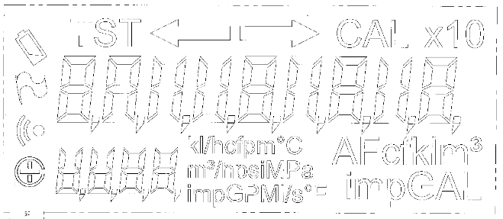 | All segments off, Active or Test mode, all locales.
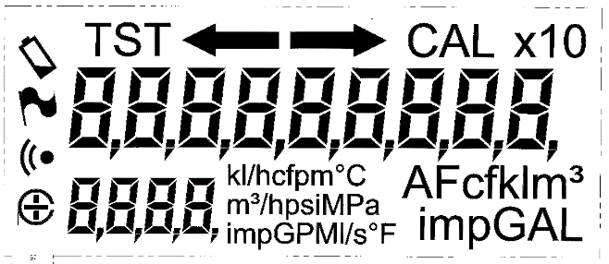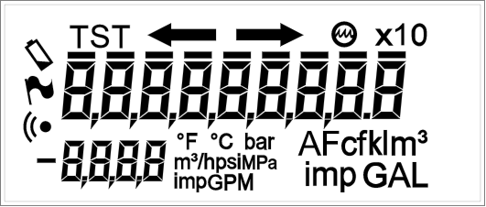 | All segments on, Active or Test mode, all locales.
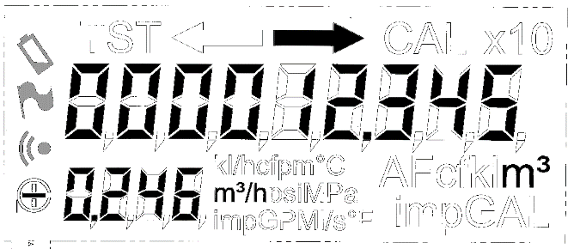 | Volume 12.345m³, forward flow left to right and flow rate -0.246m³/h. Active mode. Locales that use dots for decimal separators and nothing for thousand separators.
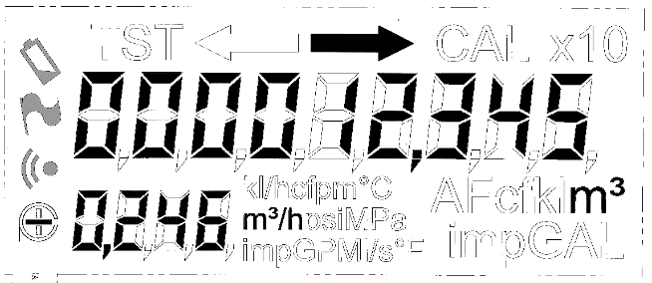 | Volume 12.345m³, forward flow left to right and flow rate -0.246m³/h. Active mode. Locales that use commas for decimal separators and nothing for thousand separators.
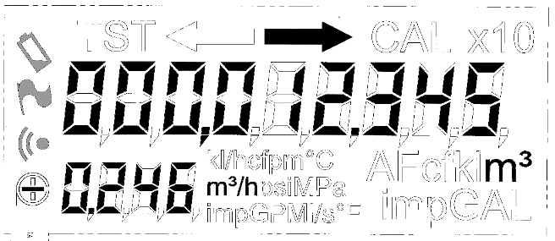 | Volume 12.345m³, forward flow left to right and flow rate -0.246m³/h. Active mode. Locales that use dots for decimal separators and commas for thousand separators.
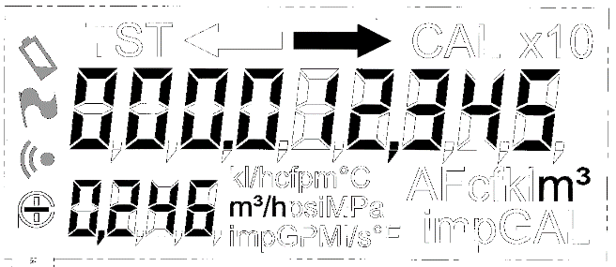 | Volume 12.345m³, forward flow left to right and flow rate -0.246m³/h. Active mode. Locales that use commas for decimal separators and dots for thousand separators.
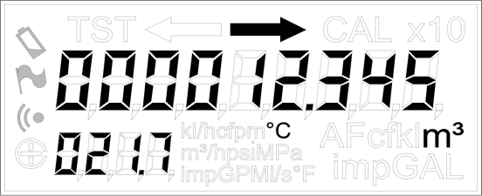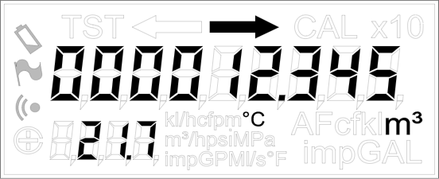 | Volume 12.345m³, forward flow left to right and temperature 21.7°C. Active mode. Locales that use dots for decimal separators and nothing for thousand separators. Display leading zeros set to True in first image and False in second.
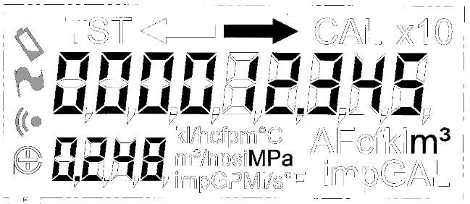 | Volume 12.345m³, forward flow left to right and pressure 0.248MPa. Active mode. Locales that use dots for decimal separators and nothing for thousand separators.
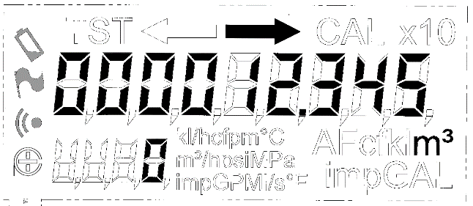 | Volume 12.345m³, forward flow left to right and no pressure, temperature or flow rate supplied. Active mode. Locales that use dots for decimal separators and nothing for thousand separators.
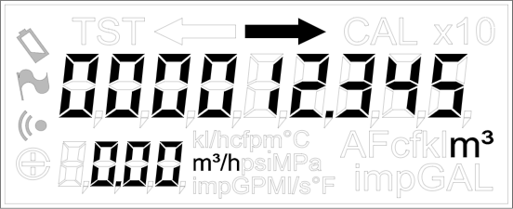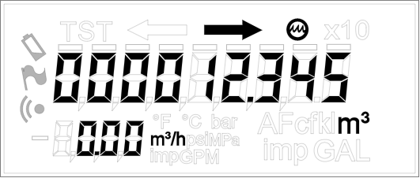 | Volume 12.345m³, in empty pipe, forward flow left to right. Active mode. Locales that use dots for decimal separators and nothing for thousand separators. AMR bars disabled. Display leading zeros set to False. ‘Original’ LCD does not have an explicit indication of empty pipe
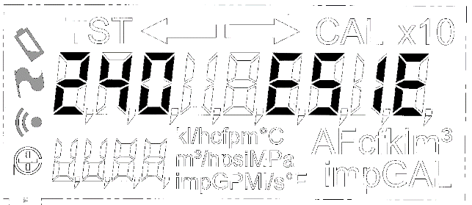 | GenesisFlow revision and CRC, Active or Test mode, all locales.
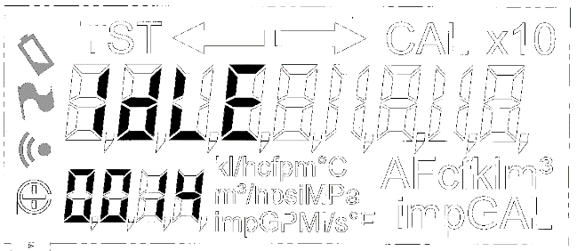 | Idle mode with 20(=0x14) in TRIGGERIDLE, all locales.
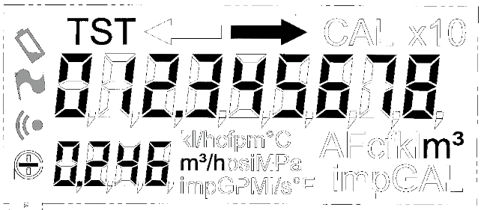 | Volume 12.345678m³, forward flow left to right and flow rate -0.246m³/h. Test mode when Active mode is set to show m³ to 3 decimal places. Locales that use dots for decimal separators.
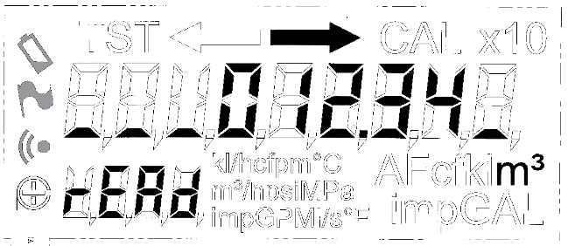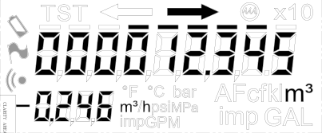 | AMR display of volume 12.345m³, forward flow left to right. Active mode. Locales that use dots for decimal separators and nothing for thousand separators. 5 AMR digits, offset by 1. Both ‘Original’ and ‘New’ LCDs shown.
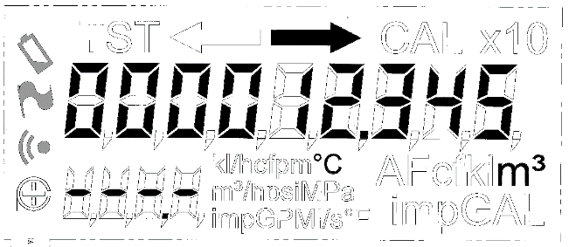 | Volume 12.345m³, forward flow left to right. Invalid temperature in °C format. Active mode. Locales that use dots for decimal separators and nothing for thousand separators.
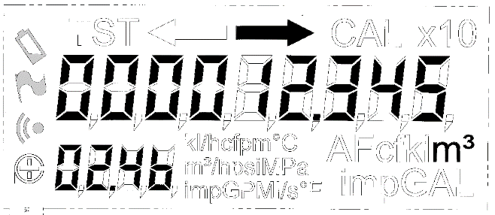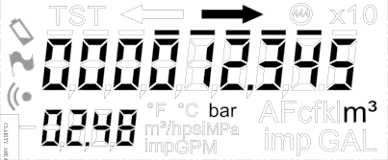 | Volume 12.345m³, forward flow left to right with AMR bars (5 digits, offset 1) and pressure 2.48bar. Active mode. Locales that use dots for decimal separators and nothing for thousand separators. Display leading zeros set to True. Both ‘Original’ and ‘New’ LCDs shown. Note ‘b’ letter used in ‘Original’ LCD as there is no icon for ‘bar’.
Table 4 - Display list entries

Configuration register list
Number | Alias | Default | Meaning
0x0F00 | Base
+0 | SAMPLERATE** | 2 | Rate of sampling each GP30 in Hz
+1 | FIRSTHITLVLUP1* | -48 | Signal level required to indicate an ultrasound hit in the up direction for GP30 number 1. Represented by 0.88mV per LSB
+2 | FIRSTHITLVLUP2* | -48 | As above for GP30 number 2
+3 | FIRSTHITLVLUP3* | -48 | As above for GP30 number 3
+4 | FIRSTHITLVLDOWN1* | -48 | As above for down direction for GP30 number 1
+5 | FIRSTHITLVLDOWN2* | -48 | As above for GP30 number 2
+6 | FIRSTHITLVLDOWN3* | -48 | As above for GP30 number 3
+7 | STARTHIT* | 6 | Number of hits before first ToF measurement
+8 | AMPLITUDEPEAKDETECTEND* | 19 | Number of hits amplitude peak detection uses
+9 | NUMFIREPULSES* | 17 | The number of ultrasound pulses fired per measurement
+10 | DISPLAYPOW10** | -6 | Log10 of the size of the smallest digit on the LCD in DISPLAYUNITS units
+11 | DISPLAYUNITS** | 0 (m³) | The units of volume to display. This is an enum of type displayunits_t. Units are converted to accuracy of 0.1%, errors up to this size should be expected when converting between units.
+12 | METERSIZE* | 1 (DN50) | The size of the meter. This is an enum of type metersize_t
+13 | CALFACTOR1* | 15625 | Calibration factor for GP30 number 1. This is a unit-less factor
+14 | CALFACTOR2* | 15625 | Calibration factor for GP30 number 2
+15 | CALFACTOR3* | 15625 | Calibration factor for GP30 number 3
+16 | ZEROOFFSET1* | 0 | Zero flow delta ToF offset for GP30 number 1. In seconds shifted up 38 bits
+17 | ZEROOFFSET2* | 0 | As above for GP30 number 2
+18 | ZEROOFFSET3* | 0 | As above for GP30 number 3
+19 | SCALEDBILLING | Undefined. | The volume on the LCD without decimal point
+20 | RESETACCUMULATORS | Undefined. | Write TRUE to reset the total volume
+21 | FORWARDARROW** | Undefined. | The direction of flow determined to be ‘forward’. This is an enum of type arrowdirection_t
+22 | LEDMODE** | 0 (off) | The mode of operation for the green LED debug output. This is an enum of type ledmode_t
+23 | STORECALIBRATION | Undefined. | Write TRUE to store all calibration related parameters to non-volatile memory. All affected parameters marked with *
+24 | UNSCALEDFWD | Undefined. | The total forward volume in ml shifted up by 10 and down by ‘pipe_scale’ from the meter size dependent lookup tables
+25 | UNSCALEDREV | Undefined. | The total reverse volume in ml shifted up as in UNSCALEDFWD
+26 | LOWFLOWTHRESOLD* | 200 | Volume in ml required for it to be added to accumulators
+27 | LOWFLOWMAXPERIOD* | 0x3C0000 | Time in seconds shifted up by 16bits in which volume above must be accumulated to avoid it being thrown away
+28 | UPDATETHRESHOLD** | 0 | Volume in ml required before LCD is updated
+29 | ARROWTHRESHOLD** | 5,000,000 | Net volume in ml required to set the flow direction
+30 | FIREBUFFER1* | 1 | The fire buffer in GP30 number1 to use
+31 | FIREBUFFER2* | 1 | As above for GP30 number 2
+32 | FIREBUFFER3* | 1 | As above for GP30 number 3
+33 | TRIGGERACTIVE | Undefined. | Write TRUE to put the application into Active mode.
+34 | TRIGGERIDLE** | Undefined. | Write a value to put the application into Idle mode and display the number written
+35 | MAXVALIDDELTATOF* | 247,390 (900ns) | The delta time of flight above which the measurement will be considered invalid in internal units
+36 | MAXVALIDTOF* | 24,739,011 (90us) | The time of flight above which the measurement will be considered invalid in internal units
+37 | MINVALIDTOF* | 13,743,895 (50us) | The time of flight below which the measurement will be considered invalid in internal units
+38 | FIRSTHITPERCENT1* | 20 | Percentage of amplitude first hit level will be set to for channel 1
+39 | FIRSTHITPERCENT2* | 20 | Percentage of amplitude first hit level will be set to for channel 2
+40 | FIRSTHITPERCENT3* | 20 | Percentage of amplitude first hit level will be set to for channel 3
+41 | FIRSTHITSHIFT** | 4 | Shift value that controls the length of the amplitude moving average
+42 | FIRSTHITMINIMUM* | 20 | Minimum absolute value for the first hit level
+43 | TOFERRORLIMIT* | 16 | Maximum ToF errors on a channel before first hit levels are reset
+44 | FIRSTHITUPDATEPERIOD** | 10 | Period in seconds between first hit level updates
+45 | PIPEFILLINGDELAY** | 30 | Period in seconds of data to ignore after pipe first fills
+46 | TOFTEMPOFFSET1* | 0 | ToF offset for temperature calculation in internal units for channel 1
+47 | TOFTEMPOFFSET2* | 0 | ToF offset for temperature calculation in internal units for channel 2
+48 | TOFTEMPOFFSET3* | 0 | ToF offset for temperature calculation in internal units for channel 3
+49 | TOFTEMPCALIBRATE | Undefined | Write the current temperature shifted by 12 bits to this to calibrate the temperature measurement
+50 | STORECONFIGURATION | Undefined | Write TRUE to store all configuration related parameters to non-volatile memory. All affected parameters marked with **
+51 | SEALDISPLAY** | FALSE | TRUE to forbid changing DISPLAYPOW10 and DISPLAYUNITS. FALSE to allow.
+52 | TRIGGERTEST | Undefined | Write TRUE to put the application into Test mode
+53 | MAXVALIDAMPLITUDE* | 0xAF000000 (700mV) | The maximum valid value of signal amplitude in mV shifted up by 22 bits
+54 | MINVALIDAMPLITUDE* | 0x0C800000 (50mV) | The minimum valid value of signal amplitude in mV shifted up by 22 bits
+55 | HARDERRORLIMIT** | 4 | Number of hard errors allowed before promoting to fatal error
+56 | TIMEOUT* | 1 | The timeout for an ultrasonic measurement (0 - 128us, 1 - 256us, 2 - 1024us, 3 - 4096us)
+57 | MAXDELTATOFDEVIATION* | 109951 (400ns) | The maximum valid delta time of flight difference between a measurement and the recent average measurements.
+58 | MAXTEMPRANGE* | 8192 (2°C) | The maximum range of temperatures between channels before one is rejected. In units of 2⁻¹² degrees Celsius
+59 | MAXDELTATOFRANGE* | 137438 (500ns) | The maximum range of delta time of flight between channels before one is rejected. In 2⁻³⁸ seconds units
+60 | LOOKUPFILECRC* | 0x8000FFFF | Write to set the expected value of the CRC of the metrology tables currently installed (16 LS bits). Read back the CRC for the loaded tables in the LS 16 bits. MS bit is set if this does not match the value written to this same register
+61 | DISPLAYLEADINGZEROS | False | Whether to display leading zeros on row 2 when numerical values are displayed.
Table 5 – Genesis Flow register list

Programmer’s interface

Functions
Eight functions will optionally be available via SysCall()from the GenesisFlow application.
status_t GenesisFlowAcceptDisplaySlot(const uint8_t *override,
void *function, uint8_t sublist)
Parameters | override – A string to display left justified, if too long it will be cropped to the display width  function – A function residing in the overriding application, used to validate the reply comes from the current slot  sublist – Number of entries that are waiting from this application
Returns | A status success code
Description | Permits external applications to override the main display if their key matches
Interrupt state | Undefined
Reentrancy | Not re-entrant

status_t GenesisFlowUpdateDisplayRateValue(int32_t ratevalue)
Parameters | ratevalue - The new scaled flow rate value
Returns | A status success code
Description | Sets the flow rate to display on row 2
Interrupt state | Undefined
Reentrancy | Not re-entrant

status_t GenesisFlowUpdateDisplayRateFormat(lcdicon_t units,
lcdicon_t dp,
bool_t disable)
Parameters | units - Flow rate units icon  dp - Decimal point icon  disable - TRUE to disable display of the flow rate
Returns | A status success code
Description | Sets the flow rate display format
Interrupt state | Undefined
Reentrancy | Not re-entrant

status_t GenesisFlowUpdateDisplayTempValue(int32_t tempvalue)
Parameters | tempvalue - The new temperature value
Returns | A status success code
Description | Sets the temperature to display on row 2
Interrupt state | Undefined
Reentrancy | Not re-entrant

status_t GenesisFlowUpdateDisplayTempFormat(lcdicon_t units,
lcdicon_t dp,
bool_t disable)
Parameters | units - Temperature units icon  dp - Decimal point icon  disable - TRUE to disable display of the temperature
Returns | A status success code
Description | Sets the temperature display format
Interrupt state | Undefined
Reentrancy | Not re-entrant

status_t GenesisFlowUpdateDisplayPresValue(int32_t presvalue)
Parameters | presvalue - The new pressure value
Returns | A status success code
Description | Sets the pressure to display on row 2
Interrupt state | Undefined
Reentrancy | Not re-entrant

status_t GenesisFlowUpdateDisplayPresFormat(lcdicon_t units,
lcdicon_t dp,
bool_t disable)
Parameters | units - Pressure units icon  dp - Decimal point icon  disable - TRUE to disable display of the pressure
Returns | A status success code
Description | Sets the pressure display format
Interrupt state | Undefined
Reentrancy | Not re-entrant

status_t GenesisFlowGetMetrologyInfo(metrologyinfo_t *metrologyinfo)
Parameters | metrologyinfo - Pointer to a structure to receive the metrology information
Returns | A status success code
Description | Gets various metrology related values
Interrupt state | Undefined
Reentrancy | Not re-entrant

status_t GenesisFlowScale(scaledvolume_t *scaled)
Parameters | scaled - Pointer to a structure to apply scaling to
Returns | A status success code
Description | Take the unscaled values in scaled and complete the scaled values based on display scaling
Interrupt state | Undefined
Reentrancy | Not re-entrant

status_t GenesisFlowReverseScale(scaledvolume_t *scaled)
Parameters | scaled - Pointer to a structure to apply reverse scaling to
Returns | A status success code
Description | Take the scaled values in scaled and complete the unscaled values based on display scaling. The opposite function to GenesisFlowScale above
Interrupt state | Undefined
Reentrancy | Not re-entrant

status_t GenesisFlowSetAMRDisplay(bool_t enable, uint8_t digits, uint8_t offset)
Parameters | enable – Whether to display the AMR digits  digits - The number of AMR digits  offset – The offset from the right of the first digit
Returns | A status success code
Description | Set up the AMR digits on the display
Interrupt state | Undefined
Reentrancy | Not re-entrant

Exports

Identity
The identity number assigned is 15.

Events
Number | Alias | Meaning
0x0F00 | Base
+0 | EVENT_GENESISFLOW_OFFER_DISPLAY_SLOT | Offer the display to another application. Application offered to as a uint8_t
+1 | EVENT_GENESISFLOW_NEW_RAW_VOLUME | New volume increment in internal units as a deltavolume_t
+2 | EVENT_GENESISFLOW_NEW_SCALED_VOLUME | New accumulated and scaled volume as a scaledvolume_t
+3 | EVENT_GENESISFLOW_PIPE_STATUS_CHANGED | State of the pipe (empty, forward flow etc) changed. New state as a flowstate_t
+4 | EVENT_GENESISFLOW_NEW_TEMPERATURE | New temperature measurement as a temp_scaled_t
+5 | EVENT_GENESISFLOW_METROLOGY_ERROR | A fatal error in metrology has been detected
+6 | EVENT_GENESISFLOW_PARAMETER_ERROR | Parameters in the GP30s have been corrupted or lookup table CRC doesn’t match configured value
+7 | EVENT_GENESISFLOW_NEW_SCALED_TEST_VOLUME | New accumulated and scaled volume as a scaledvolume_t. Scaling as displayed in Test mode. This event only raised in Test mode.
+8 | EVENT_GENESISFLOW_CALIBRATION_RECALL_INCOMPLETE | Recall of calibration parameters is incomplete
Table 6 - Events from the Genesis Flow application

Errors
Number | Alias | Meaning
0x0F00 | Base
+0 | ERROR_GENESISFLOW_BAD_TEST
+1 | ERROR_GENESISFLOW_BAD_CONFIG
+2 | ERROR_GENESISFLOW_DID_NOT_STORE
+3 | ERROR_GENESISFLOW_STORE_PENDING
+4 | ERROR_GENESISFLOW_STORE_BUFFER_SIZE
+5 | ERROR_GENESISFLOW_STRING_TOO_LONG
+6 | ERROR_GENESISFLOW_BAD_DISPLAY_MODE
+7 | ERROR_GENESISFLOW_GLASS_TOO_LONG
+8 | ERROR_GENESISFLOW_SLOT_NOT_YOURS
+9 | ERROR_GENESISFLOW_SUBLIST_TOO_LONG
+10 | ERROR_GENESISFLOW_NO_TEMP_SENSOR
+11 | ERROR_GENESISFLOW_UNDER_TEMP
+12 | ERROR_GENESISFLOW_LOW_TEMP_WARNING
+13 | ERROR_GENESISFLOW_HIGH_TEMP_WARNING
+14 | ERROR_GENESISFLOW_OVER_TEMP
+15 | ERROR_GENESISFLOW_MISMATCHING_LSB
+16 | ERROR_GENESISFLOW_OUT_OF_RANGE_PWDIFF
+17 | ERROR_GENESISFLOW_OUT_OF_RANGE_AMPLITUDE
+18 | ERROR_GENESISFLOW_OUT_OF_RANGE_TOF
+19 | ERROR_GENESISFLOW_OUT_OF_RANGE_DTOF
+20 | ERROR_GENESISFLOW_TOF_TIMEOUT
+21 | ERROR_GENESISFLOW_CAL_CHANGE
+22 | ERROR_GENESISFLOW_OUT_OF_RANGE_INTERVAL
+23 | ERROR_GENESISFLOW_VALIDATE_FAIL
+24 | ERROR_GENESISFLOW_OUT_OF_RANGE_TEMP
+25 | ERROR_GENESISFLOW_NOT_READY
+26 | ERROR_GENESISFLOW_METROLOGY_ERROR
+27 | ERROR_GENESISFLOW_GP30_ID_ERROR
+28 | ERROR_GENESISFLOW_GP30_FLAG_ERROR
+29 | ERROR_GENESISFLOW_GP30_TIMEOUT_ERROR
+30 | ERROR_GENESISFLOW_GP30_NO_TOF_ERROR
+31 | ERROR_GENESISFLOW_GP30_SEQ_ERROR
+32 | ERROR_GENESISFLOW_VALUE_SEALED
+33 | ERROR_GENESISFLOW_IN_TEST_MODE
+34 | ERROR_GENESISFLOW_UNKNOWN_STATE
+35 | ERROR_GENESISFLOW_DISPLAY_INIT_SUCCEEDED
+36 | ERROR_GENESISFLOW_DISPLAY_INIT_FAILED
+37 | ERROR_GENESISFLOW_GP30_INIT_FAILED
+38 | ERROR_GENESISFLOW_START_TIMER_SUCCEEDED
+39 | ERROR_GENESISFLOW_START_TIMER_FAILED
+40 | ERROR_GENESISFLOW_VOLUME_STORE_FAILED
+41 | ERROR_GENESISFLOW_EMPTY_PIPE
+42 | ERROR_GENESISFLOW_PARAMETER_ERROR
+43 | ERROR_GENESISFLOW_GP30_INTERNAL_ERROR
+44 | ERROR_GENESISFLOW_GLASS_TOO_SHORT
+45 | ERROR_GENESISFLOW_STORE_CAL_FAILED
+46 | ERROR_GENESISFLOW_STORE_CONF_FAILED
+47 | ERROR_GENESISFLOW_MODE_CHANGE
+48 | ERROR_GENESISFLOW_BAD_POW10
+49 | ERROR_GENESISFLOW_BAD_DECIMAL_SEPARATOR
+50 | ERROR_GENESISFLOW_BAD_UNITS
+51 | ERROR_GENESISFLOW_BAD_ICONS
+52 | ERROR_GENESISFLOW_BAD_THOUSAND_SEPARATOR
+53 | ERROR_GENESISFLOW_NEW_LOCALE_REJECTED
+54 | ERROR_GENESISFLOW_SET_ACCUMULATORS
+55 | ERROR_GENESISFLOW_SEAL_OPENED
+56 | ERROR_GENESISFLOW_CALIBRATION_RECALL_INCOMPLETE
+57 | ERROR_GENESISFLOW_BAD_AMR_SETTINGS
+58 | ERROR_GENESISFLOW_SUSPECT_CYCLE_SKIP
+59 | ERROR_GENESISFLOW_LOOKUP_FILE_LOADED
+60 | ERROR_GENESISFLOW_LOOKUP_FILE_METERSIZE_CHANGED
+61 | ERROR_GENESISFLOW_LOOKUP_FILE_FAILURE
+62 | ERROR_GENESISFLOW_LOOKUP_FILE_INVALID
+63 | ERROR_GENESISFLOW_LOOKUP_CRC_MISMATCH
+64 | ERROR_GENESISFLOW_LOOKUP_FILE_UNKNOWN_METERSIZE
Table 7 – Genesis Flow application errors

Newer versions
This section details changes that have taken place since version “302” described above

Installation Detection and Correction
TODO Fill in details of the installation detection and correction algorithms for replaceable measurement chamber meters

32 bit CRC
Newer Breeze System Cores offer a 32 bit CRC for each application as well as the default 16 bit CRC. Genesisflow uses this new 32 bit CRC and, when made available by a newer Breeze System Core will display the 32 bit CRC on the LCD rather than the 16 bit CRC.
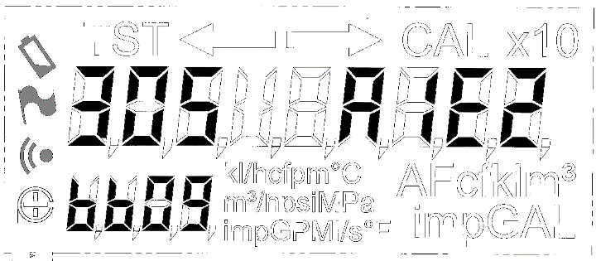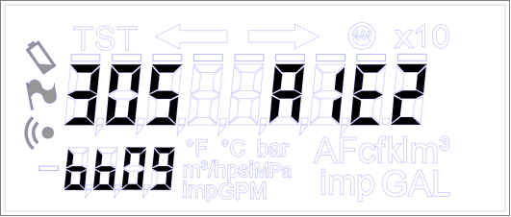 | GenesisFlow revision and 32 bit CRC (0xA1E2BB09), Active or Test mode, all locales.

AMR display in Test Mode
When GenesisFlow is in Test Mode, the display carousel no longer displays the AMR volume even if this is turned on. Instead it shows the test volume as if the AMR display was switched off. When back in Active Mode the AMR display will start to be shown again

Fractional Bars
An option was added to use the bars above the digits on the new LCD to highlight the digits that are fractions of a volume unit. This has no effect on the old LCD. An example follows.
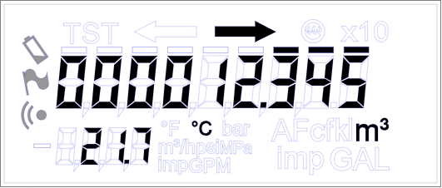

Configuration register list
Number | Alias | Default | Meaning
0x0F00 | Base
+62 | INSTALLATIONCORRECTIONENABLED | True | Whether or not to apply volume correction based on detected installation type
+63 | INSTALLATIONDETECTIONTHRESHOLD | 1000000 | Volume (in ml) to use to detect installation type
+64 | INSTALLATIONTYPE | 0x20000 | Most significant 16 bits are the type on installation (0 = 180or360 degrees Ux, 1 = 90or270 degrees Ux, 2 = Undisturbed). Least significant 16 bits are the proportion of the correction to apply based on amount of disturbance (0x8000 = 100%)
+65 | INSTALLATIONDETECTIONSTATUS |  | Percentage of the way through installation detection
+66 | FRACTIONALBARS | False | Whether or not to display bars on the LCD above the fractional digits of the volume

Events

Number | Alias | Meaning
0x0F00 | Base
+9 | EVENT_GENESISFLOW_NEW_INSTALLATION | A decision on the installation detection has been made, details sent with this event

Errors
Number | Alias | Meaning
0x0F00 | Base
+65 | ERROR_GENESISFLOW_INSTALLATION_HIGH_TIME_DIFF | Unused
+66 | ERROR_GENESISFLOW_INSTALLATION_LOW_FLOW_IGNORE | Not enough volume to make a judgement on meter installation type
+67 | ERROR_GENESISFLOW_INSTALLATION_BAD_CHANNELS | At least one channel didn’t have valid volume so this measurement didn’t get used for installation detection
+68 | ERROR_GENESISFLOW_INSTALLATION_FIXED | Installation has been detected

MetrologyAssistant

Overview
Metrology Assistant provides a collection of small functions:
- It provides an event when the flow rate is updated, reporting it in litres per hour
- It regularly reads a pressure sensor and raises an event with the new reading
- It updates the pressure, temperature and flow rate values displayed on the LCD by GenesisFlow

These functions are all closely linked to the outputs of GenesisFlow but, since they need not be part of the legally relevant code, they are kept separate.

Technical detail

Pressure
The pressure device is read at the rate defined in PRESSURERATE. The value is corrected by a configurable offset then converted to MPa or PSI for display on the LCD. When permitted by the particular LCD, one digit above the decimal point is displayed in MPa, three digits above the decimal point in PSI. The corrected value in Pa is sent to all applications in an event.

Temperature
The temperature data in the EVENT_GENESISFLOW_NEW_TEMPERATURE event is converted into Celsius or Fahrenheit for display on the LCD. When permitted by the particular LCD, three digits above the decimal point are displayed in both Celsius and Fahrenheit.

Flow rate
The flow rate data in EVENT_GENESISFLOW_NEW_RAW_VOLUME event is converted into ml/s, l/s, l/h, kl/h, m³/h, ft³/min, USgal/min or Imperial gal/min for display on the LCD. The units and precision to display the flow rate in are controlled by FLOWUNITS and FLOWPOINT. The scaled flow rate is sent to all applications in an event.

Pulse output
The volume data in EVENT_GENESISFLOW_NEW_RAW_VOLUME is converted into a pulse count in the forward and reverse directions. These counts along with the pulse mode and length are sent to all applications in an event.

User interface

Configuration register list
Number | Alias | Default | Meaning
0x1200 | Base
+1 | STORECONFIGURATION | Undefined. | Writing TRUE to this register stores the values of the other registers to the non-volatile memory
+2 | PULSEWEIGHT | 1000 | Volume represented by one pulse in ml. If this is zero pulse output will not be enabled
+3 | PULSEMODE | OFF | The way pulses are output on the two available channels. This is an enum of type pulse_mode_t.
+4 | PULSELENGTH | 50ms | The length of a pulse. This is an enum of type pulse_length_t.
+5 | FLOWUNITS | m³/h | The units of flow rate to display on the LCD. An enum of type displayflowunits_t
+6 | FLOWPOINT | 2 | Position of the decimal point on the LCD for flow rate. An enum of type displayflowpoint_t
+8 | TEMPERATUREUNITS | 0 (Celsius) | Units for displaying temperature on the LCD. 0 – Celsius, 1 – Fahrenheit.
+9 | PRESSUREUNITS | 0 (MPa) | Units for displaying pressure on the LCD. 0 – Mpa, 1 – PSI.
+10 | PRESSURERATE | 300000 | Time between pressure measurements in milliseconds
+11 | PRESSUREOFFSET | 0 | Value in Pa to subtract from measured value to correct for atmospheric pressure
+12 | PRESSUREPRESENT | TRUE | Whether there is a pressure sensor attached
+13 | PRESSUREMEASURE | Undefined. | Write TRUE to trigger a measurement, read to get the most recent measured value.
+14 | LATESTFLOWRATE | Undefined | Returns the latest flow rate. Write 0 to change scaling to internal scaling, 1 to change to display scaling
+15 | GENERATEFWDPULSES | Undefined | Generate some artificial pulses, used for testing
+16 | GENERATEREVPULSES | Undefined | Generate some artificial pulses, used for testing
+17 | PULSEEVENDISTRIBUTION | 1 (TRUE) | Boolean value for whether pulse output is to space the pulses evenly (TRUE) or grouped (FALSE)
+18 | PULSERESOLUTION | 7 | The number of bits of fractional resolution in a pulse event (read only)
Table 8 – Metrology Assistant register list

Programmer’s interface

Functions
Four functions are available via SysCall()from the MetrologyAssistant application.
status_t MetrologyAsstScalePressure(int32_t pressure, int32_t *scaled_pressure)
Parameters | pressure – The pressure in Pa  scaled_pressure – Pointer to the returned scaled pressure value
Returns | A status success code
Description | Performs scaling from Pa to the current display representation of this pressure
Interrupt state | Undefined
Reentrancy | Not re-entrant

status_t MetrologyAsstReverseScalePressure(int32_t scaled_pressure, int32_t *pressure)
Parameters | scaled_pressure – The pressure formatted as on the display  pressure – Pointer to the returned pressure in Pa
Returns | A status success code
Description | Performs scaling from the current display representation of pressure to Pa
Interrupt state | Undefined
Reentrancy | Not re-entrant

status_t MetrologyAsstScaleTemperature(int32_t temperature, int32_t *scaled_temperature)
Parameters | temperature – The temperature in 0.01 degree C  scaled_temperature – Pointer to the returned scaled temperature value
Returns | A status success code
Description | Performs scaling from 0.01 degree C to the current display representation of this temperature
Interrupt state | Undefined
Reentrancy | Not re-entrant

status_t MetrologyAsstReverseScaleTemperature(int32_t scaled_temperature, int32_t *temperature)
Parameters | scaled_temperature – The temperature formatted as on the display  temperature – Pointer to the returned temperature in 0.01 degree C
Returns | A status success code
Description | Performs scaling from the current display representation of temperature to 0.01 degree C
Interrupt state | Undefined
Reentrancy | Not re-entrant

Exports

Identity
The identity number assigned is 18.

Events
Number | Alias | Meaning
0x1200 | Base
+0 | EVENT_METROLOGYASST_NEW_FLOW_RATE | New flow rate in litres per hour, as a uint32_t.
+1 | EVENT_METROLOGYASST_NEW_PRESSURE | New pressure reading in Pa, as a uint32_t
+2 | EVENT_METROLOGYASST_PULSE_OUTPUT | Updated pulse counts as a pulse_record_t
+3 | EVENT_METROLOGYASST_NEW_SCALED_FLOW_RATE | Flow rate scaled for display as a flowrate_scaled_t
+4 | EVENT_METROLOGYASST_NEW_SCALED_TEMPERATURE | Temperature scaled for display as a temperature_scaled_t
+5 | EVENT_METROLOGYASST_NEW_SCALED_PRESSURE | Pressure scaled for display as a pressure_scaled_t
Table 9 - Events from the Metrology Assistant application

Errors
Number | Alias | Meaning
0x1200 | Base
+0 | BAD_CONFIG | User is attempting to set a maximum flow rate of zero.
+1 | DID_NOT_STORE | Returned by STORECONFIGURATION if it failed
+2 | PENDING_STORE | Returned by STORECONFIGURATION while storage of parameters is still pending
Table 10 - Metrology Assistant application errors

IrDA

Overview
The IrDA application implements the NA2W IrDA protocol, see the specification^{[3]} for details. The IrDA interface will be available at all times during manufacture and deployment.

Wakeup
Cordonel is a battery powered device so will require a wakeup burst for each message. It is not planned for Cordonel to implement a Listen After Talk window.

Payload types

Pulse
IrDA will support pulse output as described in the pulse output specification^{[6]}.
The pulse data is taken from the EVENT_METROLOGYASST_PULSE_OUTPUT event. The IrDA application is only responsible for the rate at which pulse reports are transmitted, other parameters such as pulse mode and length are taken from the received event.

Optical Command
IrDA will support the following Optical Commands:
- Ping
- Pulse subscribe
- Internal Command

For more details see the Optical Payload Specification^{[4]}. ‘Internal Command’s will be used to allow full access to ConfigExchange.

Optical Message
IrDA will support the following Optical Messages:
- Acknowledgement
- Uni-directional read string
See the Uni-directional meter read section for more on this
- Pulse setup audit
- Internal Response

For more details see the Optical Payload Specification^{[4]}. ‘Internal Response’s will be used to allow full access to ConfigExchange.

Flexnet Serial Pass-through
IrDA will support the Flexnet Serial messages required for firmware upgrade. These are:
- 0xB8 Firmware Maintenance – see section 4.42^{[5]}
- 0xB9 Firmware LoadBlock – see section 4.43^{[5]}

The way these commands are used to load an image and the way an image is constructed is the same as used is SensusRF. Please see the Firmware Upgrade Design document^{[16]} for more details.
Please note these commands are not yet supported directly through the Flexnet Serial Pass-through, rather they are supported via UI-1236 Send FlexNet Serial (0xFD 0x98) and Send Multiple FlexNet Serial Commands (0xFD 0xA2)

UI-1236 Pass-through

Supported control flags
The multiple frames, long, multiple commands, network and encryption flags described in the specification^{[7]} are all unsupported.
The response flag is supported

Setup commands
The following setup commands are supported:
- Cmd 0x01: View Factory ID
- Cmd 0x03: View Programmable ID
- Cmd 0x04: Set Programmable ID
- Cmd 0x05: View Version and Type
- Cmd 0x2B: View SmartPoint Config Info
- Cmd 0xFD: Device Specific Commands matching the format in the ally specification^{[12]}
  - View System Time (0xFD 0x10)

Readings commands
The following commands related to meter readings are supported:
- Cmd 0x09: View Number of Reading Digits
- Cmd 0x0A: Set Number of Reading Digits
- Cmd 0x0B: View Reading Units
- Cmd 0x0C: Set Reading Units
  - The following tables list the number of decimal places used on the display and for UI-1203 for each unit and meter size. All match OMNI E Register Plus^{[13]} with the exception of AF

Units | Extended Resolution Setting (see 0xFD 0x28) | DN40  DN50  DN65  1.5”  2” | DN80  DN100  3"  4" | DN125  DN150  6" | DN200  DN250  DN300  8"  10"  12"
m³, kl | Don’t care | 3 | 2 | 2 | 2
l | Don’t care | 0 | 0 | 0 | -1 (x10)
US gal,  Imp gal | Don’t care | 0 | 0 | 0 | 0
ft³ | False | 2 | 0 | 0 | 0
ft³ | True | 2 | 2 | 0 | 0
AF | Don’t care | 6 | 6 | 6 | 5
Table 11 - Decimal places for each meter size and measurement unit

- Cmd 0x0D: View Rate Units
- Cmd 0x0E: Set Rate Units
  - Every valid meter size and unit is set to be displayed on the LCD and used in UI-1203 in ‘whole’ units.

- Cmd 0x0F: View Reading Resolution
- Cmd 0x11: View Rate Resolution
- Cmd 0x13: View Reading
  - Volume numbers are zero padded to the length of the display
- Cmd 0x27: View optional uni-dir fields
- Cmd 0x28: Set optional uni-dir fields
- Cmd 0x29: View uni-dir
- Cmd 0xFD: Device Specific Commands matching the format in the ally specification^{[12]}
  - View Sensor Units (0xFD 0x79)
  - Set Sensor Units (0xFD 0x7A)
  - Set Atmospheric Pressure Offset (0xFD 0xC8)
  - View Atmospheric Pressure Offset (0xFD 0xC9)
  - Set Pressure Offset Correction (0xFD 0xD3)
  - View Pressure Offset Correction (0xFD 0xD4)
- Cmd 0xFD: Device Specific Commands matching the format in the OMNI E Register Plus specification^{[13]}
  - View Extended Resolution Setting (0xFD 0x28)
  - Set Extended Resolution Setting (0xFD 0x29)

Alarm commands
The following commands related to alarms are supported:
- Cmd 0x1F: View metrology alarm settings
- Cmd 0x20: Set metrology alarm settings
- Cmd 0x21: View metrology alarm state
- Cmd 0x22: Clear metrology alarms
- Cmd 0x25: View alarm persistence period
- Cmd 0x26: Set alarm persistence period
- Cmd 0xFD: Device Specific Commands matching the format in the ally specification^{[12]}
  - View Alarm Counters (0xFD, 0xC4)
  - Clear Alarm Counters (0xFD, 0xC5)

Datalog commands
The following commands related to datalogs are supported:
- Cmd 0xFD: Device Specific Commands matching the format in the ally specification^{[12]}
  - Set Datalog Interval (0xFD 0x7D)
  - View Datalog Interval (0xFD 0x7E)
  - View Datalog Data (0xFD 0x80)
  - View Periodic Alarm Log Entries (0xFD 0xC2)
  - View Detailed Alarm Log Entries (0xFD 0xC3)

The datalog logs different data to ally so the log IDs are different for View Datalog Data.
Log | Log ID
Water volume at the end of the logging period | 0x00
Minimum flow rate | 0x10
Maximum flow rate | 0x20
Minimum temperature | 0x11
Maximum temperature | 0x21
Average temperature | 0x31
Minimum pressure | 0x12
Maximum pressure | 0x22
Average pressure | 0x32

Two new device specific commands are defined.
- Reset Measured Range (0xFD 0x81)
  - Takes one byte sensor ID and uses it to reset the stored min/max values for that sensor. See NA2WLogger
- View Measured Range (0xFD 0x82)
  - Takes a one byte sensor ID
  - Returns the minimum and maximum values seen for that sensor since last reset in the same scaling as the matching datalog
  - Format of the response as following
Octets | Field | Details
0-3 | Minimum | int32LE
4-7 | Time of minimum | Seconds since 1/1/2000 00:00:00 uint32LE
8-11 | Maximum | int32LE
12-15 | Time of maximum | Seconds since 1/1/2000 00:00:00 uint32LE
  - If there is no valid min or max then the value will be set to 0x7FFFFFFD and the time to 0

Firmware download
The following commands supporting firmware download are supported:
- Cmd 0xFD: Device Specific Commands matching the format in the ally specification^{[12]}
  - Send FlexNet Serial (0xFD 0x98)
  - Send Multiple FlexNet Serial Commands (0xFD 0xA2)

These commands support the same FlexNet Serial commands that are listed in the “Flexnet Serial Pass-through” section.

Pulse output
The following commands supporting pulse output are supported:
- Cmd 0xFD: Device Specific Commands matching the format in the OMNI E Register Plus specification^{[13]}
  - View Pulse Output Settings (0xFD 0x0E)
    - This command doesn’t have space for the pulse mode. However for NA where this command will be used the mode will always be ‘balanced’.
  - Set Pulse Output Settings (0xFD 0x0F)
    - This command doesn’t feature the pulse mode. However for NA where this command will be used the only required mode is ‘balanced’ so this will be set alongside the pulse length and weight.

 | m³, kl, l | US gallons | Imperial gallons | ft³ | AF
1.5”, 2”, DN40, DN50, DN65 | 100,000 | 10,000 | 10,000 | 100,000 | 100,000
3”, 4”, DN80, DN100, DN125 | 10,000 | 10,000 | 10,000 | 1,000 | 100,000
6”, DN150 | 10,000 | 10,000 | 10,000 | 1,000 | 100,000
8”, DN200 | 10,000 | 10,000 | 10,000 | 1,000 | 10,000
10”, DN250 | 10,000 | 10,000 | 10,000 | 1,000 | 10,000
12”, DN300 | 10,000 | 10,000 | 10,000 | 1,000 | 10,000
Table 12 - Maximum pulse weight

Miscellaneous
The following additional commands will be supported:
- Cmd 0xFD: Device Specific Commands matching the format in the ally specification^{[12]}
  - View Manufacture Date (0xFD 0x39)
  - View Reboot Count (0xFD 0x55)
  - View Meter Size (0xFD 0xB7)
  - View Seconds Active (0xFD 0x3D)
    - The number of seconds the meter has been alive
  - View Charge Used (0xFD 0x3F)
    - Only one power source is tracked so only one value will be present in this response
  - View In-Service Start Time (0xFD 0xBD)
- Cmd 0xFD: Device Specific Commands matching the format in the Omni+ specification^{[13]}
  - View Display Mode Status (0xFD 0x14)
    - Test mode is always reported as ‘1’ even if it was entered by using the ‘2’ setting
  - Set Display Mode (0xFD 0x15)
    - This supports the following modes
Mode | Description
0 | Normal mode – ‘Active mode’ in GenesisFlow
1 | Test mode – ‘Test mode’ in GenesisFlow for 1 hour (unless cancelled manually earlier)
2 | As (1) above, only for consistency with Omni+
Table 13 – Display Modes

Uni-Directional meter read
The uni-directional meter read is based on the UI-1203^{[14]} and UI-1223^{[15]} specifications. Cordonel supports the required Identification field (I) plus the optional Current Reading (RB), Factory ID (K) and Timestamped Alarms (MSA) fields.
The readings section of the UI-1236 commands (above) lists the commands to control the various options for the uni-directional meter read.
Volume readings are zero padded up to the AMR reading length and no decimal point is used. Instead the power of 10 offset is used to indicate decimal position.

Adapter presence
The IrDA application makes a judgement about whether an IrDA adapter is present and sends this information in an event to all other applications. This information doesn’t affect the operation of the IrDA application.
If no valid IrDA messages are received by the application during ADAPTERPRESENCELIMIT consecutive 15 minute periods then the IrDA adapter is deemed not present. Otherwise the adapter is present.

ConfigExchange access
ConfigExchange can be accessed with ‘Internal Command’s (wrapped in ‘Optical Command’s) and ‘Internal Message’s (wrapped in ‘Optical Message’s). Both an Internal Command and an Internal Message start with a one byte command ID followed by data, the length of which is specified in the Optical Command/Optical Message wrapper. An Internal Message is the response to an Internal Command. The following sections describe each command.
The GenesisDisplayTool^{[10]} can send and receive these commands to configure registers in any application. There is also a python module available in CVS that allows the same access.

Get version
Command ID 0x13
No payload
Message ID 0x14
 | Data | Size
Version | Version in 16.16 fixed point BCD format | 4

Read data
Read a list of Cordonel registers.
Command ID 0x09
 | Data | Size
Register | Register ID to read | 2
Space | 0 | 4
Repeat | Repeat ‘Register’/’Space’ pairs N times as required | 6*N

Message ID 0x0A
 | Data | Size
Error | Error code for first read – 0 for no error | 2
Data | Register value for first register | 4
Repeat | ‘Error’/’Data’ repeated N times | 6*N

Write data
Write to a list of Cordonel registers.
Command ID 0x0B
 | Data | Size
Register | Register ID to write | 2
Data | Value to write | 4
Repeat | Repeat ‘Register’/’Data’ pairs N times as required | 6*N

Message ID 0x0C
 | Data | Size
Error | Error code for first write – 0 for no error | 2
Space | Undefined | 4
Repeat | ‘Error’/’Space’ repeated N times | 6*N

Multiple read data
Read a Cordonel register multiple times. For reading a single register this will be more efficient than successive reads using Command ID 0x09
Command ID 0x0D
 | Data | Size
Register | Register ID to read | 2
Repeats | Number of times to read register (N) | 2

Message ID 0x0E
 | Data | Size
Error | Error code – 0 for no error | 2
Index | Read number that caused the error, in the range 1...N | 2
Data | Value from each read | 4*N

Multiple write data
Write to a Cordonel register multiple times. For writing to a single register this will be more efficient than successive writes using Command ID 0x0B
Command ID 0x0F
 | Data | Size
Register | Register ID to write | 2
Repeats | Number of times to write register (N) | 2
Data | Value for each write | 4*N

Message ID 0x10
 | Data | Size
Error | Error code – 0 for no error | 2
Index | Write number that caused the error, in the range 1...N | 2

User interface

Configuration register list
Number | Alias | Default | Meaning
0x1200 | Base
+0 | PULSEREPORTRATE | 1 second | Rate pulse reports are sent out, a pulse_report_rate_t
+1 | ADAPTERPRESENCELIMIT | 3 | The number of consecutive 15 minute periods of no messages to assume no adapter
+2 | PULSESEQUENCE | Undefined | The current sequence number used in pulse reports
+3 | STORECONFIGURATION | Undefined | Writing TRUE to this register stores the values of the other registers to the non-volatile memory
+4 | AMRDIGITS | 9 | The number of digits to use for AMR
+5 | AMROFFSET | 0 | The offset from the right for the last significant AMR digit (negative number)
+6 | UI1203FIELDS | 0x010C | Bitfield of the UI-1203 fields in use.
+7 | MFGDATE | 0 | A timestamp of meter manufacture in seconds since 1/1/2000 00:00:00 UTC
+8 | DISPLAYAMRDIGITS | 0 (Do not display) | Whether or not to display AMR digits on the screen
+9 | ADAPTERID | Empty | The adapter ID string for the currently inserted pulse adapter. 0 if no adapter
+10 | ADAPTERFWVERSION | 0 | The adapter firmware version for the currently inserted pulse adapter. 0 if no adapter
+11 | EXTENDEDRESOLUTION | False | Whether or not to request extra resolution on the display for certain units and meters sizes
Table 14 – IrDA register list

Programmer’s interface

Functions
No functions are exported.

Exports

Identity
The identity number assigned is 20.

Events
Number | Alias | Meaning
0x1400 | Base
+0 | EVENT_IRDA_ADAPTER_PRESENCE | A change has been detected in the presence of the IrDA adapter
Table 15 - Events from the IrDA application

Errors
Number | Alias | Meaning
0x1400 | Base
+0 | BAD_CONFIG | User is attempting to set an unknown register
+1 | BAD_LENGTH | Length in a message was incorrect
+2 | OUT_OF_RANGE | Range checking failed on a parameter
+3 | PENDING_STORE | Returned by STORECONFIGURATION while storage of parameters is still pending
+4 | DID_NOT_STORE | Returned by STORECONFIGURATION if it failed
+5 | TOO_MANY_BYTES | Used internally to yield to other activity when lots of IrDA data is received
Table 16 – IrDA application errors

NFC

Overview
The NFC application implements the Product Details and Dead Meter Read NDEFs, together with the RMA, information. See the specifications ^{[8] [9]} for details.
Additionally the GenesisFlow can be put into Test Mode and Active Mode by writing to specific memory locations.
At this stage, NFC bi-directional communications are not supported.

Technical detail

NFC Hardware
The Cordonel meter uses the ST25DV04K 4-Kbit NFC EEPROM device to provide its NFC interface. Refer to the datasheets available on the ST website for further information on the functions supplied by this device. The device is connected to the Cordonel processor via I2C.

NFC Device Memory
The memory of the NFC device is divided into two sections. The range 0x0-0xFF holds the product details and dead meter information and can be read with any suitable device capable of understanding standard NDEF formatted data. It has no password protection. The RMA information resides in the range 0x100-0x1FF and can be password protected as required from the RF side.

Product Details NDEF
The product details NDEF implementation follows the version 2 format specified in reference [8] section 4. Identifier fields will be present if valid IDs are available on the meter otherwise they will be blank. The variant ID uses three characters.
Character | Meaning | Options
0 | Radio frequency | 4 – 433 MHz radio  8 – 868 MHz radio  0 – No radio
1 | Pressure sensor presence | P – pressure sensor present  X – no pressure sensor
2 | LCD glass variant | 0 – Original Cordonel  1 – New Cordonel with AMR bars

Meter Read NDEF
The meter read NDEF implementation follows the version 0 format specified in reference [8] section 5. All the fields are present and should return valid data. In addition to the volume units specified in Table 6, the Cordonel implementation supports Litres (L) and KiloLitres (KL).

NDEF Updating
As the information contained in the product details NDEF is largely static, it is only updated once every 24 hours, whereas the meter read NDEF is updated once every 30 minutes. This interval was selected based on the expected product life (20 years) and the worst case write cycle endurance specified for the NFC device by the manufacturer (minimum 400k cycles at 125 degC).

RMA Information
The RMA implementation follows the format specified in reference [9] section 8.3.2 and is placed at address 256 as recommended. During manufacturing the RMA area should be zeroed to ensure that all the fields start from a known state. A configuration register is provided to trigger this operation.
All the specified fields are present in the RMA record although not all are currently dynamically updated. See the following sub-sections for specific implementation details.

Header Record (0x100, 4 bytes)
The map revision is 0 and the size is 0x75 bytes.

Number Of Resets Record (0x104, 2 bytes)
This record reflects the number of resets that have occurred on the device and will hold at 0xFFFF.

Number Of Watchdog Resets (0x106, 2 bytes)
Currently this record always reads as 0.

Reset Records (0x108, 48 bytes)
Reset information is held in the form of two parallel 8 value arrays, one for reset reasons and the other for reset time. These are only updated each time the system starts, at which point the array entries are shuffled down one and the latest information inserted in the lowest entries.
The reset reason values reflect the systemstart_t enumeration or’ed with 0x8000 to distinguish them from empty RMA memory.

RMA Update Timestamp Record (0x138, 4 bytes)
This will be the timestamp of the last time that the RMA data was successfully updated.

Battery Seconds Active Record (0x13C, 4 bytes)
This will reflect the total used time in seconds as obtained from the PowerMon application

Seconds Since Installation Record (0x140, 4 bytes)
This takes the installation time from Customer application. If the installation time is 0 then this value will be 0.
Versions of NFC application before 0.53 report this as 0 in all cases.

Volume Reading Record (0x144, 4 bytes)
This will be updated whenever the RMA data is updated.

Lifetime Totalizer Record (0x148, 8 bytes)
Currently this record always reads as 0.

Test Totalizer Active Seconds Record (0x150, 4 bytes)
Currently this record always reads as 0.

Predefined Alarm Info Record (0x154, 8 bytes)
This will be updated whenever the RMA data is updated. See the section below for details on the data held in this record.

User Defined Alarm Info Record (0x15C, 10 bytes)
This will be updated whenever the RMA data is updated. See the section below for details on the data held in this record.

Adapter Serial Number/Factory ID Record (0x166, 13 bytes)
This will contain the adapter serial number from the IrDA application
Versions of NFC application before 0.53 report this as empty in all cases.

Adapter Firmware Version Record (0x173, 2 bytes)
This will contain the adapter firmware version from the IrDA application
Versions of NFC application before 0.53 report this as 0 in all cases.

Predefined Alarm Information
The format of the data in this record changes between the NA and EMEA meters as there is no clear mapping between them.

NA Alarm Information
On a NA meter this 64-bit field is used to hold the current state of the NA Predefined Alarms, with 2-bits allocated per alarm as described in in reference [9] section 8.3.2.

EMEA Alarm Information
The EMEA alarms don't make a distinction between alarm types and so we map the state of all the alarms into this field as follows, maintaining the 2-bit per alarm allocation:
bit offset 0 = ALARM_REBOOT
bit offset 2 = ALARM_LOW_BATTERY
bit offset 4 = ALARM_VERY_LOW_BATTERY
bit offset 6 = ALARM_CONFIG_ERROR
bit offset 8 = ALARM_EMPTY_PIPE
bit offset 10 = ALARM_MAGNETIC_TAMPER
bit offset 12 = ALARM_REVERSE_FLOW
bit offset 14 = ALARM_SUSPECT_LEAK
bit offset 16 = ALARM_BROKEN_PIPE
bit offset 18 = ALARM_LOW_PRESSURE
bit offset 20 = ALARM_HIGH_PRESSURE
bit offset 22 = ALARM_LOW_TEMPERATURE
bit offset 24 = ALARM_HIGH_TEMPERATURE
bit offset 26 = ALARM_RADIO_ERROR
bit offset 28 = ALARM_METROLOGY_PARAMS
bit offset 30 = ALARM_METROLOGY_MEASURE
Refer to the EMEA meter documentation for the exact interpretation of these alarms. The meaning of the 2-bit fields is very similar to the NA Alarm definition:
0 = Disabled alarm
1 = Enabled but not active
2 = Alarm is active
3 = Alarm has occurred

User Alarm Information
The format of the data in this record changes between the NA and EMEA meters as there is no clear mapping between them.

NA Alarm Information
On a NA meter this record is implemented as described in in reference [9] section 8.3.2.

EMEA Alarm Information
For the EMEA alarms the first 4 bytes of this record reflects the active state of the alarms in the same order as defined for predefined alarms but with only 1-bit allocated per alarm. A set bit indicates that the alarm is active.
The remainder of the record is not used for EMEA alarms and is zeroed.

RMA Updating
The dynamic RMA is updated every 12 hours at 6.00 and 18.00 to avoid clashing with the daily NDEF product information update. The NDEF static information is only updated when the system starts.

Test Mode Trigger
GenesisFlow Test Mode and Active Mode can be triggered by writing specific characters to two memory locations.
Once Test Mode is triggered a timer starts and Active Mode is automatically re-entered after 8 hours unless it is done manually before this.
The following table lists the possible commands
Memory location
480 | 481 | Action
H | R | Enter Test Mode (up to 8 hours)
H | X | Enter Active Mode
Table 17 – Test Mode triggers
When a test mode command has been actioned, the data in memory locations 480 and 481 will be written to zero. If invalid data is written to memory locations 480 or 481, no action will be taken and the data will not be written to zero.

User interface

Configuration register list
Number | Alias | Default | Meaning
0x1500 | Base
+0 | ERASERMA | 0. | Writing TRUE to this register erases the RMA area
+1 | FORCEUPDATE |  | Trigger an update to one of the
Table 18 – NFC register list

Exports

Identity
The identity number assigned is 21.

Events
Number | Alias | Meaning
0x1500 | Base
+0 | EVENT_NFC_HARDWARE_ERROR | There has been an error in communicating with the NFC hardware
Table 19 - Events from the NFC application

Errors
Number | Alias | Meaning
0x1500 | Base
+0 | BAD_CONFIG | User is access an unsupported configuration register
+1 | NDEF_WRITE_FAIL | Writing of data failed during a NDEF update
+2 | NDEF_VERIFY_FAIL | Verification of data failed during a NDEF update
+3 | NDEF_UPDATE_FAIL | Writing or verification of data failed during a NDEF update
+4 | RMA_WRITE_FAIL | Writing of data failed during a RMA update
+5 | RMA_VERIFY_FAIL | Verification of data failed during a RMA update
+6 | RMA_BAD_ENTRY | Attempting to update an unimplemented RMA value
+7 | INIT_FAIL | Basic NFC device initialisation failed
+8 | NDEF_CONFIG_FAIL | NDEF data configuration failed
+9 | RMA_CONFIG_FAIL | RMA data configuration failed
+10 | NDEF_START_FAIL | Initial NDEF data formatting failed
+11 | RMA_START_FAIL | Initial RMA data formatting failed
Table 20 - NFC application errors

OpticalPort

Overview
This application provides access to configuration parameters through the ConfigExchange application. It was developed for an optical UART but on Cordonel is connected to a wired UART. It is recommended to keep to the default 9600 baud rate which avoids the need to run any ‘Set level’ or ‘Train’ commands.
The Cordonel “GenesisDisplayTool” (AKA “One Button Solution”)^{[10]} application is available for communicating using the wired UART and OpticalPort application.
A python library for communicating using the wired UART and OpticalPort application is available in the Breeze CVS repository.
Please see “Application ’OpticalPort’”^{[1]}.

ConfigExchange

Overview
ConfigExchange is responsible for managing access to application configuration parameters. During development all login levels use the ‘Skeleton key’. Once production starts each login level on each meter will have a unique password. To login the password will need retrieving from the production database.
Please see “Application ’ConfigExchange’”^{[1]}.

SensusRF
This application controls the radio symbol on the LCD. The identity number is 16.
The Genesis Radio Functions Description document ^{[11]} describes this application.

PeriodicLogging
This application’s identity number is 17.
Please see separate documentation on this application.

PowerMon

Overview
PowerMon monitors the meter’s use of power and reports the estimated state of the battery.
Particularly useful are the registers TOTALUSEDCHARGE and TOTALUSEDSECONDS which contain the estimated amount of charge used from the battery in uAs the lifetime of the meter respectively. These values are written to non-volatile storage each hour after boot so in the case of a reboot the information should be at most one hour out of date.
For more details please see “Application ’PowerMon’”^{[1]}.

User interface

Configuration register list
In addition to the registers in ^{[1]} there are the following.
Number | Alias | Default | Meaning
0x0100 | Base
+13 | STORECONFIGURATION | Undefined | Writing TRUE to this register stores the values of the other registers to the non-volatile memory
+14 | CRITICALREPEATLIMIT | 96 | The number of 15 minute periods of consecutive low battery voltage required for the battery to be deemed critically low
Table 21 – PowerMon additional register list

Display
The display of the battery life defaults to off.

Programmer’s interface

Functions
In addition to the functions in ^{[1]} there are the following.
status_t PowerMonGetInfo(powermoninfo_t *powermoninfo)
Parameters | powermoninfo – A pointer to a structure for status information to be returned in
Returns | A status success code
Description | Retrieves information about the state of the battery
Interrupt state | Undefined
Reentrancy | Not re-entrant

Exports

Errors
In addition to the errors in ^{[1]} there are the following.
Number | Alias | Meaning
0x0100 | Base
+7 | PENDING_STORE | Returned by STORECONFIGURATION if it failed
+8 | DID_NOT_STORE | Returned by STORECONFIGURATION while storage of parameters is still pending
Table 22 – PowerMon application additional errors

Customer

Overview
Customer application is planned to support minor customisations on a per customer basis. The customisations most frequently expected are: territory localisation, power policy and alarm handling. For that reason these three features are managed from the Customer application. The “Application ’Customer’” ^{[1]} section has details of the basic Customer application, this section details the specifics for Cordonel, in the case of conflicts the details from this document should be used.

Technical detail

Localisation
Customer application supports setting the time zone to allow local time to be calculated from UTC used internally in the meter. Set the timezone using the LOCALE register.
Use of dots or commas as decimal separators and dots, commas or nothing as thousand separators is also set by the LOCALE register.
Customer application in Cordonel does not implement any month or day name dictionaries nor daylight saving offsets.
Table 23 shows the supported territories and their associated LOCALE number, time zone offset and display settings
LOCALE | Territory Name (country codes per ISO3166 alpha-2) | Timezone offset (+/-HH:mm) | Decimal separator | Thousand separator
0x0000 | TERRITORY_GB_GMT | +00:00 | Dot | Comma
0x0100 | TERRITORY_IE_GMT | +00:00 | Dot | Comma
0x01E0 | TERRITORY_IS_GMT | +00:00 | Comma | None
0x0180 | TERRITORY_PT_GMT | +00:00 | Comma | None
0x0030 | TERRITORY_AT_CET | +01:00 | Comma | None
0x0040 | TERRITORY_BE_CET | +01:00 | Comma | None
0x0060 | TERRITORY_HR_CET | +01:00 | Comma | None
0x0080 | TERRITORY_CZ_CET | +01:00 | Comma | None
0x0090 | TERRITORY_DK_CET | +01:00 | Comma | None
0x00C0 | TERRITORY_FR_CET | +01:00 | Comma | None
0x00D0 | TERRITORY_DE_CET | +01:00 | Comma | None
0x00F0 | TERRITORY_HU_CET | +01:00 | Comma | None
0x0110 | TERRITORY_IT_CET | +01:00 | Comma | None
0x0140 | TERRITORY_LU_CET | +01:00 | Comma | None
0x0141 | TERRITORY_LU_CET_ALT | +01:00 | Dot | None
0x0150 | TERRITORY_MT_CET | +01:00 | Dot | Comma
0x0160 | TERRITORY_NL_CET | +01:00 | Comma | Dot
0x0170 | TERRITORY_PL_CET | +01:00 | Comma | None
0x01A0 | TERRITORY_SK_CET | +01:00 | Comma | None
0x01B0 | TERRITORY_SI_CET | +01:00 | Comma | Dot
0x01C0 | TERRITORY_ES_CET | +01:00 | Comma | None
0x01D0 | TERRITORY_SE_CET | +01:00 | Comma | None
0x01F0 | TERRITORY_LI_CET | +01:00 | Dot | None
0x0200 | TERRITORY_NO_CET | +01:00 | Comma | None
0x0210 | TERRITORY_CH_CET | +01:00 | Dot | None
0x0211 | TERRITORY_CH_CET_ALT | +01:00 | Comma | None
0x0050 | TERRITORY_BG_EET | +02:00 | Comma | None
0x0070 | TERRITORY_CY_EET | +02:00 | Comma | None
0x00A0 | TERRITORY_EE_EET | +02:00 | Comma | None
0x00B0 | TERRITORY_FI_EET | +02:00 | Comma | None
0x00E0 | TERRITORY_GR_EET | +02:00 | Comma | None
0x0120 | TERRITORY_LV_EET | +02:00 | Comma | None
0x0130 | TERRITORY_LT_EET | +02:00 | Comma | None
0x0190 | TERRITORY_RO_EET | +02:00 | Comma | Dot
0x0024 | TERRITORY_US_AKST | -09:00 | Dot | None
0x0023 | TERRITORY_US_PST | -08:00 | Dot | None
0x0220 | TERRITORY_CA_PST | -08:00 | Dot | None
0x0226 | TERRITORY_CA_PST_ALT | -08:00 | Comma | None
0x0022 | TERRITORY_US_MST | -07:00 | Dot | None
0x0221 | TERRITORY_CA_MST | -07:00 | Dot | None
0x0227 | TERRITORY_CA_MST_ALT | -07:00 | Comma | None
0x0021 | TERRITORY_US_CST | -06:00 | Dot | None
0x0222 | TERRITORY_CA_CST | -06:00 | Dot | None
0x0228 | TERRITORY_CA_CST_ALT | -06:00 | Comma | None
0x0020 | TERRITORY_US_EST | -05:00 | Dot | None
0x0223 | TERRITORY_CA_EST | -05:00 | Dot | None
0x0229 | TERRITORY_CA_EST_ALT | -05:00 | Comma | None
0x0224 | TERRITORY_CA_AST | -04:00 | Dot | None
0x022A | TERRITORY_CA_AST_ALT | -04:00 | Comma | None
0x0225 | TERRITORY_CA_NST | -03:30 | Dot | None
0x022B | TERRITORY_CA_NST_ALT | -03:30 | Comma | None
0x0010 | TERRITORY_AU_AWST | +08:00 | Dot | None
0x0011 | TERRITORY_AU_ACST | +09:30 | Dot | None
0x0012 | TERRITORY_AU_AEST | +10:00 | Dot | None
Table 23 – Locales

Alarm handling
Alarms are either ‘set’ or ‘clear’. When an alarm is ‘set’ the EVENT_CUSTOMER_ALARM_RAISED event is raised with a bitfield of the set alarms and an alarm_indices_t indication of the alarm ID that has just been set. When an alarm is ‘clear’ed the EVENT_CUSTOMER_ALARM_MANUAL_CLEAR event is raised with the same bitfield of the set alarms and an alarm_indices_t indication of which alarm ID was just cleared.
Alarms do not clear themselves. They can only be cleared by writing to TRIGGERALARMCANCEL.
If any alarms are set the flag icon on the LCD will be solidly lit. The icon will only ever be unlit if all alarms are clear.

Reboot
The reboot alarm is set when the meter boots up. This should be manually cleared after the first boot so that further reboots are detected.

Low battery
When PowerMon estimates that there are 395 days or less of battery life remaining the battery icon on the LCD will be lit solidly. When 212 days or less are left the low battery alarm is set. If PowerMon determines that the battery voltage is critically low then the low battery alarm is set and the battery icon on the LCD is lit solidly.

Empty pipe
If GenesisFlow determines that the pipe is empty for any amount of time this alarm will be set

Reverse flow
If GenesisFlow determines that there is reverse flow for more than REVERSEFLOWTIMETHRESHOLD consecutive measurements the reverse flow alarm will be set.

Suspect leak
If the absolute value of the flow rate is greater than LEAKFLOWTHRESHOLD continuously for LEAKTIMETHRESHOLD the suspect leak alarm will be set. This means the alarm can be raised for continuous flow in either direction and both before and after the ‘forward’ direction is set.

Broken pipe
If the absolute value of the flow rate is greater than EXCESSFLOWVOLUMETHRESHOLD continuously for EXCESSFLOWTIMETHRESHOLD the broken pipe alarm will be set. This means the alarm can be raised for continuous high flow in either direction and both before and after the ‘forward’ direction is set.

Temperature
If the temperature is greater than TEMPERATUREHIGHTHRESHOLD continuously for TEMPERATUREHIGHDELAY the high temperature alarm will be set. Similarly if the temperature is less than TEMPERATURELOWTHRESHOLD continuously for TEMPERATURELOWDELAY the low temperature alarm will be set.

Pressure
If the pressure is greater than PRESSUREHIGHTHRESHOLD continuously for PRESSUREHIGHDELAY the high pressure alarm will be set. Similarly if the pressure is less than PRESSURELOWTHRESHOLD continuously for PRESSURELOWDELAY the low pressure alarm will be set.

Radio
The radio alarm is reserved but not currently implemented

Metrology Parameters
The metrology parameters alarm is raised if the EVENT_GENESISFLOW_PARAMETER_ERROR is received

Metrology Measure
The metrology measure alarm is raised if the EVENT_GENESISFLOW_METROLOGY_ERROR is received

Backup Calendar Time
Every 15 minutes the Customer application retrieves the latest calendar time and stores it in NV memory under the BACKUPCALENDARSECONDS register. When registers are recalled at boot the Customer application will set the calendar time to this backed up value if the backed up time is more recent than year 2000 and the current calendar time is during year 2000.

Installation Time
The installation time is the time the meter was installed in the field. This is determined by the meter leaving empty pipe and staying out of empty pipe for a full week. The installation time is the time the meter first left empty pipe.

User interface

Configuration register list
Number | Alias | Default | Meaning
0x0900 | Base
+0 | ALARMSTATUS0 | 0x00000000 | 8 bit counts corresponding to alarms 0-3.
+1 | ALARMSTATUS1 | 0x00000000 | 8 bit counts corresponding to alarms 4-7.
+2 | TRIGGERALARMCANCEL | Undefined. | Any set bits manually clear the corresponding alarm.
+3 | ALARMSTATUS2 | 0x00000000 | 8 bit counts corresponding to alarms 8-11.
+4 | ALARMSTATUS3 | 0x00000000 | 8 bit counts corresponding to alarms 12-15.
+5 | ALARMSTATUS4 | 0x00000000 | 8 bit counts corresponding to alarms 16-19.
+6 | ALARMSTATUS5 | 0x00000000 | 8 bit counts corresponding to alarms 20-23.
+7 | ALARMSTATUS6 | 0x00000000 | 8 bit counts corresponding to alarms 24-27.
+8 | ALARMSTATUS7 | 0x00000000 | 8 bit counts corresponding to alarms 28-31.
+9 | ALARMENABLEMASK* | 0x00000000 | Bit set of those alarms which are being monitored.
+13 | EXCESSFLOWVOLUMETHRESHOLD* | 6,400,000 (25000l/h) | Flow rate above which broken pipe alarm is set in 1/256 l/h
+14 | LEAKTIMETHRESHOLD* | 10,080 (1week) | Time threshold for leak alarm in minutes
+15 | REVERSEFLOWTIMETHRESHOLD* | 15 | Number of measurements in reverse flow required to set reverse flow alarm
+18 | LOCALE | 0 | Timezone in which this application is set to run.
+20 | REBOOTCOUNT | 0 | The number of times the meter has rebooted
+21 | EXCESSFLOWTIMETHRESHOLD* | 15 | Time threshold for broken pipe alarm in minutes
+22 | LEAKFLOWTHRESHOLD* | 12,800 (50l/h) | Flow rate above which leak alarm can be set in 1/256 l/h
+23 | MFGCHARGE | 181,440,000 | Charge in uAs available in manufacturing (read only)
+24 | TEMPERATUREHIGHTHRESHOLD* | 500 (50°C) | High temperature alarm threshold in 0.1°C
+25 | TEMPERATUREHIGHDELAY* | 600 | Time threshold for high temperature alarm in seconds
+26 | TEMPERATURELOWTHRESHOLD* | 20 (2°C) | Low temperature alarm threshold in 0.1°C
+27 | TEMPERATURELOWDELAY* | 600 | Time threshold for low temperature alarm in seconds
+28 | PRESSUREHIGHTHRESHOLD* | 1,600,000 | High pressure alarm threshold in Pa
+29 | PRESSUREHIGHDELAY* | 300 | Time threshold for high pressure alarm in seconds
+30 | PRESSURELOWTHRESHOLD* | 30,000 | Low pressure alarm threshold in Pa
+31 | PRESSURELOWDELAY* | 300 | Time threshold for low pressure alarm in seconds
+32 | STORECONFIGURATION | Undefined | Store all configuration items (marked with *) in non-volatile memory.
+33 | SERIALNUMBER | Blank | Customer serial number string
+34 | BACKUPCALENDARSECONDS | Undefined | Internal backup of calendar seconds
+35 | INSTALLATIONTIME | 0 | Time meter was determined to have been installed. 0 means not installed
+36 | LOCALEDECIMALPOINT | . | Read-only, string used for a decimal point in this locale
+37 | LOCALETHOUSANDSSEPARATOR | , | Read-only, string used for a thousands separator in this locale
Table 24 – Customer application configuration registers

Display
The battery and flag icons on the LCD are controlled by this application. See above for the conditions that set them.
When GenesisFlow offers a display slot Customer will display each alarm that is currently set for two display ticks. Following is an example of alarm 4 (empty pipe) on the Cordonel LCD
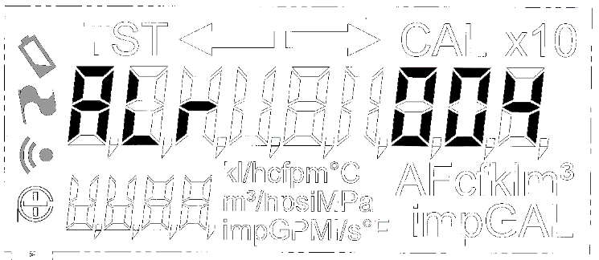

Exports

Identify
The identity number assigned is 9.

Events
Number | Alias | Meaning
0x0900 | Base
+0 | EVENT_CUSTOMER_ALARM_RAISED | A new alarm has been set. Information sent out in alarm_event_data_t
+1 | EVENT_CUSTOMER_ALARM_AUTO_CLEAR | Unused
+2 | EVENT_CUSTOMER_ALARM_MANUAL_CLEAR | An alarm has been cleared. Information send out in alarm_event_data_t
+3 | EVENT_CUSTOMER_LOCALE_CHANGED | The locale has changed. The new territory ID attached
+4 | EVENT_CUSTOMER_ALARM_CONDITION_ENDED | The condition that raised an alarm has ended, the alarm will still be active unless manually cleared
+5 | EVENT_CUSTOMER_INSTALLATIONTIME_UPDATED | The installation time has been automatically determined
+6 | EVENT_CUSTOMER_ALARM_CONDITION_STARTED | The condition that will eventually raise and alarm has begun, the alarm may not be raised yet
Table 25 - Events from the Customer application

Errors
Number | Alias | Meaning
0x0900 | Base
+0 | METER_FAULT | Alarm set
+1 | METER_FAULT_STOP | Alarm cleared
+2 | REVERSE_FLOW_IN_PROGRESS | Alarm set
+3 | REVERSE_FLOW_IN_PROGRESS_STOP | Alarm cleared
+6 | MAGNETIC_TAMPER | Alarm set
+7 | MAGNETIC_TAMPER_STOP | Alarm cleared
+8 | BATTERY_TAMPER | Alarm set
+9 | BATTERY_TAMPER_STOP | Alarm cleared
+10 | METER_REMOVED | Alarm set
+11 | METER_REMOVED_STOP | Alarm cleared
+12 | WRONG_CONDUCTIVITY | Alarm set
+13 | WRONG_CONDUCTIVITY_STOP | Alarm cleared
+14 | EXCESS_FLOW | Alarm set
+15 | EXCESS_FLOW_STOP | Alarm cleared
+18 | LOW_BATTERY_LIFE | Alarm set
+19 | LOW_BATTERY_LIFE_STOP | Alarm cleared
+20 | SUSPECT_LEAK | Alarm set
+21 | SUSPECT_LEAK_STOP | Alarm cleared
+22 | LOW_PRESSURE | Alarm set
+23 | LOW_PRESSURE_STOP | Alarm cleared
+64 | UNKNOWN_PARAMETER | Attempted to access an unknown register
+65 | LOCALE_UNDEFINED | Attempted to set an unknown locale
+66 | NO_SUCH_ALARM | Unused
+67 | OUT_OF_RANGE | Value failed range checks
+68 | NOT_IMPLEMENTED | Feature not implemented
+69 | BAD_CONFIG | Unused
+70 | DID_NOT_STORE | Returned by STORECONFIGURATION if it failed
+71 | STORE_PENDING | Returned by STORECONFIGURATION while storage of parameters is still pending
+72 | STRING_TOO_LONG | String used for customer string won’t fit
Table 26 – Customer application errors

Alarm IDs
The alarm_indices_t enum has the following values
Name | ID
REBOOT | 0
LOW_BATTERY | 1
EMPTY_PIPE | 4
REVERSE_FLOW | 6
SUSPECT_LEAK | 7
BROKEN_PIPE | 8
LOW_PRESSURE | 9
HIGH_PRESSURE | 10
LOW_TEMPERATURE | 11
HIGH_TEMPERATURE | 12
RADIO_ERROR | 13
METROLOGY_PARAMS | 14
METROLOGY_MEASURE | 15
Table 27 – Alarm IDs

Logger

Overview
Please see “Application ’Logger’”^{[1]}.

User interface

Configuration register list
In addition to the registers in ^{[1]} there are the following.
Number | Alias | Default | Meaning
0x0800 | Base
+3 | STORECONFIGURATION | Undefined | Writing TRUE to this register stores the values of the other registers to the non-volatile memory
Table 28 – Logger additional register list

Exports

Errors
In addition to the errors in ^{[1]} there are the following.
Number | Alias | Meaning
0x0800 | Base
+3 | PENDING_STORE | Returned by STORECONFIGURATION if it failed
+4 | DID_NOT_STORE | Returned by STORECONFIGURATION while storage of parameters is still pending
Table 29 – Logger application additional errors

NA2WLogger

Overview
The NA2WLogger application provides similar functionality to the logger described in the Ally documentation ^{[12]}. Information derived from measurements of pressure, temperature and volume will be logged. The number of entries that can be logged will depend on the other usage of the meter flash however it is expected that 2880 readings for each sensor will be able to be stored, this matches the ally capability.
The NA2WLogger application will also provide logging functionality for periodic and detailed alarm logs as described in the Ally documentation ^{[12]}.

Technical detail

General Implementation Notes
The NA2W logger follows where possible the Ally documentation ^{[12]} unless mentioned otherwise here.
The source code breaks down into four main parts, with an additional supporting section as follows:
NA2WLogger.c/h | Supplies the Breeze application main and exported functions
Na2WLogger_top.c/h | Handles creation of log records which are queued for writing to the log files
Na2WLogger_fiing.c/h | Implements the filesystem access functions for log read/writing and management
Na2WLogger_settings.c/h | Management of the settings file
Na2WLogger_bottom.c/h | Common functions needed by the above files
config.c/h | Configuration exchange support
events.c/h | Event capture and dispatching

Sensors And Log Files
The NA2W logger supports three sensor types: Water, Temperature and Pressure. Certain operations work in terms of the sensor and others in terms of the actual log files. There are defines for these in the exports.h which should be used in all exported functions. The following files are created by the logger:
"1\\NAwater" | Holds the logged volume/flow records (4320 entries maximum) | Periodic
"1\\NAtempC" | Holds the logged temperature records (4320 entries maximum) | Periodic
"1\\NApress" | Holds the logged pressure records (4320 entries maximum) | Periodic
"1\\NAalarm" | Holds the logged detailed alarm records (4320 entries maximum) | Event driven
"1\\NAconfig" | Holds configuration/settings | Periodic/event driven

The water, temperature and pressure files behave as a circular buffer with a fixed maximum number of entries, overwriting the oldest once the maximum is reached. The detailed alarm log holds a record of each time an alarm is raised or cleared and the settings file is simply a snapshot of the logger settings saved whenever something changes or when 1 hour has elapsed.

Logger Units
Internally the logger uses the units currently set for the system, with the resolution adjusted to match the Ally documentation ^{[12]} section 6.1. The only exception to this is values for the detailed alarm log entries where the specific data is stored as received from the NA2W Alarms application.

Sensor Averaging Process
The sensor data (water, temperature and pressure) is subject to an averaging process before being logged. As events are received containing relevant raw data, this is accumulated and periodically averaged. This process is driven from a regular 5 second tick handler which processes the accumulated data for each sensor generating average, minimum and maximum values as required. These 5 second data sets are then accumulated as part of a ‘logging period’ dataset. The logging period is expressed in minutes and represents the rate at which new records are added to the sensor data log files.
A similar process of generating the average, minimum and maximum values is performed on the ‘logging period’ dataset when it is time to create a new log record. Conveniently, this operation can be incorporated into the same 5 second tick handler simply by counting ticks and generating a new log entry whenever the ‘logging period’ number of minutes have passed.
For each sensor there is a single static log record structure that is used to queue a record for writing to the log. Due to the need for filesystem operations to be performed only in the main loop a signalling system is use to wake up the main loop when there is one or more records in the queue.

Measured Range
As well as the periodic logs for each sensor, the minimum and maximum over all time is stored. For the volume sensor the minimum and maximum flow rate is stored. Each of these also stores the associated timestamp. The same scaling is used as in the periodic data logs. The range and timestamps can be queried or reset by the appropriate exported function.

Detailed Alarm Logging
In contrast to sensor logging, the detailed alarm log is only updated when an alarm update event is received from the NA2W Alarms application. In the event handler, a new detailed alarm log record is created and added to a small circular buffer allowing several records to be queued for writing to the filesystem. Once again the main loop signalling system is used to trigger the actual writing process.

Periodic Alarm Logging
In addition to the detailed alarm log the Ally meter also implements a periodic alarm log that records alarm changes in relation to sensor ‘logging periods’. In Cordonel this is achieved by recording alarm changes in the ‘logging period’ dataset, which results in each sensor log entry also containing information on which alarms have been active within the logging period. This alarm information is added to the current logging period’ dataset for the sensor as part of processing alarm update events to build the detailed alarm log.

Accessing Exported Functions
The logger uses the Breeze filesystem to store data. The filesystem can only be accessed safely from the application main loop and it is important that any external applications using the exported functions conform to this requirement.
The exported functions have been implemented with the needs of the UI1236 interface in mind and should map onto it with minimal additional work.

Querying Logs
Owing to system constraints it is likely that any query of the logged data will need to be performed in multiple steps each of which returns a subset of the matching data. To achieve this searching the logged data has been implemented as two stage process. First a call is made to the NA2WLoggerQueryNew function which performs an initial query based on the provided specification and returns the first batch of results. Some details of this first query are saved internally so that one or more subsequent calls to the NA2WLoggerQueryNext allow the complete result set to be retrieved in modest batches.

User interface

Configuration register list
Number | Alias | Default | Meaning
0x1600 | Base
+0 | STORECONFIGURATION | Undefined | Store all configuration items (marked with *) in non-volatile memory.
+1 | LIMITLOGSIZE | Undefined | Allows the size of all log files to be changed for testing
Table 30 - NA2WLogger application register list

Programmer’s interface

Functions
Ten functions are available via SysCall()from the NA2W Logger application.
status_t NA2WLoggerQueryNew(log_query_t *plogquery)
Parameters | plogquery – A pointer to a log query structure
Returns | A status success code
Description | Performs a new log query operation
Interrupt state | Undefined
Reentrancy | Not re-entrant

status_t NA2WLoggerQueryNext(log_query_t *plogquery)
Parameters | plogquery – A pointer to a log query structure
Returns | A status success code
Description | Perform the next query operation in a sequence (assumes a previous query new)
Interrupt state | Undefined
Reentrancy | Not re-entrant

status_t NA2WLoggerSetInterval(const na2wlog_loginterval_t
*ploginterval)
Parameters | ploginterval – A pointer to a log interval structure
Returns | A status success code
Description | Changes the logging interval for a sensor
Interrupt state | Undefined
Reentrancy | Not re-entrant

status_t NA2WLoggerReadConfig(na2wlog_settings_t *plogsettings)
Parameters | plogsettings – A pointer to a log settings structure
Returns | A status success code
Description | Read the current configuration/settings for a log
Interrupt state | Undefined
Reentrancy | Not re-entrant

status_t NA2WLogResetRangeOverAll(na2wlog_sensor_t sensorid)
Parameters | sensorid – The sensor id
Returns | A status success code
Description | Reset the overall min/max values for a sensor
Interrupt state | Undefined
Reentrancy | Not re-entrant

status_t NA2WLogViewRangeOverAll(na2wlog_overall_minmax_t *pdata)
Parameters | pdata – A pointer to the overall min/max structure
Returns | A status success code
Description | Get the overall min/max values for a sensor
Interrupt state | Undefined
Reentrancy | Not re-entrant

status_t NA2WLogGetEntry(log_entry_t *logentry)
Parameters | logentry – A pointer to a log entry structure
Returns | A status success code
Description | Get a single log entry
Interrupt state | Undefined
Reentrancy | Not re-entrant

status_t NA2WLogGetInfo(log_info_t *loginfo)
Parameters | loginfo – A pointer to a log information structure
Returns | A status success code
Description | Get information about a log
Interrupt state | Undefined
Reentrancy | Not re-entrant

status_t NA2WLogGetState(log_state_t *logstate)
Parameters | logstate – A pointer to a log state structure
Returns | A status success code
Description | Get the state of a log
Interrupt state | Undefined
Reentrancy | Not re-entrant

status_t NA2WLogLiveAlarmState(log_live_alarm_t *live_alarm)
Parameters | live_alarm – A pointer to a log live alarm state structure
Returns | A status success code
Description | Get the live state of the alarms associated with a sensor, which may not have been logged yet
Interrupt state | Undefined
Reentrancy | Not re-entrant

Exports

Identity
The identity number assigned is 22.

Events
The NA2W Logger application does not generate any events.

Errors
Number | Alias | Meaning
0x1600 | Base
+0 | ERROR_NA2WLOGGER_UNKNOWN_PARAMETER | An invalid configuration parameter was provided
+1 | ERROR_NA2WLOGGER_NOT_MAIN_LOOP | An exported function was not called from the main loop
+2 | ERROR_NA2WLOG_LOG_INVALID | A log file was found to be invalid during restoration
+3 | ERROR_NA2WLOG_LOG_OPEN_FAILED | A log file could not be opened
+4 | ERROR_NA2WLOG_LOG_CLOSE_FAILED | A log file could not be closed
+5 | ERROR_NA2WLOG_LOG_REMOVE_FAILED | A log file could not be removed
+6 | ERROR_NA2WLOG_LOG_FLUSH_FAILED | A log file could not be flushed
+7 | ERROR_NA2WLOG_LOG_CLEAR_FAILED | A log file could not be cleared (emptied)
+8 | ERROR_NA2WLOG_LOG_BAD_REQUEST | Something was wrong with a request
+9 | ERROR_NA2WLOG_LOG_BAD_LIMIT | The requested log limit is invalid
+10 | ERROR_NA2WLOG_LOG_BUSY | A request could not be completed as the log was busy
+11 | ERROR_NA2WLOG_QUERY_FAILED | There was an error during a query request
+12 | ERROR_NA2WLOG_QUERY_UNKNOWN_SENSOR | Attempted to query an unknown sensor
+13 | ERROR_NA2WLOG_QUERY_UNKNOWN_LOGFILE | Attempted to query an unknown log file
+14 | ERROR_NA2WLOG_QUERY_BAD_ARGS | Something was wrong with the requested query arguments
+15 | ERROR_NA2WLOG_QUERY_NOT_ENOUGH_SPACE | Not enough space for the requested maximum number of records
+16 | ERROR_NA2WLOG_QUERY_NO_RECORDS_FOUND | No records were found that match the query
+17 | ERROR_NA2WLOG_QUERY_FILE_READ_PROBLEM | File read error during a query
+18 | ERROR_NA2WLOG_SETTINGS_STORE_FAILED | There was an error whilst saving the settings file
+19 | ERROR_NA2WLOG_SETTINGS_BAD_SENSORID | Attempted to access the settings for unknown sensor
+20 | ERROR_NA2WLOG_SETTINGS_BAD_PERIOD | The logging period was invalid
+21 | ERROR_NA2WLOG_SETTINGS_BAD_CHECKSUM | There was a checksum error when reading the settings file
+22 | ERROR_NA2WLOG_SETTINGS_BAD_TIMESTAMP | The timestamp in the settings file is invalid
+23 | ERROR_NA2WLOG_FILING_BAD | An error occurred whilst adding a log record
+24 | ERROR_NA2WLOG_BAD_RECORD | An error occurred whilst reading a log record
+25 | ERROR_NA2WLOG_RANGE_SENSORID_BAD | Attempted to access the overall min/max for unknown sensor
+26 | ERROR_NA2WLOG_STORE_PENDING | A configuration store request is already pending
+27 | ERROR_NA2WLOG_DID_NOT_STORE | Failed to store configuration
Table 31 - NA2WLogger application errors

NA2WAlarms

Overview
The NA2WAlarms application provides alarm functionality as described in the Ally documentation^{[12]}. This includes both the ‘user-defined’ and ‘predefined’ alarms.

Technical detail

Supported Sensors
Like the Ally meter, Cordonel supports Water (0), Temperature (1) and Pressure (2) sensor classes. Each sensor type supports a number of user alarms, but predefined alarms are only associated to the Water sensor.
Note that sensor 0xFF (Water metrology, using AMR digits only) is not supported within the NA2W Alarms and it is assumed that other applications will handle such requests as needed.

Supported Predefined Alarms
Not all the 24 predefined alarms supported by Ally are implemented in Cordonel as some have no corresponding function. The following table lists the implemented predefined alarms and their type:
0 | Upgrade Mode | Normal
1 | Hardware Failure | Removed
2 | Non-Volatile Memory Error | Removed
4 | Empty Pipe | Threshold
7 | Near End-of-Life | Threshold
8 | Beyond End-of-Life | Permanent
9 | Internal Comms Error | Removed
10 | Hardware Warning | Agglomerative
11 | Reboot | One shot
15 | Low Primary Battery | Threshold
19 | Configuration Error | Normal

Alarms marked as ‘Removed’ are implemented internally but currently have no triggering conditions associated with them. All other predefined alarms not mentioned in the table are not implemented beyond the ability to return default responses.

Hardware Warning
The additional data bitfield for the Hardware Warning alarm differs from ally, only two bits are presently used.
bit | Condition
0 | NFC Initialisation Fail
1 | NFC Write Fail

Low Primary Battery
As well as critical battery voltage, Cordonel will raise the Low Primary Battery alarm if the estimated remaining battery lifetime drops below 212 days.

Configuration Error
Ally has a bitfield of missing data as the additional data, Cordonel simply has the number of missing calibration factors. This alarm is only updated at boot.

Supported User Alarms
The Ally meter allows for up to 24 user alarms but actually supports a much smaller subset. Cordonel follows this approach, implementing 4 user alarms each for Water, Temperature and Pressure.
Likewise, Ally reserves of certain user alarms for specific functions and Cordonel follows Ally in this regard. All other implemented users alarms are available for customer specific usage.

Supported Water Sensor User Alarms
The following user alarms are implemented for the Water sensor:
0 | Custom alarm | Supports rate alarms
1 | Leak detection | Over rate
2 | High flow | Over rate
3 | Custom alarm | Supports rate alarms
4 | Reverse flow | Under rate

Supported Temperature Sensor User Alarms
The following user alarms are implemented for the Temperature sensor:
0 | High temperature | Over threshold
1 | Custom alarm | Supports threshold and range alarms
2 | Low temperature | Under threshold
3 | Custom alarm | Supports threshold and range alarms

Supported Pressure Sensor User Alarms
The following user alarms are implemented for the Pressure sensor:
0 | High pressure | Over threshold
1 | Custom alarm | Supports threshold and range alarms
2 | Low pressure | Under threshold
3 | Custom alarm | Supports threshold and range alarms

General Implementation Detail
The NA2W alarm application functions by listening to a wide variety of events that are passed around the system. These cover volume, pipe status, temperature, pressure, battery/power states and various abnormal system notifications. Depending on how the user alarms are configured certain conditions may result in an alarm being triggered or subsequently cleared. Unlike user alarm, predefined alarms tend to have fixed triggering criteria and may be enabled by default.
When an alarm condition changes an event is generated to notify other interested parties of its occurrence. The most likely listener for these events would be a system logging application.
The alarms have a lifecycle that that follow which is detailed in the Ally documentation^{[12]} and the Cordonel implementation attempts to mimic that as closely as possible.

Internal Units
The NA2W alarm application works internally in the following units:
Volume | Scaled billing (display) units
Flow Rate | 1/1024 ml/s
Temperature | 1/100 degree C
Pressure | Gauge pressure in Pa

A consequence of this is that when defining user alarms they must be specified in the above units and alarm specific data included in alarm update events will be also be expressed in the above units. Where different units are required, it is assumed that other applications will perform conversions as needed.

Alarm Backup And Restore
In order to preserve the NA2W alarm application state over a meter reboot, the state of all the alarms is written to the file ‘1\\NAstate’ once an hour or upon being notified that the system is being shut down via reception of the EVENT_SHUTTING_DOWN event.

User interface

Configuration register list
Number | Alias | Default | Meaning
0x1700 | Base
+0 | STORECONFIGURATION | Undefined | Store all configuration items (marked with *) in non-volatile memory.
+1 | PREDEFENABLE | Undefined | Allows access to the predefined alarms enable mask
Table 32 - NA2WAlarms application register list

Programmer’s interface

Functions
Eighteen functions are available via SysCall()from the NA2W Alarms application.
status_t NA2WAlarmsGetPersistence(uint8_t sensorid,
uint8_t *persistence)
Parameters | sensorid – The sensor Id to access  persistence – A pointer to a variable to receive the persistence period
Returns | A status success code
Description | Gets the current user alarm persistence period (in days) for a sensor
Interrupt state | Undefined
Reentrancy | Not re-entrant

status_t NA2WAlarmsSetPersistence(uint8_t sensorid,
uint8_t persistence)
Parameters | sensorid – The sensor Id to access  persistence – The new persistence period
Returns | A status success code
Description | Sets the user alarm persistence period (in days) for a sensor
Interrupt state | Undefined
Reentrancy | Not re-entrant

status_t NA2WAlarmsGetPredefEnableMask (uint32_t *mask)
Parameters | mask– A pointer to a variable to receive the predefined alarm mask
Returns | A status success code
Description | Gets the current predefined alarm enable mask
Interrupt state | Undefined
Reentrancy | Not re-entrant

status_t NA2WAlarmsSetPredefEnableMask(uint32_t mask)
Parameters | mask – The new predefined alarm enable mask
Returns | A status success code
Description | Sets the predefined alarm enable mask
Interrupt state | Undefined
Reentrancy | Not re-entrant

status_t NA2WAlarmsGetStateVectors(uint8_t sensorid,
uint64_t *predefvector, uint64_t *uservector)
Parameters | sensorid – The sensor Id to access  predefvector – Pointer to a variable to receive the predefined alarm state vector  uservector – Pointer to a variable to receive the user alarm state vector
Returns | A status success code
Description | Gets the alarm state vectors for a sensor
Interrupt state | Undefined
Reentrancy | Not re-entrant

status_t NA2WAlarmsGetActiveMask(uint8_t sensorid,
uint32_t *predefactive, uint32_t *useractive)
Parameters | sensorid – The sensor Id to access  predefvector – Pointer to a variable to receive the predefined alarm active mask  uservector – Pointer to a variable to receive the user alarm active mask
Returns | A status success code
Description | Get the alarm active masks for a sensor
Interrupt state | Undefined
Reentrancy | Not re-entrant

status_t NA2WAlarmsResetPredef(uint32_t mask, bool_t ackonly)
Parameters | mask– A mask for which predefined alarms to reset/ack  ackonly – TRUE for ack otherwise reset
Returns | A status success code
Description | Reset the predefined alarms
Interrupt state | Undefined
Reentrancy | Not re-entrant

status_t NA2WAlarmsResetUser(uint8_t sensorid,
uint32_t mask, bool_t ackonly)
Parameters | sensorid – The sensor Id to access  mask– A mask for which user alarms to reset/ack  ackonly – TRUE for ack otherwise reset
Returns | A status success code
Description | Reset the user alarms
Interrupt state | Undefined
Reentrancy | Not re-entrant

status_t NA2WAlarmsGetUserState(uint8_t sensorid,
uint8_t alarm, na2walarms_state_t *alarmstate)
Parameters | sensorid – The sensor Id to access  alarm – The user alarm number  alarmstate – Pointer to an alarm state structure
Returns | A status success code
Description | Gets the state of a user alarm
Interrupt state | Undefined
Reentrancy | Not re-entrant

status_t NA2WAlarmsGetPredefState(uint8_t alarm,
na2walarms_state_t *alarmstate)
Parameters | alarm – The predefined alarm number  alarmstate – Pointer to an alarm state structure
Returns | A status success code
Description | Gets the state of a predefined alarm
Interrupt state | Undefined
Reentrancy | Not re-entrant

status_t NA2WAlarmsGetLatestState(uint8_t sensorid,
na2walarms_state_t *alarmstate)
Parameters | sensorid – The sensor Id to access  alarmstate – Pointer to an alarm state structure
Returns | A status success code
Description | Get the state of the most recently changed alarm
Interrupt state | Undefined
Reentrancy | Not re-entrant

status_t NA2WAlarmsGetUserSettings(uint8_t sensorid,
uint8_t alarm, na2walarms_setting_t *alarmsettings)
Parameters | sensorid – The sensor Id to access  alarm – The user alarm number  alarmstate – Pointer to an alarm state structure
Returns | A status success code
Description | Get the current settings for a user alarm
Interrupt state | Undefined
Reentrancy | Not re-entrant

status_t NA2WAlarmsSetUserSettings(uint8_t sensorid,
uint8_t alarm, na2walarms_setting_t *alarmsettings)
Parameters | sensorid – The sensor Id to access  alarm – The user alarm number  alarmstate – Pointer to an alarm state structure
Returns | A status success code
Description | Update the settings for a user alarm
Interrupt state | Undefined
Reentrancy | Not re-entrant

status_t NA2WAlarmsGetUnacked(na2walarms_unacked_t **unacked)
Parameters | Unacked – Pointer to a pointer that will be filled in by this function to a structure containing the unacked information
Returns | A status success code
Description | Gets the current predefined alarm enable mask
Interrupt state | Undefined
Reentrancy | Not re-entrant

status_t NA2WAlarmsGetUserCounts(uint8_t sensorid, uint16_t *counts)
Parameters | sensorid – The sensor Id to access  counts – Pointer to an array to write the counts to
Returns | A status success code
Description | Get the user alarm counts for a sensor
Interrupt state | Undefined
Reentrancy | Not re-entrant

status_t NA2WAlarmsResetUserCounts(uint8_t sensorid)
Parameters | sensorid – The sensor Id to access
Returns | A status success code
Description | Reset the user alarm counts for a sensor
Interrupt state | Undefined
Reentrancy | Not re-entrant

status_t NA2WAlarmsGetPredefCounts(uint16_t *counts)
Parameters | counts – Pointer to an array to write the counts to
Returns | A status success code
Description | Get the predefined alarm counts
Interrupt state | Undefined
Reentrancy | Not re-entrant

status_t NA2WAlarmsResetPredefCounts(void)
Parameters | None
Returns | A status success code
Description | Reset the predefined alarm counts
Interrupt state | Undefined
Reentrancy | Not re-entrant

Exports

Identity
The identity number assigned is 23.

Events
Number | Alias | Meaning
0x1700 | Base
+0 | EVENT_NA2WALARMS_UPDATE | A new alarm has been set. Information sent out in na2walarms_event_t
+1 | EVENT_NA2WALARMS_RESTORE | An alarm has been restored. . Information sent out in na2walarms_event_t although not all fields are valid
Table 33 - Events from the NA2W Alarms application

Errors
Number | Alias | Meaning
0x1700 | Base
+0 | ERROR_NA2WALARMS_SENSOR_INVALID | An invalid sensor was requested
+1 | ERROR_NA2WALARMS_UNKNOWN_PARAMETER | An invalid parameter was provided
+2 | ERROR_NA2WALARMS_ALARM_INVALID | An invalid alarm was requested
+3 | ERROR_NA2WALARMS_UNIMPLEMENTED | An unimplemented function was requested
+4 | ERROR_NA2WALARMS_UNCONFIGURED | Attempted to access an unconfigured alarm
+5 | ERROR_NA2WALARMS_CONFIG_INVALID | Attempted to set an invalid configuration
+6 | ERROR_NA2WALARMS_NO_LATEST | There was no latest alarm found
+7 | ERROR_NA2WALARMS_FIXED_TYPE | Attempted to change a fixed function user alarm
+8 | ERROR_NA2WALARMS_PREDEF_SET | A predefined alarm was set (used in log message and events)
+9 | ERROR_NA2WALARMS_USERDEF_VOLUME_SET | A user volume alarm was set (used in log message and events)
+10 | ERROR_NA2WALARMS_USERDEF_TEMPERATURE_SET | A user temperature alarm was set (used in log message and events)
+11 | ERROR_NA2WALARMS_USERDEF_PRESSURE_SET | A user pressure alarm was set (used in log message and events)
+12 | ERROR_NA2WALARMS_PREDEF_CLEAR | A predefined alarm was cleared (used in log message and events)
+13 | ERROR_NA2WALARMS_USERDEF_VOLUME_CLEAR | A user volume alarm was cleared (used in log message and events)
+14 | ERROR_NA2WALARMS_USERDEF_TEMPERATURE_CLEAR | A user temperature alarm was cleared (used in log message and events)
+15 | ERROR_NA2WALARMS_USERDEF_PRESSURE_CLEAR | A user pressure alarm was cleared (used in log message and events)
+16 | ERROR_NA2WALARMS_DID_NOT_STORE | Failed to store configuration
+17 | ERROR_NA2WALARMS_STORE_PENDING | A configuration store request is already pending
+18 | ERROR_NA2WALARMS_PREDEF_BACKUP_FAILED | Predefined alarm backup failed
+19 | ERROR_NA2WALARMS_PREDEF_RESTORE_FAILED | Predefined alarm restore failed
+20 | ERROR_NA2WALARMS_USERDEF_BACKUP_FAILED | User alarm backup failed
+21 | ERROR_NA2WALARMS_USERDEF_RESTORE_FAILED | User alarm restore failed
+22 | ERROR_NA2WALARMS_USERDEF_UNSUPPORTED_TYPE_FOR_SENSOR | The alarm type requested isn’t supported for this sensor
Table 34 - NA2WAlarms application errors

FlexNetVersion

Overview
The FlexNetVersion application is a library application whose sole purpose is to provide a version number for use in other applications.
Sensus products are required to have a single version number for the entire firmware. This application provides this number, it must be updated with a new number whenever any firmware update is applied.
The FlexNet version format has a 3 bit major version, 4 bit minor version and 8 bit build version. Additionally there is a 1 bit ‘beta’ flag.
When formatted as a string the version number is “BX.Y.ZZ” where:
- B is the beta flag and can be ‘B’ or ‘R’
- X is the major version number
- Y is the minor version number as a capitalised hex character
- ZZ is the build version number as capitalised hex characters
The application version number is the FlexNet version as a 16 bit number:
Bit
15 (MS) | 14 | 13 | 12 | 11 | 10 | 9 | 8 | 7 | 6 | 5 | 4 | 3 | 2 | 1 | 0 (LS)
Beta | Major |  |  | Minor |  |  |  | Build

User interface

Configuration register list
This application has no configuration registers

Programmer’s interface

Functions
One function will optionally be available via SysCall()from the FlexNetVersion application.
status_t FlexNetVersionString(const uint8_t **string)
Parameters | string – A pointer to a string, the version string will be returned here
Returns | A status success code
Description | Returns the FlexNetVersion in a string format.
Interrupt state | Undefined
Reentrancy | Not re-entrant

Exports

Identity
The identity number assigned is 24.

Events
This application generates no events

Errors
This application has no error codes

